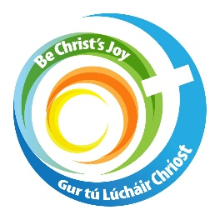
Diocese of Kerry
First Holy Communion
Parish Preparation Programme

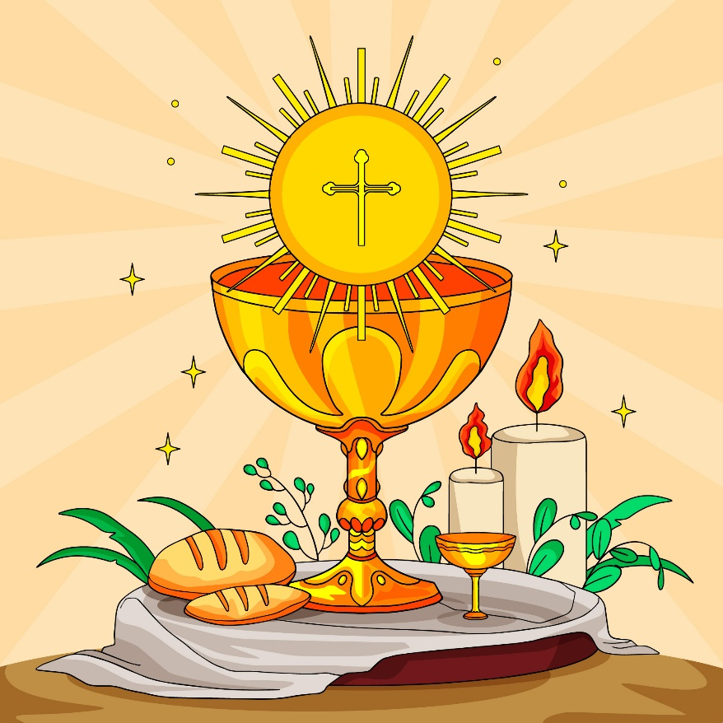

September 2026 – June 2027

Contents

Introduction 3
Programme Implementation Suggestions 4
Parent’s/Guardian’s Welcome Letter 6
Activities During Mass 7

October 2026 Let’s Begin – Enrolment 11
Enrolment Certificate 12
Enrolment Ceremony at Sunday Mass 13
Enrolment Ceremony Outside of Sunday Mass 19
November 2026 In November, We Remember 25
December 2026 Advent 28
January 2027 We listen to God’s word 31
February 2027 I’m sorry 34
March 2027 Lent 37
April 2027 We give thanks 40
May 2027 We receive the Body of Christ 42
June 2027 Living as Followers of Jesus 45
Appendix: Dates and Gospel readings 48

Introduction
Welcome to our parish Holy Communion preparation programme for 2026 - 2027.

This programme offers the parish a way of welcoming, supporting and engaging with families as they journey towards the celebration of their child’s First Holy Communion, a very special and memorable year for them all. This resource aims to help both parents and children prepare for the sacraments of Reconciliation and First Holy Communion by building on the children’s experience of faith at home, at school and through their participation and sense of belonging at the parish Mass. We also hope that through accompanying and supporting their child during this sacramental preparation, parents may strengthen or renew their own faith formation and beliefs. That they too may find a sense of God in their lives and that this will be a nourishing and enriching journey for all.

Home
“The role of parents and families in their child’s religious education is vital. Their involvement is not and should not be confined to times of sacramental preparation, but many parents are more conscious of their role at this time than at others. If families are to be more involved in their child’s Religious education, they need to be provided with concrete opportunities to engage in something together. By sending home a piece of work, a prayer or a topic to chat about, parents and families are being offered such support”. (Grow In Love – Second Class)
This resource offers themed monthly Masses and gatherings, with possible accompanying worksheets you could give to the children to take home and complete before the next meeting. It might be a nice idea to prepare a space in your church where Families would be encouraged to return the completed worksheets/artwork to be displayed. Alternatively, you or the parents may have your own creative ideas.

School
Deepening faith at home and through parish life is richly supported by the religious education programme Grow In Love in school.
“Traditionally our Catholic schools prepare children for the sacraments and have played a prominent role in children’s first celebration of Eucharist and Reconciliation, building on the foundation of children’s experience of faith in the home and in the parish. With changing times, that foundation can no longer be presumed, and schools often find themselves in a role far beyond what was previously expected. There is therefore now broad agreement that a new balance is needed; a balance that encourages and empowers home and parish communities to take on a greater sense of responsibility. That said, the Catholic school contributes an indispensable amount of commitment, expertise and resources to sacramental preparation and celebration”. (Grow In Love – Second Class)

One evening per week, the Grow In Love programme asks Teachers to send home the children’s workbook for a page/activity to be completed together with a parent or family member. This is an invaluable yet simple resource that we at parish level could support and encourage in our school visits throughout the year.

Parish
“The celebration of the sacraments are events in the life of the Christian community, not just in the life of the individual. The celebration of First Holy Communion and Reconciliation are graced moments in the child’s initiation into the community of faith. Therefore, they are also moments in the life of that community. They are events that happen to the community not just in the community”. (Grow In Love – Second Class)

As a parish community, we can support parents and children on their sacramental journey by welcoming them and integrating their journey into the weekly Mass. This booklet offers some suggestions and resources on how to do so.

Safeguarding
As a parish community, we recognise and uphold the dignity and rights of all children, are committed to ensuring their safety and well-being and will work in partnership with parents and guardians to do this, in compliance with the Diocesan safeguarding policies. (National Board for Safeguarding Children in the Catholic Church in Ireland)

Programme Implementation Suggestions
- This programme follows the liturgical year from October to June and is designed to be incorporated into your parish’s weekly Mass, once a month.
- It is also designed to be flexible and to suit the needs and possibilities of your parish context.
- Complement it with practices that have worked well for your parish in the past.
- There is a nice ‘Parents/Guardians Letter’ which you may wish to give out to the parents/guardians at/prior to the enrolment ceremony. There are some reassuring, thoughtful words of encouragement on how they can best support their child this year in preparing for this sacrament. Please amend as you wish. (See page 6 for letter)
- There are also some fun suggestions below of how you can include the children and their parents more in each Mass. It would only add an extra 5 mins to the overall Mass time. Please feel free to adopt, amend or indeed say no to any of the suggestions. They are just that – suggestions! Please see page 7 for the list
- Take time to consider the profile of the parents and children who are presenting for First Holy Communion this school year – what are their talents and interests. What resources/skills could the parents offer. Consider themes that locally mean something to your parish – is it a fishing town or a hillside sheep farming village, or is there a local Saint of importance to your parish for example?
- This programme ideally, should be coordinated by a team of parents in collaboration with the Priest and the Parish Pastoral Council. Please include the liturgy groups and music ministers if these resources are available to you/if you wish.
- It would be a nice idea to involve the children themselves and their parents, in the Mass, as much as is possible - readings, prayers of the faithful, the offertory, post communion reflection, music.
- While there are Prayers of the Faithful included in this resource, please feel free to invite children/families to create their own prayers.
- Rest assured, other parishioners would only be too delighted to also support these children and their families, on their faith journey, as we are all part of a faith community. Don’t be afraid to remind your parishioners of this, especially as these monthly Masses may possibly take an extra few minutes!
- Create a ‘Sacred Space’ in the church where the children’s work may be displayed.
- Use music from the children’s Grow In Love programme if you can, as these songs are familiar to them and are quite catchy and uplifting. Alternatively, ask your choir to consider that this is a ‘child friendly Mass’ in their song choices. Though none of this is essential!
- Please see our website https://www.dioceseofkerry.ie/primary/first-communion/ for suitable music from the Grow In Love Programme. The songs and accompanying lyric and music sheets are also available to download, which would be idea for your choir/music group to have and practice.
- Invite people to come forward for a blessing if they do not wish to receive Communion as this allows the First Communion children to become familiar with processing to the altar.
- As the time of First Communion draws closer, include the prayer before Communion and prayer after Communion at Mass.
- Invite the children to process in/out at the end of Mass, should you wish.
- Children are naturally very religious. This is a huge moment in their lives, and they will be excited, nervous but eager to be included so have some fun with these Masses and allow them to be that bit more ‘child friendly’! See pages 7 - 10 for some fun suggestions of additional activities to do during Mass.

First Holy Communion Preparation - Parent’s Letter

Dear Parents and Guardians,
We are very happy to begin the journey with your child as they prepare to receive their First Holy Communion this coming year. This is a very special time in your child's life and in the life of our parish community.
Preparing for this sacrament is a wonderful chance to grow closer to God. Your family is the most important part of this journey. Your love and example help your child learn what it means to follow Jesus every day.
We are here to support you, walk with you, and help your child get ready.
Our Top Tips for you as you guide them through this year…
- You are their first teacher: Your daily actions, kindness, and love show your child the heart of Jesus more than any textbook can.
- Progress over perfection: You do not need to be a theological expert; simply sharing your own faith and praying together in your own words is exactly what your child needs.
- A beautiful opportunity: Use this preparation season as an opportunity for your family to bond and spend time talking and praying together. You might be surprised what could come from it!
- Do not be afraid: Do not be afraid of the big questions children can often have/ask. It is okay not to have all the answers. Sometimes saying “What do you think” or “I often wonder about that myself” is perfectly sufficient.
- The gift of formatting habits: Bringing your child to Mass and talking about God creates lasting spiritual anchors they will carry into adulthood.
- Seeing faith through a child's eyes: Children often understand God's love with a beautiful, pure simplicity that can renew our own adult faith.
Please keep your child, and all the children in the preparation group, in your prayers. We look forward to working together to make this a joyful and holy experience for your family.
Warm blessings,
[Your Name / Title / Parish Priest]
[Parish Name]

Four Fun Activities for During Mass – Suggestions
*All accompanying Worksheets/Instructions follow this page*
- A family treasure hunt inside a Catholic church is an engaging, hands-on way to help children discover sacred objects and learn their meanings during their First Holy Communion preparation.
- Our Family Prayer: Before the end of one of the preparation Masses, ask the children to into the sanctuary. Give them each the ‘Our Family Prayer’ Worksheet and ask them to design and write a prayer for their own family, in their own words and decorate it. Allow some of the children to read their prayers from the pulpit, time allowing, at the next Mass. Display all the family prayers in the First Communion Sacred Space in the church. You could always read out the following one to give them some inspiration …

God our Father, up above,
Fill our home with peace and love.
Bless Mom and Dad, and sisters too,
And every brother in the crew!

With Mary’s help and Jesus' grace,
Make our house a happy place.
Help us share and laugh and pray,
Growing closer every day.
Amen

- Gospel Challenge: Have a prior look at your Gospel Reading, chose a word that is important and repeated a few times. Tell the children prior to reading the Gospel that you have chosen the word ---- and that they have to listen carefully and count how many times the word is said in the Gospel. You can invite them to tell you at the end. Give them the correct number if they don’t get it right! This is a great way to keep children focused and on task.
- Mass Listening BINGO!: This is one of my favourites! Make sure to have enough pens/pencils ready for the number of sacramental children. At the start of the Mass, invite the children to gather around the altar. Explain that you have a listening BINGO challenge for them. Give each child the Bingo Worksheet and a pen/pencil. Explain some of the more difficult words, for example – ‘Genuflect’ – as most children wouldn’t understand this word though they know how to do it! This task will once again keep children very focused all through the Mass! We would hope anyway!! I’ve added in two funny ones!
Church Treasure Hunt
Priest invites the children to stand around the front of the altar. Explain that you will call out clues about different objects/places around the church and that the children need to walk to, stand beside/point to what they think it is. Priest then announces which children (if not all) are correct and he explains, very simply, the meaning of each one. Remind children that they are in the house of God and that thought this is a fun activity, we must remain respectful at all times.
- The Baptismal Font: Clue: "Where we first became children of God with living water." (Connects to remembering our baptismal promises before receiving the Eucharist)
- The Tabernacle Clue: "The special golden house where the Blessed Sacrament is kept safe and close to us."
- The Altar: Clue: "The holy table where the bread and wine become the Body and Blood of Jesus during Mass."
- The Ambo (Pulpit): Clue: "The raised stand where God speaks to us through the readings of the Bible."
- The Sanctuary Lamp: Clue: "The burning red candle that lets us know Jesus is present in the Tabernacle."
- The Paschal Candle: Clue: "The large, tall candle lit at Easter that reminds us Jesus is the Light of the World."


Our Family Prayer


Mass Bingo!
Make sure you have your pen/pencil ready!
Tick each box when you see/hear the item written … Go!
Altar Bells   | People Genuflecting   | Altar Candles  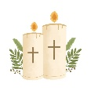 | The Gospel  
Sign of Peace   | A baby cries!   | What colour is the priest wearing? | The Chalice  
The Eucharist  (Holy Bread)  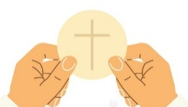 | Our Father Prayer   | Kneeling   | Singing/Music  
Holy Water  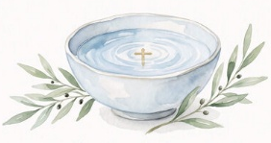 | Opening the Tabernacle  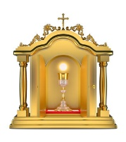 | Someone coughs/sneezes!   | “Amen”  

Enrolment Ceremony
The journey towards First Holy Communion begins with the Enrolment Ceremony in October. This takes place preferably during the Saturday Vigil / Sunday Mass, highlighting the parish as the context of our faith journey. However, a parish might decide to have the Enrolment Ceremony outside of Mass due to the size of the group involved.

Enrolment Ceremony at Weekly Mass

- The enrolment ceremony takes place after the Gospel.

- Ensure you have enough candles beforehand for every child who is preparing for Holy Communion. Place these candles on a table in the sanctuary or in the sacred space ready for distribution at the end of the ceremony.

Enrolment Ceremony outside of Mass
- Where possible this would take place in the local church rather than the school. Let the parish community know of the enrolment by announcing it at Mass and in the parish newsletter and invite them to be present.

- Ensure you have enough candles beforehand for every child who is preparing for Holy Communion. Place these candles on a table in the sanctuary or in the sacred space ready for distribution at the end of the ceremony.

- Please see a copy of our Diocesan Enrolment Certificate on page 12. It is available to download from our website www.dioceseofkerry.ie/primary/first-communion/.

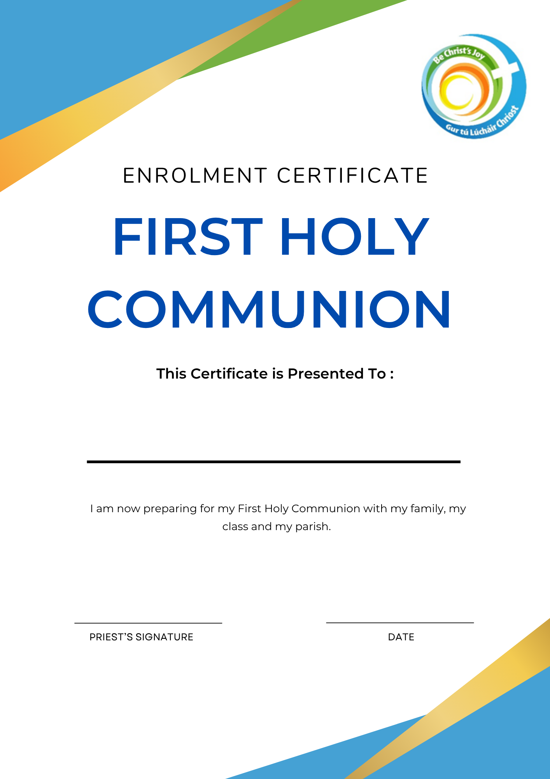
Enrolment Ceremony
October 2026
Let’s Begin
at Weekly Mass

Gathering Rite
Reader We would like to welcome in a special way today, the girls and boys who are preparing for their First Holy Communion next May. During the year you will be learning lots more about our great friend Jesus, who calls and chooses each one of us to be his friend. We need Jesus and we need one another for our faith to grow, no matter what age we are! Our theme for today’s Mass is “Let’s Begin” and we ask all present here to remember where our faith journey began – our baptism, when our parents, priest, family, friends and members of the parish community gathered to welcome and pray for the tiny baby we once were. We recall our baptism now with the lighting of the Paschal candle.
Paschal candle is lit

Rite of Blessing and Sprinkling of Water
Altar server holds bowl of water in front of priest.

Priest: Dear brothers and sisters,
Let us now ask our heavenly Father to bless this water.
Water is an invaluable gift for all of creation,
without it there would be no life
Let us never take this precious gift for granted.
Let our hearts grow in deep respect and appreciation for the gift of water.
Each time we bless ourselves with Holy water, we remember our baptism.
Brief pause of silence…
Almighty ever living God, who willed that, through water,
the fountain of life and the source of purification,
every soul should be cleansed and receive the gift of eternal life;
be pleased, we pray to + bless this water,
by which we seek protection on this your day, O Lord.

Renew the living springs of your grace within us
and grant that, by this water, we may be defended
from all ills of spirit and body,
and so, approach you with hearts made clean and worthy,
to receive your salvation.
Through Christ our Lord. Amen.

Priest sprinkles himself, ministers and congregation…

May almighty God cleanse us from our sins and, through the celebration of
this Eucharist, make us worthy to share at the table of his Kingdom.

All Amen.

Liturgy of the Word

Enrolment Ceremony
Reader: Now we will have a short ceremony of enrolment for the children who are preparing for their First Holy Communion, the first of many communions throughout their lives we pray. In the Grow In Love programme, the children have been learning that through our baptism, each person has been called and chosen by God. Every time we gather as a circle of friends, as a family, as a parish faith community, we do so in the company of our friend Jesus.
I now invite the children who are preparing for Holy Communion to stand. The response to each promise is We Do. After the priest’s blessing, say Amen.

Priest: Girls and boys, you have been preparing to receive the gift of Jesus through Holy Communion since you were small. Next year you will receive you First Holy Communion for the first time, to nourish and strengthen you in life. As you prepare in a special way over the coming months, do you promise to listen carefully to all the people who will help you learn about God’s love?

Children: We do

Priest: Do you promise to try to get to know God better by praying at home with your family, by being a friend to Jesus and by coming to Mass as often as you can?
Children: We do

Priest: May you know God’s great love for you. May you experience much joy growing in love with Jesus. May this joyful love flow out to your families, friends and wider community.
All: Amen
Reader: Thank you girls and boys, you may now sit down.
I invite all parents and guardians to stand for their commitment.

Priest: God has called and chosen you to be parents and guardians. You have asked that your children continue the faith journey that they began at their Baptism. Do you promise to help your child Grow In Love with Jesus by praying together at home and by committing to engage in the Grow In Love homework/programme with your child?

Parents: We do.

Priest: Do you promise to love, support and pray with your child as members of this parish community through regular celebration of weekly Mass?

Parents: We do.

Priest: May God bless you abundantly with wisdom, patience, joy and laughter.
May you discover God’s love on this faith journey, more than you could ever imagine, as your family grows in love.
All: Amen.

Reader: We now invite everyone to stand.

Priest: As members of the family of God it is our responsibility to be a welcoming, compassionate faith community.
Do you promise to welcome and enable these families to deepen their faith and together as a faith community be a compassionate presence in our world?
All: We do.

Priest: As your priest, I commit to proclaiming the Good News of Jesus joyfully that together we may be a community gathered in love.

All: Amen.

Prayers of the Faithful
Priest: Loving God, you call each one of us to be your friends. You choose each of us to be a sign of your love. We ask you now to hear the prayers of our hearts.

Reader: For our moms, dads, and families. Thank you for loving us, helping us to learn about God, and bringing us to church. Lord, hear us.

Reader: We pray for our priest(s) and our teachers that God will continue to bless their good work. Lord, hear us.

Reader: We pray for each child preparing to receive their First Holy Communion, that we grow more in love for God and for all God’s people. Lord, hear us.

Reader: For our teachers and parish leaders who help us understand the Bible and God’s great love. May God bless them with joy and patience. Lord, hear us.

Reader: For our church family here today. May we always care for one another and share the light of Jesus with everyone in our neighbourhood. Lord, hear us.

Reader: We pray for those who have little food and who often go hungry, that we share with them from what we have. Lord hear us.

Reader: We pray for all who have died, that they may experience eternal peace.
Lord, hear us.

Priest: O God, generous creator of all life,
hear and answer the prayers of our hearts.
We ask this through Jesus Christ our Lord.

All: Amen.

Liturgy of the Eucharist
Communion Reflection


Small Beginnings
Many, if not all great undertakings
begin in small and often hidden ways.
Seeds need darkness, they need isolation,
and earth’s protection for them to germinate.
Something to begin small,
hidden, is an advantage.
It means it can develop away from publicity,
and it can develop at its own pace.
Hence, the importance of beginnings.
Of taking care of things in their beginnings.
Jesus began his great work quietly. No fanfare, no public launching.
He began calling a few people-two in fact.
His mission was passed on from one person to another.
Let us trust that if our cause is good,
and if we plant one seed at a time,
God will support us, and it will grow and prosper.

Sr. Antoinette Dilworth

Before the Concluding Rite
Priest
I invite the children who are preparing for Holy Communion to come up to the sanctuary to receive a candle. This candle may be lit when you pray at home as a family or when you are discussing your Grow In Love homework or at other special moments shared together at home.
When each child has received their candle:
Priest to children and their families:
Receive this candle. May lighting it at home remind you that this faith Community welcomes, encourages and supports you as a circle of faith friends. May Christ’s light always shine brightly in your hearts, your homes, in our parish and in the world.

All: Amen.

Concluding Rite as usual

Enrolment Ceremony
October 2026
Let’s Begin
outside of Mass

Gathering Rite
Reader We would like to welcome in a special way today, the girls and boys who are preparing for their First Holy Communion next May. During the year you will be learning lots more about our great friend Jesus, who calls and chooses each one of us to be his friend. We need Jesus and we need one another for our faith to grow, no matter what age we are! Our theme for today’s Mass is “Let’s Begin” and we ask all present here to remember where our faith journey began – our baptism, when our parents, priest, family, friends and members of the parish community gathered to welcome and pray for the tiny baby we once were. We recall our baptism now with the lighting of the Paschal candle.

Paschal candle is lit
Reader: As we light the Paschal candle, may we be reminded of God’s love for us.

Priest: May God, who through water and the Holy Spirit has given us a new birth in Christ, be with you all.

All: And also with you.

Priest This holy water reminds us of Christ, the living water. It also reminds us of our Baptism. Whenever we use holy water in blessing ourselves, as we enter the church or at home, we’re thanking God for the precious gift of life. We’re also asking for God’s protection.
Priest sprinkles holy water on the assembly
Priest: In the name of the Father, and of the Son, and of the Holy Spirit

All: Amen.

Priest: Loving God, you have chosen each one of us to be here today. During this special time of preparation for Holy Communion, open all our hearts and continue to draw us closer to your friendship.

Help us to become followers of Jesus by loving and serving one another in our homes, school/s and parish community. We ask this through Christ our Lord.

All: Amen.

Reader: We stand to listen to God’s word.

Alleluia, alleluia!
I call you friends, says the Lord,
because I have made known to you everything I have learnt from my Father.
Alleluia!

Gospel Reading John 15: 9 - 15

Priest: A reading from the Holy Gospel according to John. Jesus said to his disciples: “As the Father loves me, so I also love you. Remain in my love. If you keep my commandments, you will remain in my love, just as I have kept my Father’s commandments and remain in his love. “I have told you this so that my joy might be in you and your joy might be complete. This is my commandment: love one another as I love you.”
The Gospel of the Lord.

All: Praise to you Lord Jesus Christ.

Enrolment Ceremony
Reader: Now we will have a short ceremony of enrolment for the children who are preparing for their First Holy Communion, the first of many communions throughout their lives we pray. In the Grow In Love programme, the children have been learning that through our baptism, each person has been called and chosen by God. Every time we gather as a circle of friends, as a family, as a parish faith community, we do so in the company of our friend Jesus.
I now invite the children who are preparing for Holy Communion to stand. The response to each promise is We Do. After the priest’s blessing, say Amen.

Priest: Girls and boys, you have been preparing to receive the gift of Jesus through Holy Communion since you were small. Next year you will receive you First Holy Communion for the first time, to nourish and strengthen you in life. As you prepare in a special way over the coming months, do you promise to listen carefully to all the people who will help you learn about God’s love?

Children: We do

Priest: Do you promise to try to get to know God better by praying at home with your family, by being a friend to Jesus and by coming to Mass as often as you can?
Children: We do

Priest: May you know God’s great love for you. May you experience much joy growing in love with Jesus. May this joyful love flow out to your families, friends and wider community.
All: Amen

Reader: Thank you girls and boys, you may now sit down.
I invite all parents and guardians to stand for their commitment.

Priest: God has called and chosen you to be parents and guardians. You have asked that your children continue the faith journey that they began at their Baptism. Do you promise to help your child Grow In Love with Jesus by praying together at home and by committing to engage in the Grow In Love homework/programme with your child?

Parents: We do.

Priest: Do you promise to love, support and pray with your child as members of this parish community through regular celebration of weekly Mass?

Parents: We do.

Priest: May God bless you abundantly with wisdom, patience, joy and laughter.
May you discover God’s love on this faith journey, more than you could ever imagine, as your family grows in love.
All: Amen.

Reader: We now invite everyone to stand.
Priest: As members of the family of God it is our responsibility to be a welcoming, compassionate faith community.
Do you promise to welcome and enable these families to deepen their faith and together as a faith community be a compassionate presence in our world?
All: We do.

Priest: As your priest, I commit to proclaiming the Good News of Jesus joyfully that together we may be a community gathered in love.

All: Amen.

Prayers of the Faithful
Priest: Loving God, you call each one of us to be your friends. You choose each of us to be a sign of your love. We ask you now to hear the prayers of our hearts.

Reader: For our moms, dads, and families. Thank you for loving us, helping us to learn about God, and bringing us to church. Lord, hear us.

Reader: We pray for our priest(s) and our teachers that God will continue to bless their good work. Lord, hear us.

Reader: We pray for each child preparing to receive their First Holy Communion, that we grow more in love for God and for all God’s people. Lord, hear us.

Reader: For our teachers and parish leaders who help us understand the Bible and God’s great love. May God bless them with joy and patience. Lord, hear us.

Reader: For our church family here today. May we always care for one another and share the light of Jesus with everyone in our neighbourhood. Lord, hear us.

Reader: We pray for those who have little food and who often go hungry, that we share with them from what we have. Lord hear us.

Reader: We pray for all who have died, that they may experience eternal peace.
Lord, hear us.

Priest: Loving God who calls each one of us by name, look with kindness on
your friends gathered in your name today. Throughout this time of preparation for Holy Communion, may we continue to Grow In Love with you and with one another. We ask this through Christ our Lord.
All: Amen.

Priest: Together we pray the prayer that Jesus taught us …..Our Father…

Priest: As friends of Jesus, let us reach out and offer one another a sign of peace.

Priest: May Christ’s light always shine brightly in your hearts, your homes, in our parish and in the world.

All: Amen.

Liturgy of the Eucharist

Communion Reflection

Small Beginnings
Many, if not all great undertakings
begin in small and often hidden ways.
Seeds need darkness, they need isolation,
and earth’s protection for them to germinate.
Something to begin small,
hidden, is an advantage.
It means it can develop away from publicity,
and it can develop at its own pace.
Hence, the importance of beginnings.
Of taking care of things in their beginnings.
Jesus began his great work quietly. No fanfare, no public launching.
He began calling a few people-two in fact.
His mission was passed on from one person to another.
Let us trust that if our cause is good,
and if we plant one seed at a time,
God will support us, and it will grow and prosper.

Sr. Antoinette Dilworth

Activity Sheet 1
In November, We Remember
Write the name of a loved one who has died in the centre of the candle. Colour the candle and cut it out. Display it on the Sacred Space in your church before our next First Communion Preparation Mass.


November 2026
In November, We Remember

Gathering Rite
Reader
We welcome the children who are preparing for the sacraments of Reconciliation and First Holy Communion, and their families.

Today, as a faith community we celebrate the communion of saints. The saints can be described as ordinary men and women who showed God’s love in extraordinary ways. The saints can teach us something about living as faithful Christians, and so we try to follow their example. They lived in a world as we are now doing and experienced the same struggles as we do. They are now in heaven with God and we can pray to them to ask them to help us to live our lives with love for God and for others, as they did.

Liturgy of the Word
Readings of Sunday liturgy are proclaimed by Ministers of the Word
Prayers of the Faithful
Priest: Jesus, light of the world, we trust in your unconditional love for us and as we
follow in your footsteps, hear the prayers of our hearts and minds as we journey to the life you have called us to live.

Reader: We pray for Pope Leo, Bishop Ray and all leaders in our community,
that they may continue to be a source of hope for us. Lord, hear us.
Reader: We pray for all those who are finding life hard at the moment, that our words and actions might be a source of hope and healing. Lord, hear us.
Reader: For those who are mourning the death of a loved one at this time –
may they know your closeness through the kindness of friends and the prayers of our community. Lord, hear us.
Reader: We pray for all families in our community. Especially the parents and children who are preparing for sacraments at this time. Lord, hear us.
Reader: We remember all of those who have died. Those who have touched our hearts and shaped our lives in a loving way. Lord, hear us.

Priest: Ever living God, you call us daily
to be a radiant reflection of your love.
Open our hearts to listen to your voice.
We ask this through Christ our Lord.
All: Amen.

Liturgy of the Eucharist
Communion Reflection

Enfolded in Eternal Light
Try not to think of me as gone away,
I am now dwelling in an eternal place,
back home where I belong.
Think of me as resting,
from all life’s pain and struggle
in everlasting peace.
Think of me reunited with my loved ones,
cherished forever,
in the circle of their love.
Think of me as living on
in the shelter of your heart
with my presence beside you
we are never apart.
Think of me enfolded in the radiance of light,
and resting in God’s loving sight.
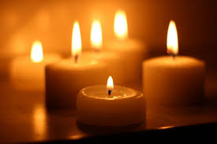

Sr. Antoinette Dilworth

Activity Sheet 2
Advent – ‘Prepare, Prepare’

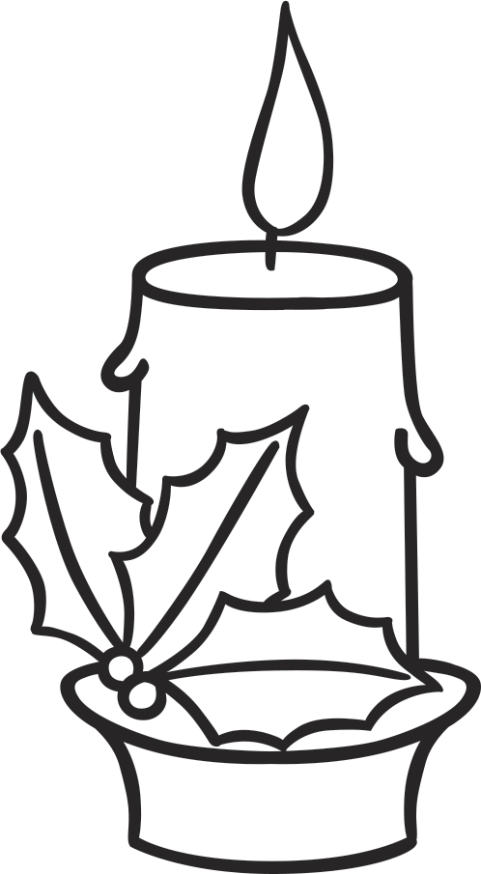

PEACE
HOPE

JESUS

JOY
LOVE

December 2026
Advent

Gathering Rite
Reader
Welcome everyone. As a parish community, we welcome especially the children who are preparing for First Holy Communion and Reconciliation, and their families. In a way, preparing for these sacraments is like preparing for Christmas. In both instances we are preparing to welcome Jesus more closely. This special time of preparation over the next four weeks is called Advent, when we wait with great joy for Jesus’ birth. To help us visually, we light one candle each week on the Advent Wreath. Notice how, as the weeks pass, the wreath gets brighter. At Christmas, we welcome Jesus, the Light of the World.
Lighting of candle on Advent Wreath

Liturgy of the Word
Readings of Sunday liturgy are proclaimed by Ministers of the Word.

Prayers of the Faithful
Priest: Generous God, we gather as a parish united with all who call you loving parent. We bring our prayers as we wait in hope for Jesus’ birth.

Reader: We pray for all world leaders, especially Pope Leo and Bishop Ray,
that their guidance may inspire kindness and care for all people.
Lord, hear us.
Reader: For all who are homeless, that they may know God’s love through our words and acts of compassion. Lord, hear us.
Reader: For all families, especially those who are finding relationships challenging at this time. Lord, hear us.
Reader: We pray for the children in our community preparing to receive the sacraments, that they may grow in friendship with Jesus and know his love for them. Lord, hear us.
Reader: We pray, that as we prepare for the birth of Jesus, that we create a
welcoming place in our hearts and homes for his loving presence. Lord, hear us.
Reader: We remember and pray for all of our loved ones who have died,
that they may have the gift of your eternal peace. Lord, hear us.

Priest: Loving God, as we await the birth of your Son, soften our hearts to find words of forgiveness and love. Make us messengers of your peace.
We make this prayer through Christ our Lord.
All: Amen.

Liturgy of the Eucharist
Communion Reflection


Prepare, Prepare!

Prepare, prepare,
Get ready, get set!
Prepare, prepare,
And don’t forget!
This is a special time of year,
Christmas is coming,
Advent is here!

Prepare, prepare,
Make ready! Make Way!
To hear the story
Of Christmas Day.
Prepare, prepare,
The time has come,
Soon we will welcome
Mary’s Son.

(Grow In Love 2nd Class)

Activity Sheet 3
We Listen to God’s Word

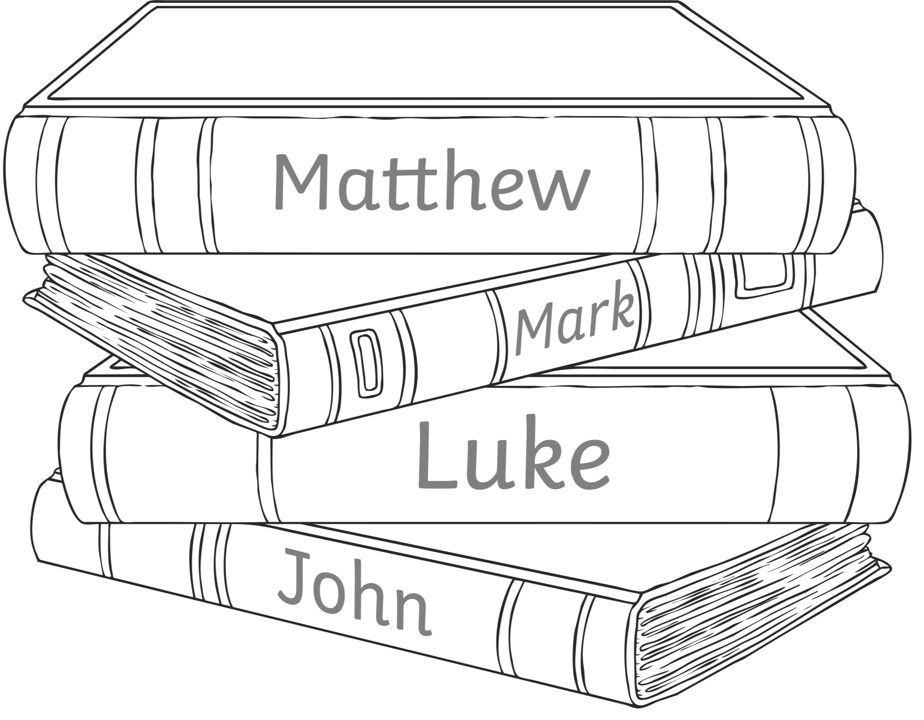

January 2027
We Listen to God’s Word

Gathering Rite
Reader Welcome everyone. A special welcome to the children preparing to receive the sacraments of First Holy Communion and Reconciliation, and their families. In our ongoing parish journey helping you, we explore today how we can listen better to God’s Word. We learn to listen with our ears, then with our eyes and mostly with our hearts! As we begin our celebration of Mass, ask Jesus to help you to hear his message today. Open our ears, our eyes and our hearts Lord so that we can hear and respond to your word. Amen

Liturgy of the Word
Readings of Sunday liturgy are proclaimed by Ministers of the Word.

Prayers of the Faithful
Priest: Loving and gentle God, help us to hear and carry out your word faithfully in our lives. Help us to be living witness to your word and be led by the Holy Spirit in all that we do. Lord, hear us.

Reader: We pray for Church leaders, especially Pope Leo and Bishop Ray,
and the clergy in our community as they lead us into the fullness of your word. May they be blessed and led by the Holy Spirit with courage in these challenging times. Lord, hear us.
Reader: For Christians, and all people of other faiths and none, may we find a path of unity through respect and kindness. Lord, hear us.
Reader: We pray for the children and their families in our parish who are preparing for the sacraments. That they may be led by the Holy Spirit and feel God’s presence close to them. Lord, hear us.
Reader: We pray for all families in our parish, that they may be blessed with forgiveness, love and care. Lord, hear us.
Reader: We pray for the Earth, our common home. That we may always care for our Earth’s precious resources. Lord, hear us.
Reader: For all who have died, that they may be held close in your love. Lord, hear us.

Priest: Gentle and loving God,
in your kindness answer our prayers
and deepen in us the gift of listening heart.
We make this prayer through Jesus Christ your Son,
who lives and reigns with you and the Holy Spirit, one God for ever and ever.

All: Amen.

Liturgy of the Eucharist
Communion Reflection


January is a month of new beginnings, and resolutions.
Each year we are handed a blank page and we have an opportunity to decide,
What the new year and the rest of our lives will be like.

We are offered a choice whether to really live the new year,
Or to merely endure it.

Beginnings require courage, but the moment we make a commitment to the journey, then God’s light circles us and sees us on our way.

With God’s light within us and around us, there is nothing we cannot endure or achieve.
It is important that we enter fully into each day and embrace whatever the new year offers us.

Sr Antoinette Dilworth

Activity Sheet 4

The Act of Sorrow
When you have finished talking to the priest and you have told him about the times when you did not show love to God, he will ask you to say a prayer called the Act of Sorrow. By saying this prayer, you are showing that you are truly sorry.
Fill in the Blanks

God | sins | you | Jesus
others | sorry | loving | again
Act of Sorrow
O my ,
l thank for loving me.
I am for all my ,
for not loving and not you. Help me to live like and not sin . Amen.
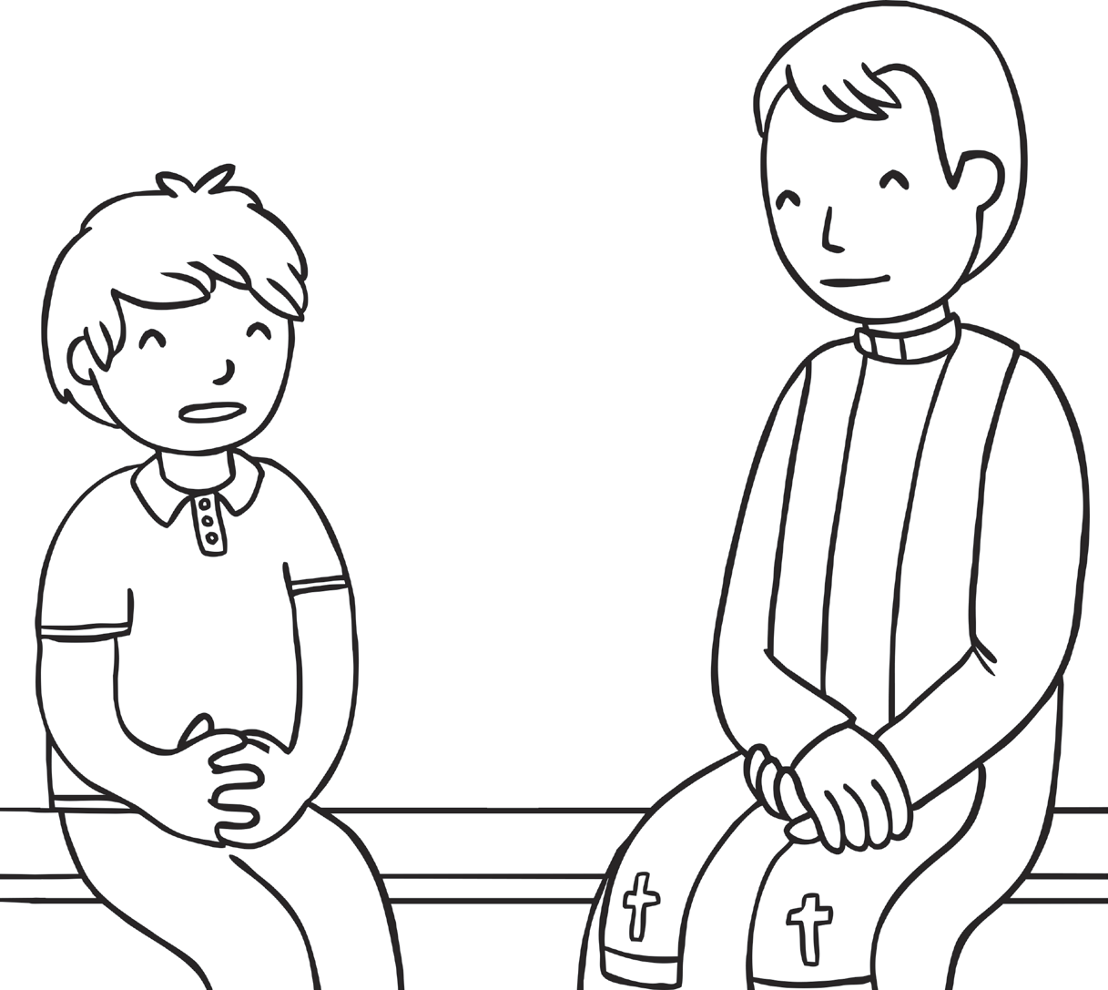

February 2027
I’m sorry

Gathering Rite
Reader
Welcome everyone. Today we welcome especially the children preparing for their First Holy Communion and who are preparing for their First Confessions also known as the Sacrament of Reconciliation.

This is a very special time for the children and their families and also our Church community as we reflect on God’s love for us and the role forgiveness and reconciliation plays in this loving relationship between each one of us and God. It is important that we express when we are sorry and also when we are forgiving someone. Let us pause for a moment and remember God’s great love for each one of us.

Act of Sorrow
Priest: Instead of the Confiteor today, we join in praying the Act of Sorrow that the children have been learning. In this prayer, we begin with thanking God for his love. We tell God we are sorry for the times we have made mistakes and then we look to future with hope.

O my God, I thank you for loving me.
I’m sorry for all my sins, for not loving others, and not loving you.
Help me to live like Jesus and not sin again.

Amen.

Liturgy of the Word
Readings of Sunday liturgy are proclaimed by Ministers of the Word.

Prayers of the Faithful
Priest: Loving and forgiving God, you always forgive us and welcome us with love and friendship. Today we bring you our prayers.
Reader: For leaders of churches and nations, especially Pope Leo and Bishop Ray,
that they may always encourage forgiveness and reconciliation. Lord, hear us.

Reader: We pray for peace in our world. Especially those affected by war, natural disasters and other forms of conflict. That God may give them strength and the gift of peace. Lord, hear us.
Reader: Lord, help us to say sorry to those we hurt and forgive those who
have hurt us with open, honest hearts. Lord, hear us.
Reader: We pray for families in our communities, that they may experience God’s gentle and loving presence in their lives. We pray especially for the children preparing for sacraments. Lord, hear us.
Reader: Lord we think of our loved ones who have died and are with God in heaven.
Lord, hear us.
Priest: Gracious and patient God, bring healing to our lives,
That we may sow beauty, not hurt and destruction.
We make these and all our prayers through Christ your Son, our Lord,
All: Amen.

Liturgy of the Eucharist
Communion Reflection

Each year the trees gives us a lesson in renewal.
First the bud, then the blossom, and finally the shoot.
Spring dresses the trees in a new robe,
And makes them young again.
But this is possible only because in autumn
They let go of their old leaves,
And in between endured a period of nakedness.
Lent is the springtime of the spirit.
Lord, help us not to be afraid to let go of old habits,
And to face our spiritual poverty,
In order that you may renew us, and so at Easter
We will feel young again in our discipleship.

Flor McCarthy

Activity Sheet 5 - Lent
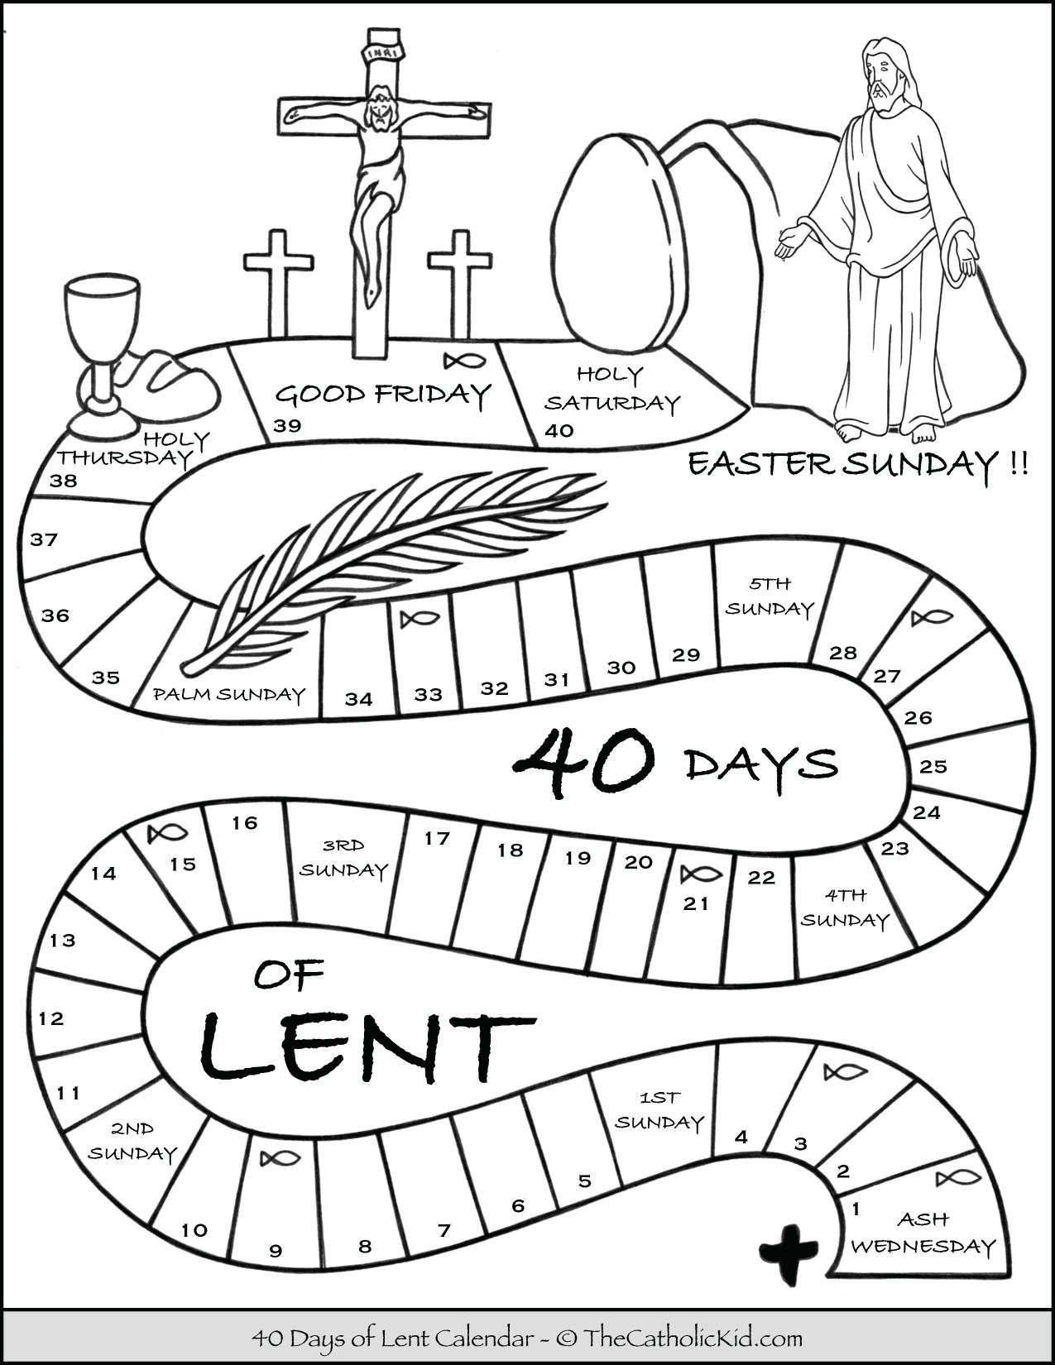

March 2027
Lent

Gathering Rite
Reader: Welcome everyone. Today we welcome especially the children who are
preparing for their First Holy Communion and their families. The season of Lent begins on Ash Wednesday and lasts 40 days until Easter Sunday. The journey of Lent brings us on an adventure through deserts and up mountains. It challenges us to leave unhelpful ways of doing and thinking. Lent invites us to Grow In Love through prayer, fasting and almsgiving. As we begin Mass, we pause to remember God’s constant love for us.

Liturgy of the Word
Readings of Sunday liturgy are proclaimed by Ministers of the Word.

Prayers of the Faithful
Priest: God of unfailing mercy, we come together in your name to give
you praise and thanks for all that we are blessed with in our lives.
In your unconditional love for us, hear the prayers we bring to you today.

Reader: We pray for all faith leaders in our world, especially Pope Leo and Bishop Ray, that they may lead us faithfully to live our lives as followers of Jesus.
Lord, hear us.
Reader: We pray for all charities and the work they do around the world. That the Holy Spirit will continue to guide, inspire and bless their work. Lord, hear us.
Reader: Lord, we remember those in our community who are suffering, grieving or carrying a heavy burden in their hearts and minds. May they know your gentle, loving presence in their lives. Lord, hear us.
Reader: For all children preparing for Holy Communion and Confirmation, that this Lenten journey may deepen their awareness of God’s love for them, especially through the sacrament of Reconciliation. Lord, hear us.
Reader: Lord, we think of our loved ones who have died and are now with God in heaven. Lord, hear us.

Priest: God of abundant love, mercy and compassion,
Help us to recognise your presence in our lives and know that you are with us in whatever we face. Continue to help us find you when we stray from your unconditional love. Let us use this time of Lent to reconnect and renew loving and healthy relationships and connections in our lives. We make these and all our prayers through Christ your Son, our Lord.

All: Amen.
Liturgy of the Eucharist
Communion Reflection

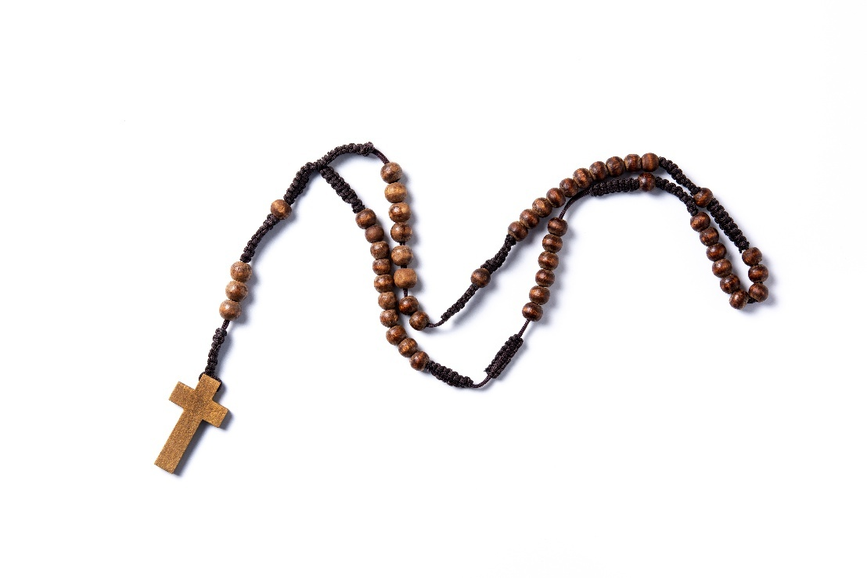
I carry a cross in my pocket, a simple reminder to me,
Of the fact that I am a Christian no matter where I may be.

This little cross is not magic, nor is it a good luck charm.
It isn’t meant to protect me, from every physical harm.

It is not for identification, for all the world to see.
It’s simply an understanding, between my Saviour and me.

When I put my hand in my pocket, to bring out a coin or a key,
The cross is there to remind me, of the price He paid for me.

It reminds me too to be thankful, for my blessings day by day,
And to strive to serve Him better, in all that I do or say.

Verna Thomas

Activity Sheet 6 - Easter

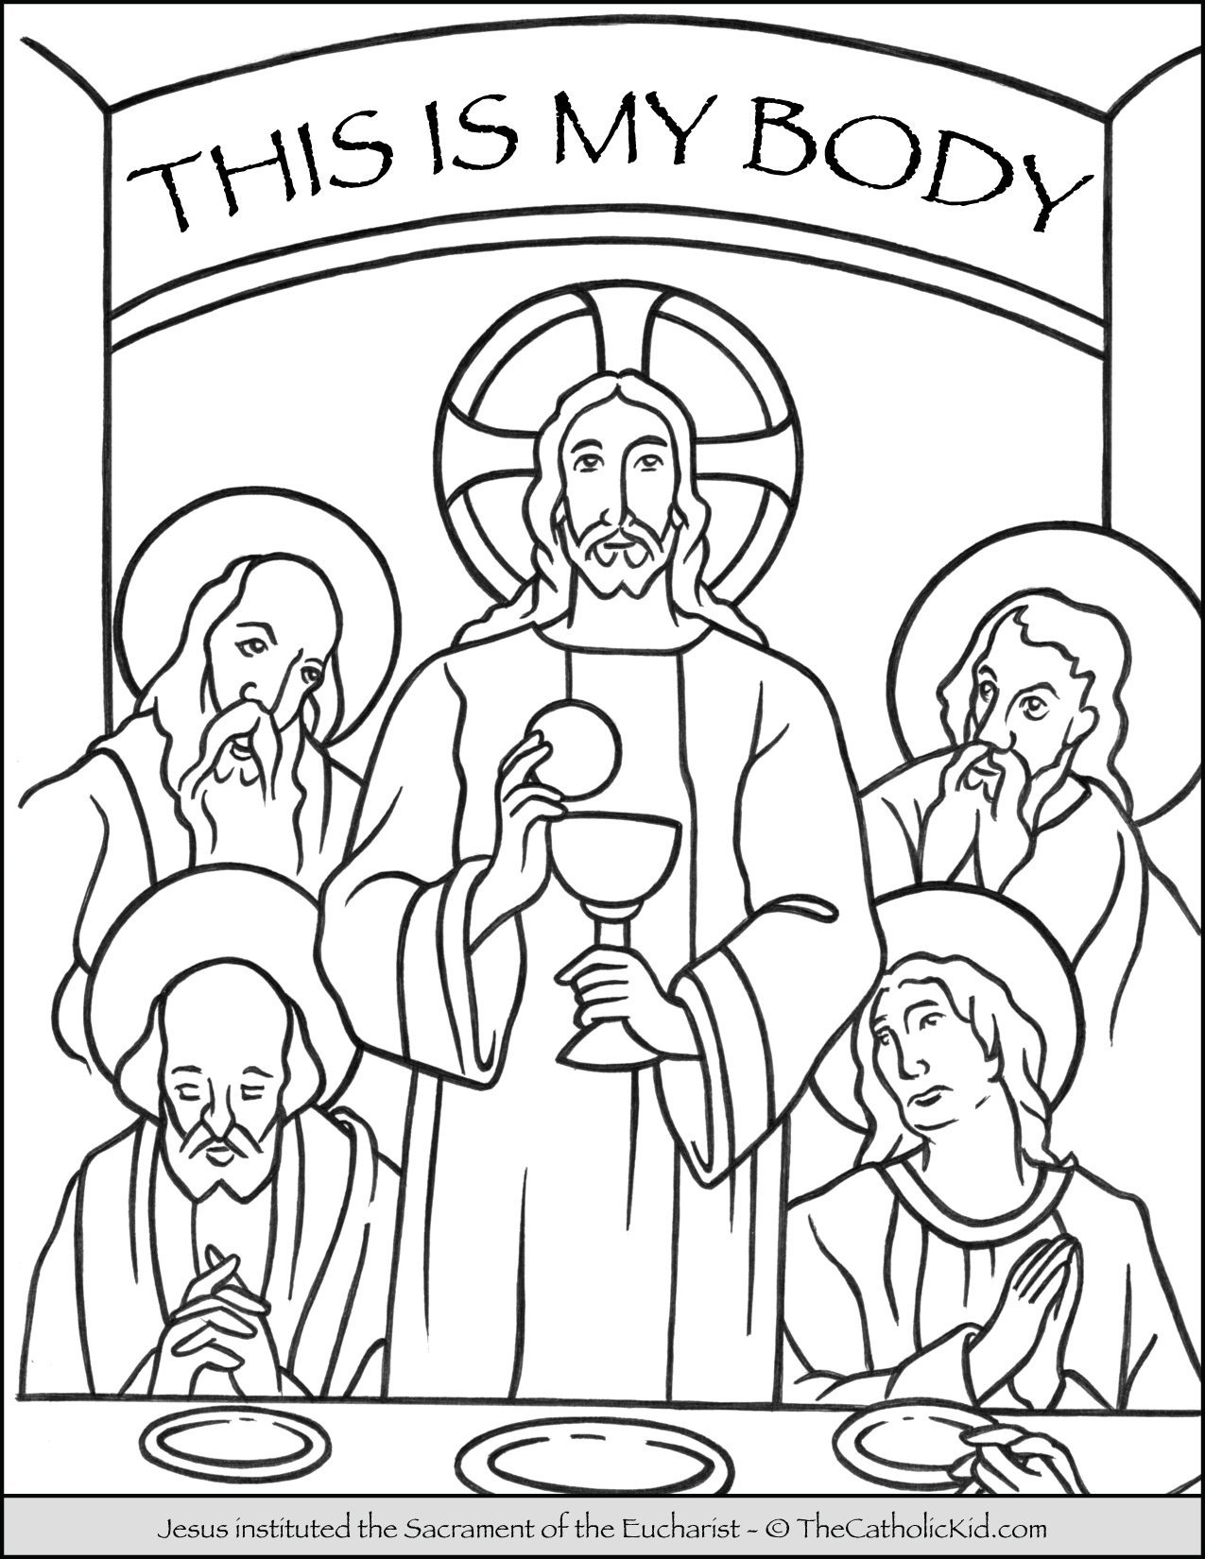

April 2027
We give thanks

Gathering Rite
Reader: Welcome everyone. Today we gather as a community to celebrate Mass, giving thanks to the God for all that he has blessed us with in our lives. We especially thank God for sending us his only son Jesus, who has been our role model, teaching us how to live, how to love. How to give to others and how to receive from others. How to appreciate the many gifts and talents that each one of us has and how they can enrich the lives of many and our communities. Today we welcome especially the children who are preparing for their First Holy Communion and their families. Let us take a moment before we begin today’s celebration of the Eucharist, to reflect on what we are thankful for.

Liturgy of the Word
Readings of Sunday liturgy are proclaimed by Ministers of the Word
Prayers of the Faithful
Priest: Loving God, today we gather to give you praise and thanks for all that you
have blessed us with. Trusting in your unconditional love, mercy and compassion for us, we bring you our prayers.

Reader: We pray for all world leaders, especially Pope Leo and Bishop Ray, that they may lead us with faith, hope and love. Lord, hear us.
Reader: We pray for peace in our homes, families, communities and in the world. We remember all the people affected by war, conflict and oppression. May they feel the Lord’s presence in their lives. Lord, hear us.
Reader: Loving God, we thank you for giving the world your only son Jesus, who has taught us to live and to love. May we continue to be inspired by Jesus in our daily life and follow in his footsteps in all that we do for others. Lord, hear us.
Reader: We pray for the children preparing to receive their First Holy Communion: that each child knows how valued they are in their faith community as they continue to Grow In Love with Jesus. Lord, hear us.
Reader: We pray for the Earth, our common home. That we may continue to love, respect and care for it. Lord, hear us.
Reader: Lord, we think of our loved ones who have died and are now with God in heaven. Lord, hear us.

Priest: Loving God, help us to feel and know your loving, merciful and compassionate presence in our life always. Guide us to live a faith filled and purposeful life, caring for all of God’s people and creation.
Through Christ our Lord, who lives and reigns with you and the Holy Spirit, one God, forever and ever.
All: Amen.

Liturgy of the Eucharist
Communion Reflection
Loving God
alive in the risen Lord,
lift my spirit
to receive the gift of this new day.
Shine in my heart
and on my life with your radiant glory
filling me with joy, renewed hope, and peace.

Draw me into your circle of light
so that I may be wide wake
to all the possibilities
that waits for me in every moment.

Breathe new life
into my thoughts
and into my actions.
Revive my spirit
so that I may shine your light
upon all I meet this day.
In the risen Lord, I pray.


Sr. Antoinette Dilworth
May 2027
We receive the Body of Christ

Post First Holy Communion
Gathering Rite
Reader: Today as we gather to celebrate the sacrament of the Eucharist, we welcome especially the children who have made their First Holy Communion. Congratulations to the children and their families on such a special occasion.

Each one of us is made in the image and likeness of God. Today, we will celebrate with joy the gift of God’s unconditional love for each one of us, in our own uniqueness. One of God’s gifts to us, is his presence to us in the sacrament of Holy Communion.

Liturgy of the Word
Readings of Sunday liturgy are proclaimed by Ministers of the Word

Prayers of the Faithful
Priest: God of love, today we gather in your name to praise you and thank you for all that you have given to us. With gratitude in our hearts for the love and compassion you bless us with in our lives, we know that we can always bring to you our concerns and prayers.

Reader: We pray for our Church leaders, especially Pope Leo and Bishop Ray and all our Church community. Lord, hear us.
Reader: We thank God for giving his only Son Jesus, bringing us closer to God and teaching us how to live a life of love and service to others. Lord, hear us.
Reader: We pray especially today for the children who have received the sacrament of First Holy Communion this year, that they may come to know Jesus as a forever friend and follow in his footsteps. Lord, hear us.
Reader: We pray for peace in our world, our communities, homes and families, that
we may live as Jesus has taught us to, with love, compassion, respect and
forgiveness. Lord, hear us.
Reader: Lord we think of our loved ones who have died and are now with God in heaven. Lord, hear us.
Priest: God of love,
encourage us to see your friendship present in our daily lives,
as we go through the week ahead.
May we share this joy with everyone we meet.
We make this prayer in the name of Jesus, your Son, our Lord.
All: Amen.
Liturgy of the Eucharist
Communion Reflection



Christ has no body now but yours,
No hands, no feet on earth but yours,
Yours are the eyes with which
he looks compassion on this world,
Yours are the feet with which he walks to do good,
Yours are the hands with which he blesses all the world.

Yours are the hands, yours are the feet,
yours are the eyes, you are his body.

Christ has no body now but yours
No hands, no feet, on earth but yours
Yours are the eyes with which
he looks compassion on this world
Christ has no body now on earth, but yours’.

St. Teresa of Ávila

Activity Sheet 7 – We Receive the Body of Christ

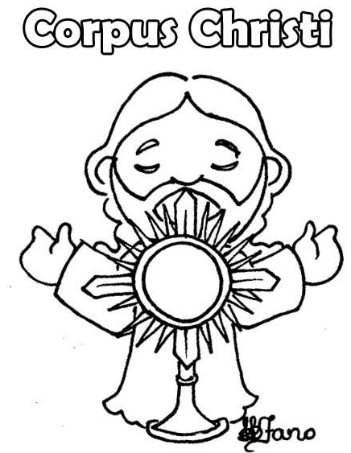

May 30th 2027
Living as Followers of Jesus

Corpus Christi
Gathering Rite
Reader: Today we gather on this the feast of Corpus Christi, to celebrate the most Holy Body and Blood of Jesus Christ. We celebrate the real presence of Christ in the blessed Eucharist.

Today, we welcome especially the children who have received their First Holy Communion in our Parish. We remember and give thanks to all of those who have nurtured our faith - our family, friends, teachers and our parish community.

Each one of us is a child of God. Though we are all unique, though we are many, we are united through our faith in Jesus. Together we are the one body of Christ, and we are all connected to each other to make up this body. On this feast of Corpus Christi, let the strength of Christ renew us to become God’s compassion in our parish and in our world.
Liturgy of the Word
Readings of Sunday liturgy are proclaimed by Ministers of the Word
Prayers of the Faithful
Priest: As God’s family and as the body of Christ, we bring our prayers to our loving Creator.
Reader: We pray for our Church and faith leaders, especially Pope Leo and Bishop Ray and all of the clergy in their ministry and care of all people. Lord, hear us.
Reader: We pray for Christians all around the world, that all may go and tell the good news of our Lord Jesus Christ. Lord, hear us.
Reader: We pray for the children in our parish who have received the sacraments of Baptism, Communion and Confirmation. May their faith continue to be nourished at home, school and in their parish community. Lord, hear us.
Reader: We pray especially for all those who are preparing for exams, that they may know and trust the guidance of the Holy Spirit in their lives.
Lord, hear us.
Reader: Lord we think of our loved ones who have died and are now with God in heaven. Lord, hear us.
Priest: God of love and care, hear the prayers we make today in the name of your Son, Jesus, our Lord.
All: Amen.
Liturgy of the Eucharist
Communion Reflection


Blessing for the Journey

When you come to an end
Is to make a beginning …

as you continue your journey
down the road of life,
may it be a pathway strewn with blessings.

May you have enough joy to give you hope,
enough pain to make you wise,
enough love to keep you strong.

May no hill be ever too hard to climb.
No problem too difficult to share.

May you experience each new day as a precious gift.
May you always feel what you have is enough,
filling you hearts with gratitude.

May God’s gaze of love always rest upon you.
May your inner light continue to illuminate you,
surrounding you to sustain you today and always.

Sr. Antoinette Dilworth
Appendix Liturgical Calendar
Date |  | Sunday | Gospel | Theme
October | Let’s Begin
4 | Respecting Life | Ordinary 27th | Matthew 21:33-43 | Fairness of Judgement
11 | Prisoner’s Sunday | Ordinary 28th | Matthew 22:1-14 | The Kingdom of God is open to everyone - Universalism
18 | Mission Sunday | Ordinary 29th | Matthew 22:15-21 | Our Christian responsibilities to God and others
25 | Bible Sunday | Ordinary 30th | Matthew 22:34-40 | The Commandment of Love
November | In November, We Remember
1 | All Saints Day  National Vocation Awareness Week | Ordinary 31st | Matthew 5:1-12 | Your reward will be great in heaven
8 |  | Ordinary 32nd | Matthew 25:1-13 | Prepare for you know neither the day nor the hour
15 | World Day of the Poor | Ordinary 33rd | Matthew 25:14-30 | Trust God’s wisdom and give thanks
22 | Our Lord Jesus Christ, King of the Universe | Christ the King- Solemnity | Matthew 25:31-46 | Serve those in need without judgement
29 | First Sunday of Advent | Advent 1 | Mark 13:33-37 | Stay awake
December | Advent
6 | Second Sunday of Advent | Advent 2 | Mark 1:1-8 | John the Baptist
13 | Gaudete Sunday | Advent 3 | John 1:6-8, 19-28 | Being a witness to Jesus
20 | Fourth Sunday of Advent | Advent 4 | Luke 1:26-38 | Mary accepting God’s plan for her
27 | The Holy Family Of Jesus, Mary and Joseph |  | Luke 2:22-40 | Mary and Joseph as parents to Jesus
January | We Listen to God’s Word
3 | Second Sunday of Christmas  (Epiphany of the Lord Solemnity) |  | Matt 2:1-12 | Jesus is the light of the world
10 | Baptism of Jesus | Ordinary 1 | Mark 1:7-11 | Baptism of Jesus
17 | Week of Christian Unity | Ordinary 2 | John 1:35-42 | Called to be followers of Jesus
24 |  | Ordinary 3 | Mark 1:14-20 | The call of the disciples
31 |  | Ordinary 4 | Mark 1:21-28 | The authority of Jesus
February | I’m Sorry
7 | Ash Wednesday | Ordinary 5 | Mark 1:29-39 | Jesus heals and casts out devils
14 | First Sunday of Lent | Lent 1 | Mark 1:12-15 | Jesus tempted by Satan
21 | Second Sunday of Lent | Lent 2 | Mark 9:2-10 | The transfiguration of Jesus
28 | Third Sunday of Lent | Lent 3 | John 2:13-25 | Jesus destroys the temple
March | Lent
7 | Fourth Sunday of Lent (Laetare)  (Mother’s Day) | Lent 4 | John 3:14-21 | God loved the world
14 | Fifth Sunday of Lent | Lent 5 | John 12:20-33 | Law of God written in our hearts
21 | Palm Sunday | Palm Sunday | Mark 14:1-15:47 | Passion of Jesus
28 | Easter Sunday | Resurrection | John 20:1-9 | Jesus rises from the dead
Date |  | Sunday | Gospel | Theme
April | We Give Thanks
4 | Divine Mercy Sunday | Easter 2 | John 20:19-31 | Happy those who believe but have not seen
11 |  | Easter 3 | Luke 24:35-48 | Jesus has risen
18 |  | Easter 4 | John 10:11-18 | The Good Shepherd
25 |  | Easter 5 | John 15:1-8 | I am the vine, and you are the branches
May | We Receive the Body of Christ
2 |  | Easter 6 | John 15:9-17 | Called to friendship with Jesus
9 | The Ascension of the Lord | Easter 7 | Mark 16:15-20 | Proclaim the good news
16 | Pentecost |  | John 20:19-23 | Peace be with you
23 | The Most Holy Trinity |  | Matt 28:16-20 | Make disciples of all the nations
30 | Corpus Christi |  | Mark 14:12-16, 22-26 | This is my Body, This is my Blood

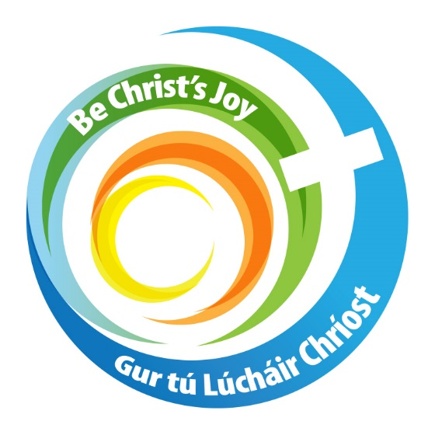

www.dioceseofkerry.ie

