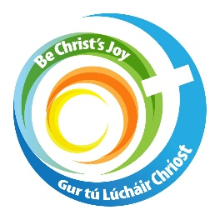
Confirmation
Parish Preparation Programme
Diocese of Kerry

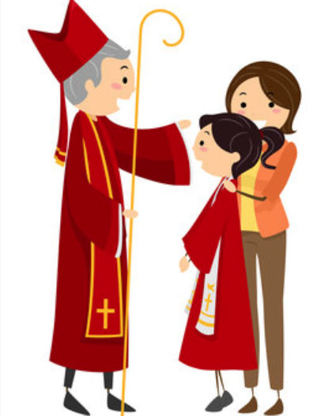

September 2026 – June 2027

CALLED & SENT

An eight month parish based preparation programme for Confirmation.

“You will receive the power when the Holy Spirit comes upon you; and you will be my witnesses.” Acts 1:8



Contents

Introduction 3
Parent’s/Guardian’s Welcome Letter 4
Gifts of the Holy Spirit Poster 5
Fruits of the Holy Spirit Poster 6
Enrolment Certificate 7
October 2026 I Belong – Enrolment Ceremony 8
November 2026 I am God’s Work of Art 11
December 2026 Jesus Walks With Me 13
January 2027 The Spirit Gives Me Courage 15
February 2027 I Have Gifts To Share 17
March 2027 I Can Pray And Listen 19
April 2027 Let The Fruits Grow 21
May 2027 I Am Called And Sent 25
Appendix: Dates and Gospel readings 29

Introduction
Confirmation is an invitation to grow in faith, to recognise the presence of the Holy Spirit and to discover that each young person has a unique place and purpose within the Church and the world.
Called & Sent is an eight month parish journey for children preparing for Confirmation.
Each monthly gathering centers around a weekly Mass. The children are encouraged to participate actively in the Mass through welcoming, Scripture, music, symbols, the Prayers of the Faithful and a short reflection.
The emphasis is not simply on learning about Confirmation, but on helping young people discover who they are, who God is, how the Holy Spirit works in their lives, and how they are called to live as disciples.
The seven Gifts and nine Fruits of the Holy Spirit are woven through the programme. Each month has a corresponding worksheet. The children can be asked to complete these at home, as a reflective exercise after each mass, or indeed prior to each mass. Whichever you prefer.
I have given a key message to accompany each mass. You may wish to use these words in your homily. Please feel free to rewrite them and make them your own.
The symbols and worksheets are optional. Please feel free to adopt, amend or indeed say no to any of the suggestions. They are just that – suggestions! As too are the suggested scripture readings, though they do match in lovely with each monthly theme!

The programme follows a simple journey:
- I BELONG - I am part of God's family.
- I AM GOD'S WORK OF ART - God knows and loves me.
- JESUS WALKS WITH ME - I am never alone.
- THE SPIRIT GIVES ME COURAGE - I can make good choices.
- I HAVE GIFTS TO SHARE - God has given me gifts.
- I CAN PRAY AND LISTEN - The Holy Spirit speaks to my heart.
- I CAN LIVE THE FRUITS OF THE SPIRIT - My faith is seen in how I live.
- I AM CALLED AND SENT - I am ready to live as a witness.
Letter to Parents & Guardians

Dear Parents and Guardians,
A very warm welcome to you and your child as you enrol in our parish preparation programme for the Sacrament of Confirmation. We are delighted to share this special journey with your family. Your child is a valued member of our parish community, and we look forward to helping them grow in faith, friendship and confidence over the months ahead.
Confirmation is an important step in your child’s Christian life. It deepens the grace received at Baptism and strengthens them through the gift of the Holy Spirit. It draws them more closely into the life of the Church and helps them to live as followers of Jesus—sharing God’s love through their choices, relationships and care for others.
Our parish programme will offer opportunities for prayer, reflection and participation in Mass. We hope it will be an encouraging and joyful time, giving each child space to ask questions, recognise their gifts and discover how they can make a difference.
As parents and guardians, you have a special place in this journey. Your encouragement, example and presence mean a great deal. Small moments—sharing a prayer, talking about an act of kindness, attending Mass together or listening to your child’s questions—can help faith take root at home.
We know that family life is busy and that every family’s circumstances are different. Please be reassured that you do not need to have all the answers. Whether faith is already part of your daily life or you are reconnecting with the parish, you are warmly welcome. Our parish team is here to accompany and support you. Please let us know about any additional needs or circumstances that would help us make the programme welcoming and accessible for your child.
Our Enrolment Mass will take place on [date] at [time] in [church name]. During this celebration, we will welcome the children and their families, pray together and mark the beginning of their preparation.
Thank you for entrusting us with a part in your child’s preparation. Together, as families and parish, we will help the children recognise that they are loved by God, belong in the Church and have gifts to share with the world.
May the Holy Spirit bless your family and guide us all as we begin this journey together.

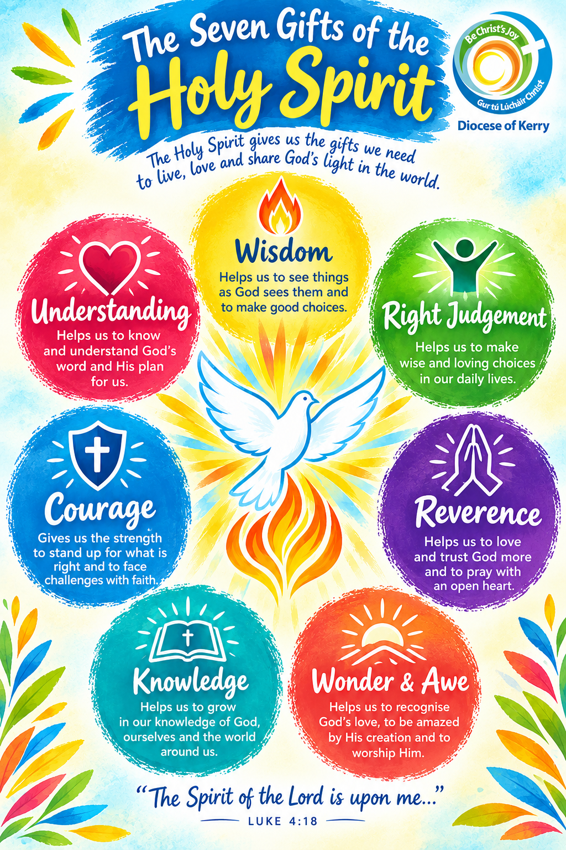
With warm wishes and every blessing
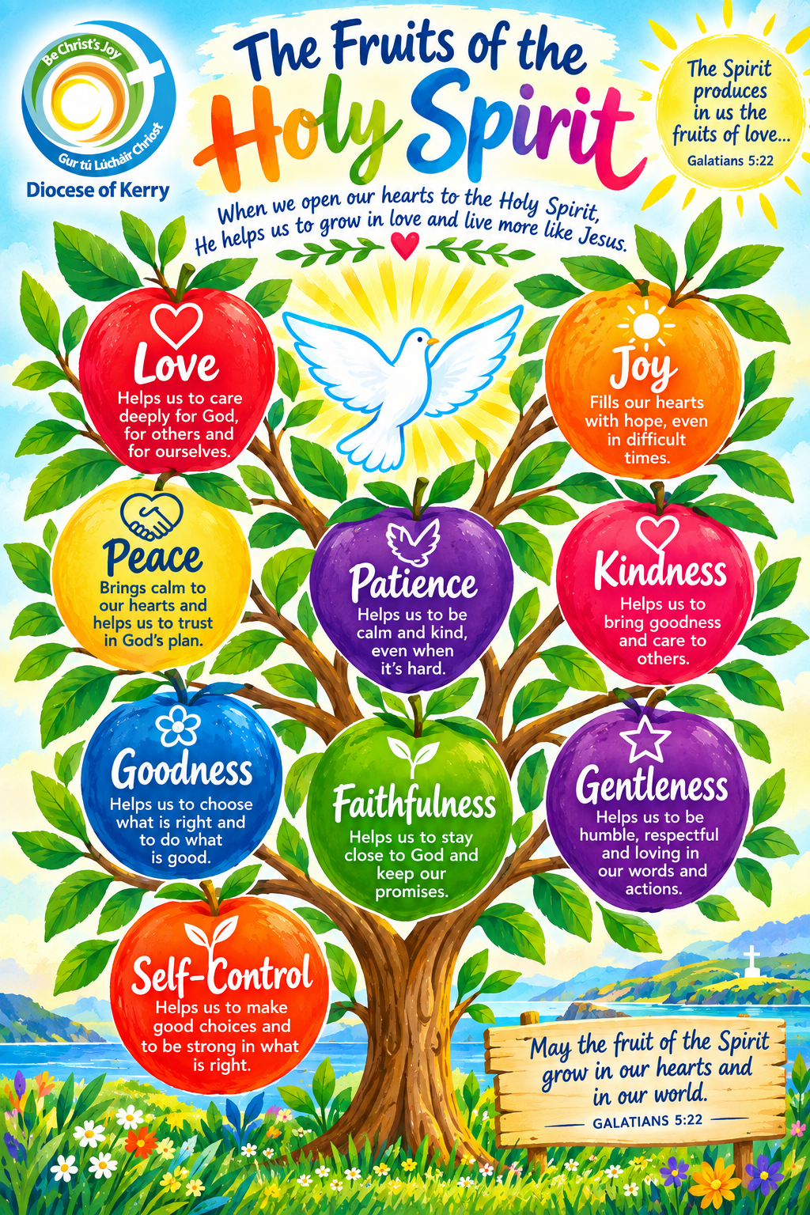
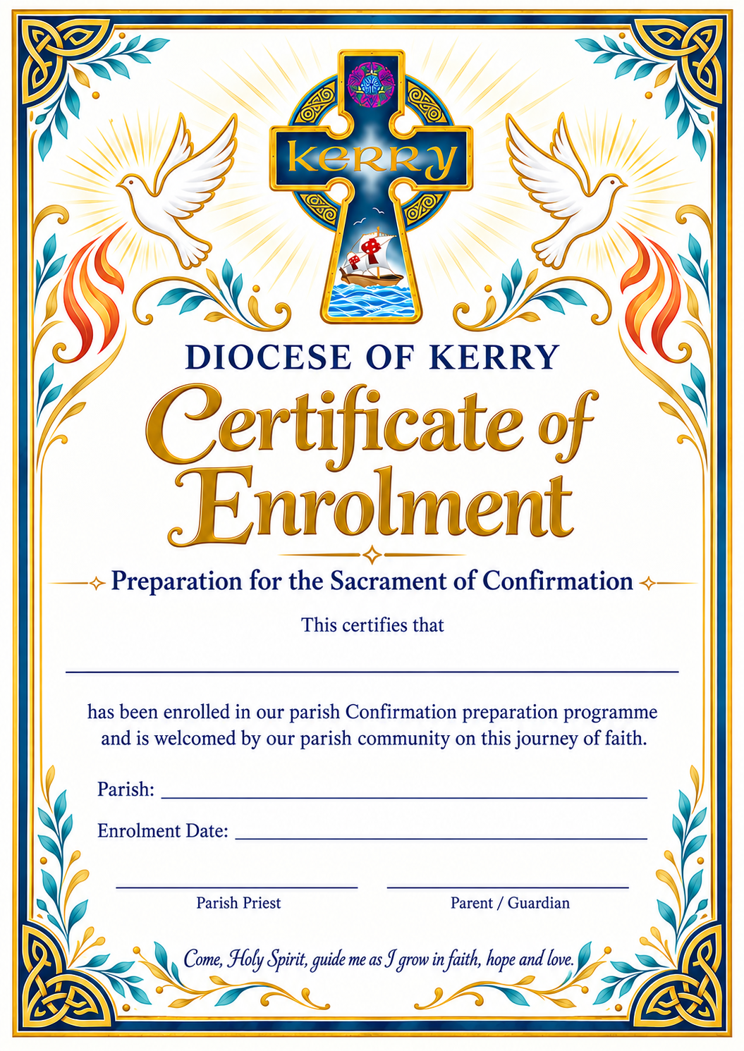
October 2026
I Belong

Enrolment Ceremony

“Beginning Our Journey”

Key Message: I am welcomed. I belong to God's family. I am beginning a journey with my parish community. You don't have to be perfect to belong to God's family. You simply have to come as you are.

Gift: Wisdom

Fruit: Love

Scripture: John 15:9
“As the Father has loved me, so I have loved you.”

Symbol: A candle or light for each child.

Priest: Today we welcome these young people who are beginning their journey towards Confirmation. During the coming months they will discover more about Jesus, the Holy Spirit, their faith and the gifts God has placed within them.”

Children:

I am ready to begin this journey. I want to learn more about Jesus. I want to listen to the Holy Spirit. I want to grow in faith. I want to become the person God created me to be.

Parents/Guardians: We promise to encourage, support and pray for our children as they prepare for Confirmation.

Parish Community: We welcome you. We will pray for you, encourage you and walk this journey with you.

Prayers of the Faithful

For our Confirmation candidates, that they may know that they are loved by God and welcomed by our parish community.

Lord, hear us.

For their parents, families and friends, that they may encourage and support our young people throughout this journey.

Lord, hear us.

For our parish, that we may always be a welcoming community where every young person knows that they belong.

Lord, hear us.

For all young people, that they may discover the gifts God has given them and have the wisdom to use them well.

Lord, hear us.

For our own needs, for the people and situations we carry in our hearts today.

Lord, hear us.

WORKSHEET 1 – MY JOURNEY

I AM BEGINNING A JOURNEY

My name: ___________________________

1. Three things I hope to discover during Confirmation preparation:

2. I feel that I belong when...

3. People who support me are:

4. One thing I would like to pray about during this journey:

November 2026
I am God’s Work of Art

“Created, Known and Loved”

Key Message: God has created every one of us uniquely and wonderfully. Imagine that God is an artist. God doesn't make copies. Every person is unique. You have a unique personality, voice, imagination, sense of humour, talents, hopes and dreams. Sometimes we compare ourselves with other people and decide that we are not good enough. But God doesn't compare us. God looks at each of us with love.

Gift: Understanding

Fruit: Joy & Peace

Scripture: Psalm 139:14
“I thank you because I am wonderfully made.”

Symbol: A piece of artwork.

Prayers of the Faithful

For every young person, that they may recognise their own dignity and worth.

Lord, hear us.

For those who struggle with confidence or feel that they are not good enough, that they may discover the joy of knowing they are loved.

Lord, hear us.

For our families and schools, that they may be places where every child is valued and respected.

Lord, hear us.

For ourselves, that we may use our gifts to bring peace and joy to others.

Lord, hear us.

WORKSHEET 2 - GOD'S WORK OF ART

“I AM WONDERFULLY MADE”

Three things I like about myself:

A gift or talent I have is:

Someone who has helped me recognise my gifts is:

One thing I sometimes find difficult about myself is:

I can ask God to help me with this by:

My prayer

God, thank you for making me __________________.

Help me to remember that I am loved.

Help me to see the goodness in myself and in others.

Amen.

December 2026
Jesus Walks With Me

“Never Alone”

Key Message: Jesus is with me in good times and difficult times. Sometimes life is easy. Sometimes life is difficult. We can experience friendship problems, worries about school, arguments at home, pressure from others or moments when we feel alone. The disciples on the road to Emmaus did not realise that Jesus was walking beside them. Sometimes we don't recognise God either. But God is there.

Gift: Right Judgement

Fruit: Patience & Kindness

Scripture: Luke 24:13-35

The Road to Emmaus - Jesus walks alongside two disciples who are struggling.

Symbol: A stone representing their worries/struggles.

Prayers of the Faithful

For young people facing difficult decisions, that the Holy Spirit may guide them with wisdom and counsel.

Lord, hear us.

For anyone who feels lonely, that they may find friendship and support.

Lord, hear us.

For people who are struggling with worry or sadness, that they may experience God's peace.

Lord, hear us.

For each of us, that we may be patient and kind towards those around us.

Lord, hear us.

WORKSHEET 3 - WALKING WITH JESUS

WHEN I NEED HELP...

Someone I can talk to is:

A difficult decision I sometimes have to make is:

Before making a decision I could:

☐ Stop and think
☐ Pray
☐ Ask someone I trust
☐ Think about how my choice affects others
☐ Ask the Holy Spirit for guidance

This week I will show kindness by:

Prayer

Come, Holy Spirit,
help me to make good choices
and to walk with Jesus every day.

January 2027
The Spirit Gives Me Courage

“Choosing What is Right”

Key Message: Being a Christian sometimes takes courage. Courage does not mean never being afraid. Courage means doing the right thing even when we are afraid. The Holy Spirit does not promise that we will never be afraid. The Holy Spirit gives us courage to do what is right.

Sometimes courage means saying no to something we know is wrong; standing up for someone who is being treated badly; refusing to join in when others are unkind; admitting that we made a mistake; apologising; asking for help; being faithful to our beliefs.

Gift: Courage

Fruit: Faithfulness & Self Control

Scripture: Joshua 1:9
“Be strong and courageous … for the Lord your God is with you.”

Symbol: A shield or strong tree.

Prayers of the Faithful

For young people who need courage to stand up for what is right, that the Holy Spirit may strengthen them.

Lord, hear us.

For anyone who is bullied, excluded or treated unfairly, that they may find support and friendship.

Lord, hear us.

For people who are afraid to speak up, that they may find courage.

Lord, hear us.

For ourselves, that we may be faithful to our values even when it is difficult.

Lord, hear us.

WORKSHEET 4 - MY COURAGE CARD

I SHOW COURAGE WHEN...

One situation where I might need courage is:

The right thing to do would be:

Someone who could support me is:

Complete:

Courage is not about ____________________.

Courage is about _________________________.

My courage challenge this month:

I will stand up for _______________________

by ______________________________________.

February 2027
I Have Gifts To Share

“Discovering My Gifts”

Key Message: God has given each person gifts. Our gifts are meant to be shared. Imagine that every person in the parish receives a different gift. One person can sing. Another can listen. Someone else can organise. Another can make people laugh. Someone can encourage others. Someone notices when another person is lonely. Someone is good at fixing things. Someone is creative. Someone is brave. Someone is caring. All these gifts matter.

Gift: Knowledge

Fruit: Kindness & Goodness

Scripture: 1 Corinthians 12: 4-7
“There are different kinds of gifts, but the same Spirit.”

Symbol: A gift box.

Prayers of the Faithful
For our young people, that they may recognise and appreciate the gifts God has given them.
Lord, hear us.
For those who use their gifts to serve others in our parish and community.
Lord, hear us.
For people who feel that they have nothing to offer, that they may recognise their own goodness and worth.
Lord, hear us.
For us all, that we may use our gifts generously and for the good of others.
Lord, hear us.

WORKSHEET 5 - MY GIFT BOX

Draw a gift box. Inside it write or draw:

A gift I have:

A gift I would like to develop:

A gift I see in a friend:

A gift someone in my family has:

My gift can make a difference when I...

This month I will use my gift to help:

March 2027
I Can Pray and Listen

“Making Space for the Holy Spirit”

Key Message: Prayer is not only talking to God. Prayer is also making space to listen. Our lives can be noisy: Phones, Messages, Music, Television, School, Sport, Homework, Friends. Sometimes our minds are noisy too. Prayer gives us space to be still. We can tell God what is happening in our lives. We can thank God. We can ask for help. We can say sorry. And we can simply be quiet and remember: God is here.

Gift: Reverence

Fruit: Love & gentleness

Scripture: 1 Kings 9: 11-12
Elijah discovers God not in the powerful wind or earthquake, but in the “sound of a gentle breeze.”

Symbol: A flame or open hands.

Prayers of the Faithful
For our young people, that they may discover the peace that comes from prayer.
Lord, hear us.
For those who find it difficult to pray, that they may discover that God is always ready to listen.
Lord, hear us.
For our families, that our homes may have moments of peace and prayer.
Lord, hear us.
For our parish, that we may become a community that listens to the Holy Spirit.
Lord, hear us.

WORKSHEET 6 - MY PRAYER SPACE

My favourite place to be quiet is:

When I pray I can:
☐ Talk to God
☐ Say thank you
☐ Ask for help
☐ Say sorry
☐ Listen
☐ Be quiet
☐ Pray for someone else

My own prayer
Dear God,
Today I want to thank you for:

Please help:

Please help me to:

Amen.

April 2027
Let The Fruits Grow

“Faith That Can Be Seen”

Key Message: The Holy Spirit changes the way we live and the way we treat others.

A tree doesn't produce fruit by trying to look like a fruit tree. It grows. It receives light. It receives water. Its roots become stronger. And eventually fruit appears. Our faith is similar. When we pray, listen to God, receive the sacraments, learn about our faith and try to love others, the Holy Spirit helps good things grow in us.

Gift: Wonder & Awe

Fruit: All Nine Fruits

Scripture: Galatians 5: 22-23
“The fruit of the Spirit is love, joy, peace, patience, kindness, goodness, faithfulness, gentleness and self-control.”

Symbol: Fruit display or a tree covered in fruit.

Prayers of the Faithful
For our Confirmation candidates, that the Holy Spirit may help the fruits of love, joy and peace grow in their lives.
Lord, hear us.
For families and friendships, that patience, kindness and gentleness may grow among us.
Lord, hear us.
For our parish community, that kindness, goodness and faithfulness may be seen in everything we do.
Lord, hear us.
For our young people, that they may have the self-control and courage to make good choices.
Lord, hear us.
For the whole world, that God's people may be instruments of peace and love.
Lord, hear us.

WORKSHEET 7 - MY FRUIT TREE
Draw a tree with nine pieces of fruit.
Write one Fruit of the Holy Spirit on each piece.
Then Colour …
- GREEN: A fruit I already see growing in me.
- YELLOW: A fruit I am working on.
- RED: A fruit I find difficult.

My “fruit of the month”
I would like to grow:

I can practise it by:

Someone who could help me is:

My prayer
Come, Holy Spirit.
Help your fruits grow in me.
Help me to become more loving,
more peaceful,
more patient,
more kind,
and more like Jesus.
Amen.
May 2027
I Am Called And Sent

“Receiving The Holy Spirit”

Key Message: Confirmation is not the end of the journey. It is a new beginning. Over the past eight months we have discovered:

I BELONG - I am part of God's family.

I AM GOD'S WORK OF ART - I am created, known and loved.

JESUS WALKS WITH ME - I am never alone.

THE SPIRIT GIVES ME COURAGE - I can choose what is right.

I HAVE GIFTS TO SHARE - I have something important to offer.

I CAN PRAY AND LISTEN - I can make space for God.

LET THE FRUITS GROW - The Holy Spirit can change how I live.

And now I AM CALLED AND SENT.

Confirmation is not simply something that happens to me. It is an invitation. An invitation to receive the Holy Spirit. An invitation to grow. An invitation to live my faith. An invitation to use my gifts. An invitation to become a witness to Jesus.

Gift: All Seven Gifts

Fruit: All Nine Fruits

Scripture: Acts 1:8
“You will receive power when the Holy Spirit comes upon you; and you will be my witnesses.”

Symbol: A Flame.

Prayers of the Faithful
For our Confirmation candidates, that they may open their hearts to the Holy Spirit and allow God's gifts to grow within them.
Lord, hear us.
For their families, that they may continue to encourage them in faith and prayer.
Lord, hear us.
For our parish community, that we may be a place where young people feel welcomed, valued and encouraged to use their gifts.
Lord, hear us.
For all those who will receive the Sacrament of Confirmation, that they may have courage to live as followers of Jesus.
Lord, hear us.
For those who have helped us on our journey of faith, that God may bless them for their kindness and encouragement.
Lord, hear us.
For ourselves, that we may always remember that the Holy Spirit is with us and that we are called to share God's love.
Lord, hear us.

FINAL WORKSHEET
“MY CONFIRMATION PROMISE”
I have discovered...
Something I learned about God:

Something I learned about myself:

Something I learned about the Holy Spirit:

My Gift
The gift of the Holy Spirit I most want to grow in is and why …

My Fruit
The Fruit of the Holy Spirit I most want to grow is …

I will practise it by …

My Mission
I can make a difference in my:
☐ Family
☐ School
☐ Parish
☐ Community
☐ Friendship group
☐ Online world
☐ Wider world

I can make a difference by:

A FINAL MESSAGE FOR THE CHILDREN
You are not preparing for Confirmation because you are expected to have everything figured out.
You are preparing because God is calling you to grow.
You are God's work of art. You have gifts. You have a voice. You have a place in the Church. You have something to offer the world. And you do not make this journey alone.
The Holy Spirit is with you.
You are called.
You are loved.
You are gifted.
You are sent.
Appendix Liturgical Calendar
Date |  | Sunday | Gospel | Theme
October | Let’s Begin
4 | Respecting Life | Ordinary 27th | Matthew 21:33-43 | Fairness of Judgement
11 | Prisoner’s Sunday | Ordinary 28th | Matthew 22:1-14 | The Kingdom of God is open to everyone - Universalism
18 | Mission Sunday | Ordinary 29th | Matthew 22:15-21 | Our Christian responsibilities to God and others
25 | Bible Sunday | Ordinary 30th | Matthew 22:34-40 | The Commandment of Love
November | In November, We Remember
1 | All Saints Day  National Vocation Awareness Week | Ordinary 31st | Matthew 5:1-12 | Your reward will be great in heaven
8 |  | Ordinary 32nd | Matthew 25:1-13 | Prepare for you know neither the day nor the hour
15 | World Day of the Poor | Ordinary 33rd | Matthew 25:14-30 | Trust God’s wisdom and give thanks
22 | Our Lord Jesus Christ, King of the Universe | Christ the King- Solemnity | Matthew 25:31-46 | Serve those in need without judgement
29 | First Sunday of Advent | Advent 1 | Mark 13:33-37 | Stay awake
December | Advent
6 | Second Sunday of Advent | Advent 2 | Mark 1:1-8 | John the Baptist
13 | Gaudete Sunday | Advent 3 | John 1:6-8, 19-28 | Being a witness to Jesus
20 | Fourth Sunday of Advent | Advent 4 | Luke 1:26-38 | Mary accepting God’s plan for her
27 | The Holy Family Of Jesus, Mary and Joseph |  | Luke 2:22-40 | Mary and Joseph as parents to Jesus
January | We Listen to God’s Word
3 | Second Sunday of Christmas  (Epiphany of the Lord Solemnity) |  | Matt 2:1-12 | Jesus is the light of the world
10 | Baptism of Jesus | Ordinary 1 | Mark 1:7-11 | Baptism of Jesus
17 | Week of Christian Unity | Ordinary 2 | John 1:35-42 | Called to be followers of Jesus
24 |  | Ordinary 3 | Mark 1:14-20 | The call of the disciples
31 |  | Ordinary 4 | Mark 1:21-28 | The authority of Jesus
February | I’m Sorry
7 | Ash Wednesday | Ordinary 5 | Mark 1:29-39 | Jesus heals and casts out devils
14 | First Sunday of Lent | Lent 1 | Mark 1:12-15 | Jesus tempted by Satan
21 | Second Sunday of Lent | Lent 2 | Mark 9:2-10 | The transfiguration of Jesus
28 | Third Sunday of Lent | Lent 3 | John 2:13-25 | Jesus destroys the temple
March | Lent
7 | Fourth Sunday of Lent (Laetare)  (Mother’s Day) | Lent 4 | John 3:14-21 | God loved the world
14 | Fifth Sunday of Lent | Lent 5 | John 12:20-33 | Law of God written in our hearts
21 | Palm Sunday | Palm Sunday | Mark 14:1-15:47 | Passion of Jesus
28 | Easter Sunday | Resurrection | John 20:1-9 | Jesus rises from the dead
Date |  | Sunday | Gospel | Theme
April | We Give Thanks
4 | Divine Mercy Sunday | Easter 2 | John 20:19-31 | Happy those who believe but have not seen
11 |  | Easter 3 | Luke 24:35-48 | Jesus has risen
18 |  | Easter 4 | John 10:11-18 | The Good Shepherd
25 |  | Easter 5 | John 15:1-8 | I am the vine, and you are the branches
May | We Receive the Body of Christ
2 |  | Easter 6 | John 15:9-17 | Called to friendship with Jesus
9 | The Ascension of the Lord | Easter 7 | Mark 16:15-20 | Proclaim the good news
16 | Pentecost |  | John 20:19-23 | Peace be with you
23 | The Most Holy Trinity |  | Matt 28:16-20 | Make disciples of all the nations
30 | Corpus Christi |  | Mark 14:12-16, 22-26 | This is my Body, This is my Blood

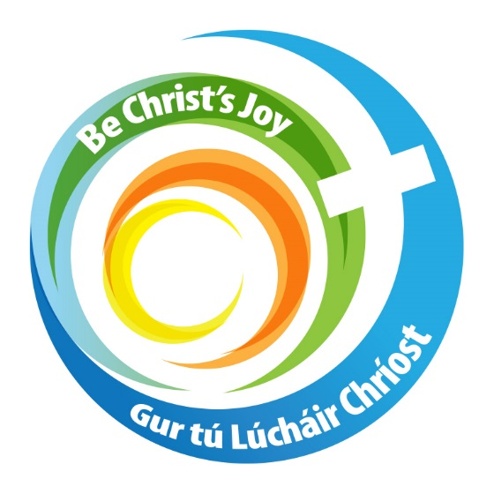

www.dioceseofkerry.ie

