Season of Creation – Living Water
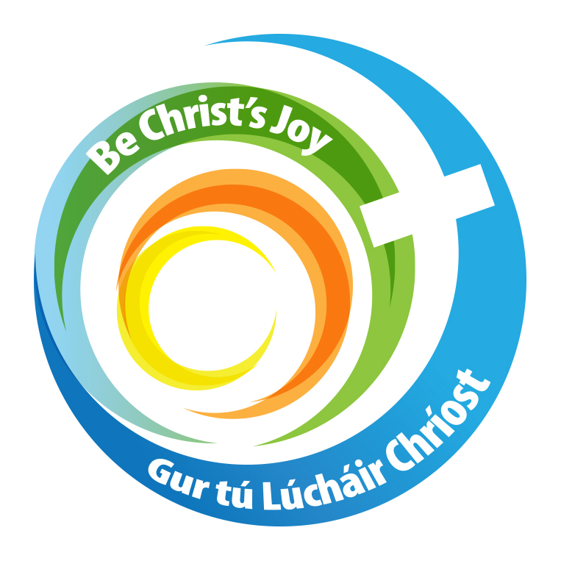
Parish Liturgy Resource 2026
Background
The Season of Creation is celebrated each year from 1 September to 4 October, bringing Christians throughout the world together in prayer, reflection and action for the care of our common home. The theme for Season of Creation 2026 is “Living Water”, inspired by the prophet Ezekiel's vision of a life-giving river flowing from the Temple:
“Wherever the river flows, every living creature shall live.” Ezekiel 47:9
In Ezekiel's vision, the river begins as a small stream but grows deeper as it flows. It brings life to barren places, heals damaged waters and allows trees and plants to flourish. It is a powerful vision of hope, healing and renewal.
Preparing a Focal Space for the Season of Creation
A simple visual focus can be created in the church for the duration of the Season. The display can develop throughout the Season.
Place near the sanctuary or entrance to your church:
- a large bowl or glass vessel containing water;
- a Bible opened at Ezekiel 47:1–12; or a sign with the scripture verse written on it.
- stones or pebbles;
- shells;
- a branch or small plant;
- photographs of a local river, lake, stream or coastline;
- a blue cloth representing the river of living water.
Parishes are encouraged to use local water imagery wherever possible. A photograph of a nearby river, lake, well, stream or coastline can help people recognise that the biblical message is connected to the place where they live.
Hymn Suggestions
Morning Has Broken  How Great Thou Art  Christ Be Our Light  Be Not Afraid  Make Me A Channel of Your Peace  The Servant Song  Here I Am Lord  Ag Críost An Síol | In You Creation Finds Its Joy – R. McDonagh  If You Find Me Psalm 38 – Warner  I Will Be the Vine – L. Lawton  The Deer’s Cry – S. Davey  The Cloud’s Veil – L. Lawton  Críost Liom – S. O’Riada  Spirit of the Living God  How Great Thou Art

Season of Creation – Sunday Mass
The following could be read after the opening prayers to introduce the symbols in the pre-prepared focal space or placed before the altar:
Reader: As we begin our celebration today, we are invited to reflect on the gift of creation through the symbols placed in our focal space or before the altar.
Water represents God’s precious gift, upon which all life depends.
A stone represents the earth and the places through which God’s living water flows.
A branch or small plant reminds us that all living things need water to grow and survive.
A shell represents the oceans and all the creatures who live within them.
An image of our local river reminds us that our care for creation begins here, in the place where God has planted us.
As we look upon these symbols, may they remind us of our shared responsibility to protect God’s creation and to cherish the gifts that sustain all life.

Homily Notes
The vision of Ezekiel’s life-giving river invites us to see water as a precious gift from God, sustaining, renewing and bringing life to all creation. Water is not simply a resource to be used; it is essential to life and a gift for which we are called to be grateful. During this Season of Creation, we are invited to pray, reflect and act for the protection of water and the whole of creation. Our care for creation is a shared responsibility. What we do today can help ensure that God’s gifts continue to bring life and healing to generations yet to come.
How do we use water?
We use water every day for drinking, cooking, washing, cleaning, growing food and caring for animals and plants. Because it is so readily available to us, we can sometimes forget how precious it is. While we often have wet winters, this year we experienced water shortages during the month of July.
How can we reduce our use of water?
- Turn off the tap while brushing our teeth.
- Take shorter showers rather than long ones.
- Only run the washing machine or dishwasher when it is full.
- Collect rainwater for watering plants using water butts.
- Repair leaking taps and toilets.
- Avoid wasting water when washing cars or outdoor areas.

As we give thanks for the gift of water, may we ask ourselves:
What small change can I make today to protect this precious gift from God?

Prayer of the Faithful
Priest: With gratitude for the gift of water and all creation, let us bring our prayers before God. May our prayers renew our commitment to care for our common home and for all who depend upon its precious gifts.
- For Pope Leo, our bishops, priests, deacons and all God's people, that the Church may lead by example in caring for creation and protecting the gifts that God has entrusted to us. Lord hear us.

- For the earth, its rivers, lakes, seas and oceans; for every creature that depends upon water; and for all the ecosystems that sustain life. Lord hear us.

- For communities throughout the world who do not have reliable access to clean and safe water, that they may receive the resources and support they need to live with dignity. Lord hear us.

- For people experiencing drought, flooding, rising sea levels and the loss of homes and livelihoods, that they may receive practical support and that the international community may respond with courage and justice. Lord hear us.

- For farmers, fishers, scientists, environmental workers and all who care for rivers, seas and the land, that their work may be valued and supported. Lord hear us.

- For ourselves, that this Season of Creation may move us from awareness to action and inspire us to make choices that protect our common home. Lord hear us.

- For all who have gone before us, that they may share in the fullness of life with God. Lord hear us.
Priest Hear our prayers and grant us our needs. We make our prayer through Christ our Lord. Amen.

