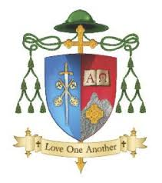
Diocese of Kerry
Administrator application form

Please read carefully:
- Please complete this application form in full
- Do not alter the format of this form
- Additional pages may not be submitted
- Shortlisting may apply based on the information supplied
- Incomplete/late applications will not be considered
Section A : Personal Details
Full Name:
Address for Correspondence:
Telephone Number:
Email Address:

Section B: Education and Qualifications
Education Level | School/Institution | Year

Other relevant, non-accredited courses

Section C : Employment Experience:
Experience in clerical/secretarial/administration role
Employer name and address
Job title
Dates of employment (from -to)
Duties and responsibilities
Reason for leaving (if applicable)

Other employment experience (list most relevant jobs first
Employer name  & address | Job title | Dates of employment | Key  Responsibilities | Reason for leaving (if applicable)

Section D: Skills and competencies
Please tick the areas in which
Competency Yes |  | No
Financial administration
Knowledge of accounts
Proficiency in MS office
Reception duties
Secretarial work
Handling confidential information
Organising events and meetings
Positive outlook and willingness to upskill
Flexibility and ability to work in a team environment
Other (please specify)

Section E: Supporting statement
In no more than 500 words, outline why you are applying for this position and why you wish to be considered for the role. Please detail any other work experience which you feel might be relevant to your application.
Section F; Referees
Please provide the names of two referees
Name | Position | Organisation | Contact number

Signed: ____________________________________________________
Date: ________________

Applications (typed) must be submitted by Thursday 24th September 2026 to
diocesanpastoralcentre@dioceseofkerry.org

