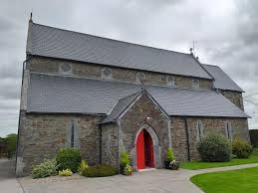
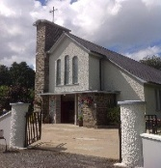
DUAGH & LYREACROMPANE
PARISH NEWSLETTER
THIRTEENTH SUNDAY IN ORDINARY TIME 28th June 2026

Parish Office – Duagh & Lyreacrompane. Tel: 068 45102. Office Hours: Tuesday, Wednesday & Thursday 10.00am - 1.00pm. Email: duagh@dioceseofkerry.ie Parish Moderator: Fr. Brendan Walsh 087-7913271

MASSES IN ST BRIGID’S CHURCH DUAGH
Sunday June 28th @ 11:30 am
Nicholas Carroll, Knockadireen (Anniversary Mass) and deceased members of the Carroll family.
Sunday July 4th @ 11:30 am
Dan O Donoghue, Trieneragh (Anniversary Mass)
Sunday July 12th @ 11:30 am
MASSES IN SACRED HEART CHURCH LYREACROMPANE
Sunday June 28th @ 10:00 am
Peg and Andy O Connell, Corrigcannon (Anniversary Mass)
Sunday July 12th @ 09:30 am
Gerard Gleeson, Knocknaglough (Anniversary Mass)
Thomas Dillon, Glashnanoon (Anniversary Mass)
REVISED MASS SCHEDULE
Sacred Heart Church, Lyreacrompane
Please note that Mass in the Sacred Heart Church, Lyreacrompane will be celebrated every second Sunday morning at the new time of 9:30 a.m.
The Mass schedule for the coming months is as follows:
- July: 12th and 26th
- August: 9th and 23rd
- September: 6th and 20th etc
This schedule will remain in place until 31 December 2026.

PRIEST ON DUTY: Fr Pat Crean-Lynch / Ardfert 087 2200114
CHURCH NOTICES
RECENT DEATHS: We offer our sympathies to the family of John Collins, Hawthorn Drive, Listowel and formerly of Lisaniskea, Kilmorna who died during the week. Rest In Peace.
ADORATION OF THE BLESSED SACRAMENT: Takes place each Friday in Duagh Church from 3.00 p.m. in the afternoon. Public Rosary starts at 6.00 p.m.
BOOKING OF MASSES / BAPTISMS / MARRIAGES /CERTS/ ETC FOR THE PARISH: You may do them in two ways: Book directly with the Parish Office during Office hours on Tuesday, Wednesday & Thursday from 10.00 a.m. to 1.00 p.m. Alternatively, book online by sending an email to: duagh@dioceseofkerry.ie and the Office can be in touch with you.
DUAGH ANNUAL CEMETERY MASS: Date for your calendar - Our Annual Cemetery Mass will take place in Springmount Cemetery on Thursday, July 23rd at 8.00 p.m. with Fr Brendan Walsh.
information contact Mairead on 0876004379.
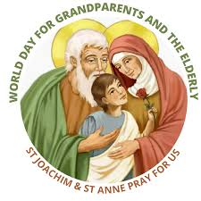
THE ANNUAL NATIONAL GRANDPARENTS PILGRIMAGE: Celebrating the 6th world day for grandparents and the elderly. All are welcome. Sunday 26th July 2026. Knock Shrine – Chief celebrant Archbishop Eamon Martin commencing at 2:30pm with the Anointing of the Sick, A Day of Grace and
Blessing for the whole Family as we honour Grandparents and the
Elderly.Please join us. Visit our website for
resources: www.catholicgrandparentsassociation.org
PILGRIMAGE TO OUR LADY OF GUADALUPE SHRINE, MEXICO: October 2027 for 10 days. The most famous Catholic site in Mexico, where Juan Diego reported visions of the Virgin Mary in 1531. Visitors can see the miraculous cloak with the Virgin’s image and attend mass at this major pilgrimage destination. Spiritual director, Fr. Brendan Walsh, Total cost €2,700, for more information contact Mairead on 0876004379.
PARISH NEWSLETTER: Any Notices for our Parish Newsletter please contact the office by phone or email before Wednesday 12.00 noon. All mass intentions must be booked at least a week in advance as the newsletter is a week ahead. Thanks.

