Eleventh Sunday in Ordinary Time
13th -14th June 2026

For emergencies only please ‘phone: During the week
Fr Gerard Finucane (087) 0554874
Fr Pat Crean-Lynch (087) 2200114
Fr Jerry Keane (087) 2844649
From 1pm Sunday –9am Monday this weekend only
Fr Jerry Keane (087) 2844649


Ballyheigue

Deaths
Kathleen Coyle (nee McEgan) Vancouver, Canada, L/O Bouleenshere
Anniversaries
Mary Costello
Mass intentions for this weekend
Saturday Vigil... Tommy Flahive
Betty, Jimmy & John Hehir
Sunday Mass..... Mary Casey (2nd ann)
Mass intentions for the coming week.
Tues…...7.00pm John, Elizabeth & Thomas Bowler
Thurs….6:30pm Adoration of the Blessed Sacrament
Thurs… 7.00pm Betty Leen (1st ann)
Fri……. 7:00pm Outdoor Mass at St James’s Cemetery
Sat…… 8.00pm Michael, Kathleen & John Michael Moloney & dec members of the Reidy family
Sun..... 10.00am Joan & Pat Joe Lucid & Eileen Lucey
Pat & Mary Barry (nee Dowling) & dec. members of the Barry & Dowling families.

Address: Chapel Rd., Ballyheigue, Tralee Co Kerry Eircode: V92 HY57
*********
Live streaming of masses on: wwwdioceseofkerry.ie-Parishes - Ballyheigue –click on picture of the Church.
*********
Under GDPR, the recording of Requiem/Funeral Masses, is a decision for the next-of-kin of the deceased, requested via the undertaker. The undertaker will make the family aware of this.
*********
Church Open: 11am –4.30pm Tuesday to Sunday
*********
The Parish Office is open in the Presbytery, 9.40am-1.00pm Wednesday & Thursday mornings (closed on Holy Days) for all bookings for Masses, Baptisms and Weddings. Mass cards also available. Email: ballyheigue@dioceseofkerry.ie
phone number (087) 4083927
*********
Baptisms: 2nd & 4th Saturdays of the month.
*******
Confessions available on request before mass.

.

Offertory Collection €1473.16 Thank you for your support and generosity to our Parish. You may continue to hand in your Parish envelopes to the Post office, and we thank the Post Office for providing this facility to us. Their assistance is greatly appreciated
Ballyheigue Outdoor Mass Schedule 2026
Friday 19th June 7pm……. St James Graveyard
Tuesday 23rd June 7pm…. Marian Park
Thursday 25th June 7pm…. Holy Family & St Marys Graveyard’s
Friday 17th July 7pm……. Keel Graveyard

*Dates and venue may be subject to change depending on weather etc.
Ask the Lord to send labourers to his harvest.
In asking us to pray for this intention, he is asking us to take some responsibility for the important work of his, by showing the same compassion to the harassed and dejected as he did. We cannot pray that prayer Jesus asks us to pray without offering ourselves to God as labourers in his harvest. There is some shepherding role that each of us can fulfil in the service of the Lord’s people
~ Fr Gerard

.

Mid-Summer Kerry Head Turas The Kerry Branch of Cumann na Sagart invites you to visit Kerry Head on Monday 22nd June next. Pilgrims will meet at St. Mary’s Well, Ballyheigue at 3pm and travel to the Parish Church en route to St. Dahillan’s Tobar na Súl Holy Well and Teampall overlooking the Shannon Estuary before moving on to visit the ancient St. Erc’s Church and reilig with the Casement Memorial as ceann chúrsa. Our bi-lingual pilgrim journey will be led by local historian Micheál Ó hAllarmhúin. O. S. and companions. Bí linn. Fáilte roimh cách. (Enquiries: Fr. Tomás Ó Luanaigh 087-2213799
*****
Annual Diocesan Pilgrimage to Knock takes place on Saturday August 22nd, the Feast Day of the Queenship of Mary. Many people look forward to this day each year, a day of faith, community, and friendship. A bus will travel from the Pastoral Area. Cost €30 per person. If interested, please contact Kathleen Murray on 087 1344699 or the parish office.
*****
Vocations Afternoon at the Poor Clare Monastery, College Road, Cork; Saturday June 20th, 2 - 4 pm. For young women considering a contemplative vocation. For further information, see our website poorclarescork.ie
*****
The Half on the Head (Kerryhead Half Marathon & 10km Run) takes place this Saturday 13th June @ 11am. A large number of runners are expected so we would kindly request farmers, machinery operators and householders along the route to be aware of runners between the hours of 11am and 2pm and to please keep dogs off the road during this period..The Half on the head is a non-profit event which contributes to the local community. Thank you for your cooperation.

Visitation On Monday 22 June the ancient foundational
sites of Faith in our parish will be visited by priests from
the national heritage body Cumann na Sagart, under the
direction of Rev Fr Tom Looney. We deeply appreciate
the cooperation of everyone. Thank you

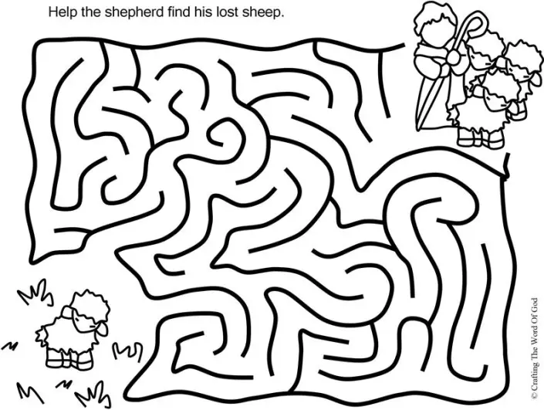

Seanfochail:

Ag obair as laimhe a ceile le Dia.
Working hand in hand with God

