Kilcummin Parish Newsletter
Fr. Kieran O’Brien, Fr. Joe Begley,
Fr. Jim Lenihan, Fr. Padraig Kennelly,
Fr. Vitalis Barasa, Fr. Noel Spring.
For a priest in an emergency at any time call
064 6631014 / mobile 087 6501998
www.kilcumminparish.com. Eircode V93 K22T
Email: kilcummin@dioceseofkerry.ie
Priest on duty this weekend:
Glenflesk 064 7754008 Mobile 087 6554655

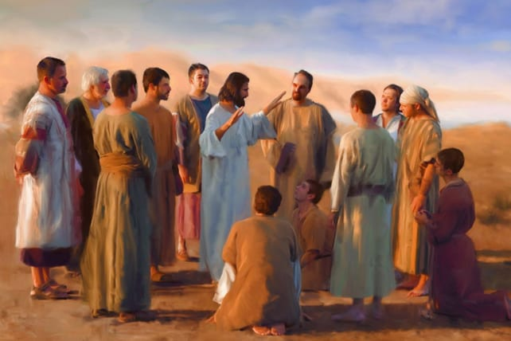

Jesus sees the need for labourers in the harvest. His choise of the Twelve is for the purpose of going out to seek the lost sheep, to cure and heal. The aim will be to form a people that will be his very own.

This weekend’s response to the Responsorial Psalm is:
We are his people:
the sheep of his flock.
11th Sunday in Ordinary Time 14/06/2026
Please pray for Eileen Foley (née Fleming) Castletownbere and late of Inch; Sean Tangney, Ross Road, Killarney. May they rest in peace.
Priest on duty this weekend: Fr. Jim Lenihan 064 7754008/ Mobile 087 6554655 (for emergencies only).
Masses for the coming week

Sat 13th June | 7.30pm | Thank you Mass for all who supported our Good Friday walk and in memory of all our loved ones R.I.P.
Sun 14th June | 11.30am | Arthur, Eileen & Martin O’Keeffe R.I.P. Gattabawn  Sheila Leahy and her son John R.I.P. Ballyheigue and Inch
Tues 16th June | 9.30am  10-6pm  11.00am  6-7pm | Graduation Mass for Kilcummin School  Adoration  Annual Mass for Kilcummin Community Care at GAA Clubhouse  Legion of Mary Meeting (Sacristy)
Thur 18th June | 7.30pm | Paudie O’Leary and deceased family members R.I.P. Tournanough
Sat 20th June | 7.30pm | Kathleen Morrissey (1st Anniv) R.I.P. Glounacopple  50th Anniversary of Our Lady Of Lourdes Church
Sun 21st June | 11.30am | Con Counihan R.I.P. Dunrine

20th & 21st June | Readers | Eucharistic  Ministers | Altar Servers
Vigil  7.30pm | M. Healy | E. Walsh  P. Healy | E. O’Mahony  A. Sheahan  E.R. Lyne
Sun  11.30am | P.O’Donoghue | K. O’Donoghue  N. Fleming  G. Fleming | E. O’Riordan  S. O’Callaghan  C. O’Riordan

Offertory Collection: € 1,025.00. Míle Buíochas.
Second Collection: € 430.00. Míle Buíochas.
Parish Office: Open: Tues, Wed & Fri 10.00am – 12 noon. Tel: 064
6643176 / Mobile: 087 1339732, e-mail kilcummin@dioceseofkerry.ie
Trip to Knock: The Annual Parish Pilgrimage to Knock on Saturday, 27th June, leaving Kilcummin village @7am. Food/refreshments in Gort (optional) morning and evening. Cost €30. Please contact Post Office.
New Eucharistic Minister’s Schedule available in the Church Sacristy.
Our Sincere Thanks to all who took part in and helped organise our Corpus Christi procession. We are especially grateful to all the schools, children and especially our Holy communicants, parish groups, volunteers and all who contributed in any way. Your support and participation made the celebration a very special one. God bless you all. Also thanks to Fr. Joe Begley for the very meaningful Mass and Benediction.
The 50th Anniversary of Our Lady of Lourdes Church - Golden Jubilee 1976 – 2026: As we joyfully celebrate the 50th Anniversary we warmly invite all parishioners from our Parish and beyond to join us on this special day. We’re honoured to welcome Bishop Ray and all the other priest’s, we hope everyone in our community will be part of this milestone. All are warmly welcome.
Church Events Over the Coming Months:
* The 50th Anniv. of Our Lady of Lourdes Church, Mass on Sat, 20th June.
* Holy Cross Graveyard Mass on Wednesday, 1st July @ 7.30pm.
* Old Kilcummin Graveyard Mass on Wednesday, 5th August @ 7.30pm.
Midsummer Kerry Head Turas: The Kerry Branch of Cumann na Sagart invites you to visit Kerry Head on Monday 22nd June next. Pilgrims will meet at St. Mary’s Well, Ballyheigue at 3pm and travel to the Parish Church en route to St. Dahillan’s, Tobar na Súl Holy Well and Teampall overlooking the Shannon Estuary before moving on to visit the ancient St. Erc’s Church and relic with the Casement Memorial as ceann chúrsa. Our bi-lingual pilgrim journey will be led by local historian Micheál Ó hAllarmhúin. O. S. and companions. Bí linn. Fáilte roimh cách. (Enquiries: Fr. Tomás Ó Luanaigh 087-2213799).
Good Friday Hospice Walk: The organising committee of the Good Friday Hospice walk wishes to thank all those who walked, contributed or supported our annual fundraiser in anyway, €2,500.13 was raised. The Remembrance Mass for those whose names are in the memory book will take place on Saturday, June 13th at 7.30pm.
Tidy Towns Adjudicator: With the impending arrival of the Tidy Towns Adjudicator expected over the next few weeks, we would ask all house holders to make a special effort outside their houses to ensure it is presented at its very best. Please ensure if you are a dog owner that you take on your responsibilities associated with dog fouling on footpaths and park. We appreciate and thank you for your assistance and co-operation.
Retirement Celebration: Invitation to the Anabla community, past pupils, family and friends to join in a celebration in honour of Mrs Patricia O'Shea on Wed. 17th June. Mass in the school at 12.30pm in conjunction with the 6th class graduation. Refreshments afterwards. All welcome.
Pilgrimage to Medjugorje will take place on the 22nd to 29th September. €630 approx. For more information contact Tom 086 8380406.
Kilcummin Looking Good: Coffee Morning takes place this Sunday the 14th June in the Recreational Hall at 12pm. All are welcome.

Our prayers and good wishes to the children from
Anabla, Coolick and Kilcummin National Schools who celebrated
their First Holy Communion in our parish.

Anabla
Blake, Gavin, Jack, Oisín, Oran, Tadgh, TJ.
Coolick
Aida, Elara, Jessi-Mai, Olivia, Katija, Kyle Roder, Luke, Donal, Rian, Daniel, Monty, Seán, Conor.
Kilcummin
Luke, Ciarán, Daniel, Ronan, Odhran, Joseph, Áine, Abbie,
Erin, Emilie, Laura, Mia, Robyn.

Special thanks to Fr. Joe and Fr. Gerard for a beautiful ceremony, their teachers for preparing them for their special day, to Denis, Helen and the school choir for the beautiful singing and helping the children with their hymn’s, also to the church cleaning team who had the church spick and span, to the participant’s from the Rural Development who had the lawn and flower beds looking fabulous, many thanks to the parents who provided refreshments in the Recreational Hall afterwards. Mile Buíochas.

Reflection
Kind hearts are the gardens,
Kind thoughts are the roots,
Kind words are the flowers,
Kind deeds are the fruits,
Take care of your garden
and keep out the weeds.
Fill it with sunshine
Kind words and
Kind deeds.

