
Scan to Donate

ST MARY’S PARISH NEWSLETTER - TARBERT
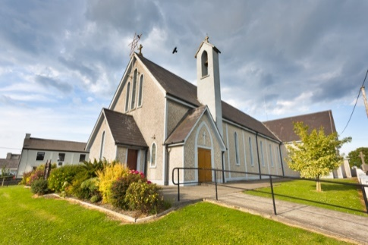
Parish Office Opening Hours:
Mon. 10.30am -2.30pm. Wed. 10.30am-2.30pm Priests :
Phone ; 068-36111. Fr. Sean Hanafin 087-8341083

Email: tarbert@dioceseofkerry.ie Fr. John Buckley 087-2409624
Notices for Parish Newsletter have to be in on Safeguarding Children: 087-6362780 Wednesday by 12 Noon. Defib. Emergency No. 999 or 112
Webpage: www.stmarystarbert.com (Outside Surgery Hours)

13th Sunday in Ordinary Time
Sunday 28th June 2026

R.I.P. Denis Holly, Ballybunion / Ahanagran. Mary Kissane, Luton.
Day/Date | Time | Intention
Saturday 27th | ______ | No Mass.
Sunday 28th | 11.30am | James Murphy, Church St.  John Joe and Peggy Barrett, Tarmons.  Seán, Bridget, Michael and Mary Ahern, Tarmons East.  Johnny, Michael and Joseph Kissane, St. Patrick’s Tce.
Monday 29th | ______
Tuesday 30th | _______
Wednesday 1st | 7pm | Mass in Tarbert.  Maureen Stack, Kilpadogue.  Peggy and Johnny Stack, Kilpadogue.
Thursday 2nd | ______
Friday 3rd | ______
Saturday 4th | ______ | No Mass.
Sunday 5th | 11.30am | Josephine Walsh, Tarmons. ( 1st Anniversary )  Caroline ( Cathy ) McAuliffe, St. Patrick’s Tce.  John Finucane, Piermount.  Margaret O’ Dowd, Carhoona.  Daniel (Snr) and Tessie Kiely &  Deceased Family Members, Main St.
PRIEST ON DUTY THIS WEEKEND: Fr. Pat Crean-Lynch 087-2200114 / 066-7134131.
PARISH OFFERTORY COLLECTION Sunday 21st June - € 707 Míle Buíochas.
THE SICK & RETIRED PRIESTS COLLECTION – will be taken up next weekend Sat. 4th and Sunday 5th July.
GRAVEYARD MASSES – St. Mary’s Cemetery, Tarbert --- Friday 31st July at 7pm. Lislaughtin Abbey – Friday 7th August @ 7pm. Kilnaughtin Cemetery – Thursday 13th August @ 7pm. Reilg Mhichíl --- Friday 4th September at 7pm.

All our Masses at St. Mary’s Church, Tarbert can be viewed online at www.stmarystarbert.com
The Stream of Life

Life could be compared to a stream.
In its journey to the sea
a stream cannot always advance by the shortest route,
but has to twist and turn,
and pause a while here and there,
without ever coming to a complete stop.
And yet in spite of all this dallying,
in spite of all these detours,
how quickly life’s stream runs down to the sea.
Lord, may your gentle hand guide us,
so that in spite of doubts, difficulties and dangers,
we may keep the stream of our lives
flowing towards your kingdom.

Prayer for going on holiday

Heavenly Father,
please bless our holiday time.
Help our family to have patience and understanding.
Guide us to be mindful of this gift of time together.
Help us to make compromises when necessary and
handle any chaos that comes our way with Your love and grace.
Open our eyes to truly see the beauty of the memories we are creating.
Through Christ our Lord. Amen.

TARBERT ACTIVE RETIREMENT – has now finished for the Summer and they will resume again in September.

ANNUAL PILGRIMAGE TO KNOCK – is next Wednesday 1st July. The bus will be leaving Listowel @ 7am, Knockanure @ 7.10am , Moyvane @ 7.20am, Tarbert @ 7.30am and Glin 7.40am. As the bus is fully booked, if anyone who has booked and is not travelling, would they please contact Nuala or Margaret as there is a waiting list of people wishing to travel. Contact Nuala on 068-36166 or Margaret on 087-2976304.

FR. MAURICE BRICK – P.P. Castleisland is retiring in July of this year. He served in Tarbert from July 2000 to July 2006 and the Brick family are compiling a book for his retirement. People who knew him might like to write an anecdote or memory of their time spent with him and also include any photographs that they may have. Any information can be sent by email or post to – carolinebrick27@gmail.com or Caroline Redmond, Radharc an Chuain, The Spa, Tralee.

THANK YOU - for your continuing support and financial donations that underpin the smooth running of St. Mary’s Parish Church. Please continue to donate what you can on a weekly basis at any of our Masses on Wednesday or Sunday. Donations can also be made by bank transfer or on our QR Code on the Parish Newsletter.

