
Scan to Donate

ST MARY’S PARISH NEWSLETTER - TARBERT
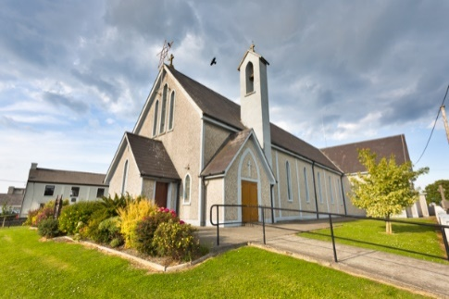
Parish Office Opening Hours:
Mon. 10.30am -2.30pm. Wed. 10.30am-2.30pm Priests :
Phone ; 068-36111. Fr. Sean Hanafin 087-8341083

Email: tarbert@dioceseofkerry.ie Fr. John Buckley 087-2409624
Notices for Parish Newsletter have to be in on Safeguarding Children: 087-6362780 Wednesday by 12 Noon. Defib. Emergency No. 999 or 112
Webpage: www.stmarystarbert.com (Outside Surgery Hours)

12th Sunday in Ordinary Time
Sunday 21st June 2026

Day for Life

Day/Date | Time | Intention
Saturday 20th | ______ | No Mass.
Sunday 21st | 11.30am | Con Leane, Tieraclea. ( 1st Anniversary )  Brendan and Maureen Cregan, Tieraclea.  Nancy and Jimmy Enright, Tieraclea.
Monday 22nd | ______
Tuesday 23rd | _______
Wednesday 24th | 7pm | Mass in Tarbert.  Mike Sheehan, Tarmons.
Thursday 25th | ______
Friday 26th | ______
Saturday 27th | ______ | No Mass.
Sunday 28th | 11.30am | James Murphy, Church St.  John Joe and Peggy Barrett, Tarmons.  Seán, Bridget, Michael and Mary Ahern, Tarmons.  Johnny, Michael and Joseph Kissane, St. Patrick’s Tce.
PRIEST ON DUTY THIS WEEKEND: Fr. Gerard Finucane 087-0554874 / 066-7148404.
PARISH OFFERTORY COLLECTION Sunday 14th June - € 639 Míle Buíochas.
GRAVEYARD MASSES – Aghavallen Cemetery – Friday 26th June @ 7pm. St. Mary’s Cemetery, Tarbert --- Friday 31st July at 7pm. Lislaughtin Abbey – Friday 7th August @ 7pm. Kilnaughtin Cemetery – Thursday 13th August @ 7pm. Reilg Mhichíl --- Friday 4th September at 7pm. Please note that all Graveyard Masses will be celebrated at 7pm.
LIVE SERVICES – All Masses are now being live streamed from our Church. Just go to the Church website – www.stmarystarbert.com and you can watch on your phone, tablet, computer or smart T.V. When you log in and see the picture of the Altar, just underneath this, click on the mute button and you will then have the audio as well
All our Masses at St. Mary’s Church, Tarbert can be viewed online at www.stmarystarbert.com
Prayer for Families

Jesus, Lord and Saviour, you have shown us your love
in your care for all, especially those in need.
We ask you to show this love for our family,
those sick and well, at home and away.
May we live in your heart, young and old in our family,
as we make your home in the heart of each of us.
Make strong our faith in you and in each other.
Enliven our hope and make us joyful in love.
Protect us all and welcome home
those who have gone before us.
We pray this, in gratitude for our family life,
and with the prayers of Mary, our Mother. Amen.

Prayer of Day for Life

Father and maker of all, you adorn all creation
with splendour and beauty and fashion human lives
in your own image and likeness.
Awaken in every heart reverence for the work of your hands
and renew among your people a readiness to nurture
and sustain your precious gift of life.
Grant this through our Lord Jesus Christ,
Your Son, who lives and reigns with you
in the unity of the Holy Spirit,
God forever and ever. Amen.

TARBERT ACTIVE RETIREMENT – (over 55’s) meet in Tarbert Bridewell every Friday between 10.30am and 12 Noon. We have different activities every week followed by refreshments. New Members are welcome.

SHANNONSIDE WOMEN’S GROUP – are holding a coffee morning in the Tarbert Community Centre on Saturday 27th June from 10am until 2pm in aid of Brú Columbanus, Cork. Join us for a cuppa, some treats and good company. “All in aid of a great cause.”

KNOCK SHRINE PILGRIMAGE – will take place this year on Wed. 1st July. The bus pick up times are Knockanure @ 7.10am, Moyvane @ 7.20am and Tarbert @ 7.35am. Contact - Margaret on 087-2976304 or Nuala on 068-36166.

FR. MAURICE BRICK – P.P. Castleisland is retiring in July of this year. He served in Tarbert from July 2000 to July 2006 and the Brick family are compiling a book for his retirement. People who knew him might like to write an anecdote or memory of their time spent with him and also include any photographs that they may have. Any information can be sent by email or post to – carolinebrick27@gmail.com or Caroline Redmond, Radharc an Chuain, The Spa, Tralee.

THANK YOU - for your continuing support and financial donations that underpin the smooth running of St. Mary’s Parish Church. Please continue to donate what you can on a weekly basis at any of our Masses on Wednesday or Sunday. Donations can also be made by bank transfer or on our QR Code on the Parish Newsletter.

