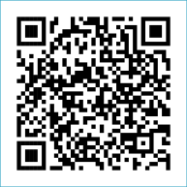
Scan to Donate

ST MARY’S PARISH NEWSLETTER - TARBERT
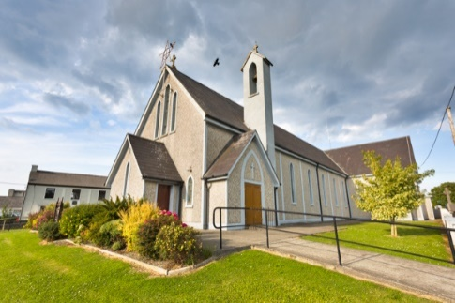
Parish Office Opening Hours:
Mon. 10.30am -2.30pm. Wed. 10.30am-2.30pm Priests :
Phone ; 068-36111. Fr. Sean Hanafin 087-8341083

Email: tarbert@dioceseofkerry.ie Fr. John Buckley 087-2409624
Notices for Parish Newsletter have to be in on Safeguarding Children: 087-6362780 Wednesday by 12 Noon. Defib. Emergency No. 999 or 112
Webpage: www.stmarystarbert.com (Outside Surgery Hours)

The Most Holy Trinity
Sunday 31st May 2026

Day/Date | Time | Intention
Saturday 30th | _______ | No Mass.
Sunday 31st | 11.30am | John ( Johnny ) Coolahan, Dublin / Main St.  Annie, Tom, Margaret, Thomas and Michael O’ Hanlon,  St. Patrick’s Tce.
Monday 1st | ______
Tuesday 2nd | _______
Wednesday 3rd | 7pm | Mass in Tarbert.  Tadhg and Liam Foley, Doonard Lower / Tieraclea.
Thursday 4th | ______
Friday 5th | ______
Saturday 6th | ______ | No Mass.
Sunday 7th | 11.30am | Eileen O’ Connor, Sallowglen. ( Months Mind )  Joanne O’ Connor, Killarney / Glin. ( Months Mind )  Fr. Tommy O’ Hanlon, Dooncaha.  Jack Downey, The Square.

PRIEST ON DUTY THIS WEEKEND: Fr. Declan O’ Connor 087-0908949 / 068-21188.
PARISH OFFERTORY COLLECTION Sunday 24th May - € 559 Trócaire - € 1,745 Míle Buíochas.

DIOCESAN COLLECTION - for Peter’s Pence will be held next weekend Sat. 6th / Sun. 7th June. You may use one of the Special Collection envelopes if you wish.

All our Masses at St. Mary’s Church, Tarbert
can be viewed online at www.stmarystarbert.com
THE BEAUTIFUL HANDS OF A PRIEST

We need them in life's early morning,
We need them again at its close;
We feel their warm clasp of true friendship,
We seek them when tasting life's woes.
At the altar each day we behold them,
And the hands of a king on his throne
Are not equal to them in their greatness;
Their dignity stands all alone;
And when we are tempted and wander,
To pathways of shame and sin,
It's the hand of a priest that will absolve us --
Not once, but again and again;
And when we are taking life's partner,
Other hands may prepare us a feast,
But the hand that will bless and unite us --
Is the beautiful hand of a priest.
God bless them and keep them all holy
For the Host which their fingers caress;
When can a poor sinner do better,
Than to ask Him to guide thee and bless?
When the hour of death comes upon us,
May our courage and strength be increased,
By seeing raised over us in blessing --
The beautiful hands of a priest! Author Unknown

Exam Prayer

‘Lord, as I take this exam, I ask for Your peace and clarity of mind. Calm my nerves, help me to focus and guide my memory to recall what I have studied. Give me the wisdom to understand the questions and the ability to express my answers clearly. I trust in You. Amen.

TARBERT ACTIVE RETIREMENT – (over 55’s) meet in Tarbert Bridewell every Friday between 10.30am and 12 Noon. We have different activities every week followed by refreshments. New Members are welcome.

KNOCK SHRINE PILGRIMAGE – will take place this year on Wed. 1st July. The bus pick up’s are in Listowel, Knockanure, Moyvane, Tarbert and Glin. For more details please contact - Margaret on 087-2976304 or Nuala on 068-36166.

FR. MAURICE BRICK – P.P. Castleisland is retiring in July of this year. He served in Tarbert from July 2000 to July 2006 and the Brick family are compiling a book for his retirement. People who knew him might like to write an anecdote or memory of their time spent with him and also include any photographs that they may have. Any information can be sent by email or post to – carolinebrick27@gmail.com or Caroline Redmond, Radharc an Chuain, The Spa, Tralee.

THANK YOU - for your continuing support and financial donations that underpin the smooth running of St. Mary’s Parish Church. Please continue to donate what you can on a weekly basis at any of our Masses on Wednesday or Sunday. Donations can also be made by bank transfer – our bank details are as follows :

IBAN No- IE76 AIBK 9354 3380 3... .., Account Name – Tarbert Church Account,
Bank - AIB, The Square, Listowel, Co. Kerry.

