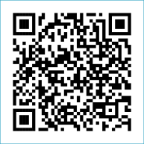
Scan to Donate

ST MARY’S PARISH NEWSLETTER - TARBERT
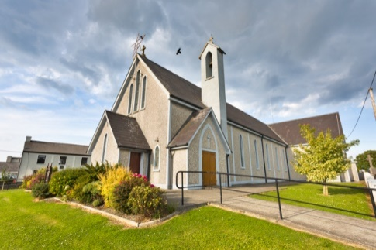
Parish Office Opening Hours:
Mon. 10.30am -2.30pm. Wed. 10.30am-2.30pm Priests :
Phone ; 068-36111. Fr. Sean Hanafin 087-8341083

Email: tarbert@dioceseofkerry.ie Fr. John Buckley 087-2409624
Notices for Parish Newsletter have to be in on Safeguarding Children: 087-6362780 Wednesday by 12 Noon. Defib. Emergency No. 999 or 112
Webpage: www.stmarystarbert.com (Outside Surgery Hours)

The Ascension of the Lord
Sunday 17th May 2026
World Communications Day
R.I.P. Joanne O’ Connor, Killarney / Glin. Fr. Seán Slattery, Limerick.
Breeda Abbott ( née Manning ), Bantry.
Day/Date | Time | Intention
Saturday 16th | 11am  6pm | First Holy Communion.  Johnny, Mikie and Martin O’ Connell, Ballydonoghue.
Sunday 17th | 11.30am | Frank Kelly, Carhoonakilla. ( Months Mind )  Michael, Margaret, Bill and Mary O’ Carroll, Pulleen.
Monday 18th | ______ | No Mass.
Tuesday 19th | ______ | No Mass.
Wednesday 20th | ______ | No Mass.
Thursday 21st | 10am | Mass in Asdee.
Friday 22nd | 7pm | Mass in Ballylongford.
Saturday 23rd | 6pm | Nora and Jacky Shanley, Dooncaha.
Sunday 24th | 11.30am | Seamus and Paddy Griffin, Shanaway.  Kitty and Michael Finucane, Piermount.  Margaret Carmody, New York / Chapel St.
PRIEST ON DUTY THIS WEEKEND: Fr. John Buckley 087-2409624 / 068-43110.
PARISH OFFERTORY COLLECTION Sunday 10th May - €1,125 Easter Garden - €145 Diocesan Collection - €447 Míle Buíochas.
ROSARY AT THE GROTTO – the rosary will be prayed every Monday, Tuesday, Thursday and Friday evening during the month of May at 7pm at the Marian Shrine in the Square. All are welcome.

TRÓCAIRE – Just a reminder that the Trócaire Collection is due to be sent away. If anyone has any box or envelope for Trócaire please return it to the Sacristy or to the Parish Office. Thank you.

All our Masses at St. Mary’s Church, Tarbert can be viewed online at www.stmarystarbert.com
Prayer of St. Brendan the Navigator

( Feast Day, 16th May )

Help me to journey beyond the familiar and into the unknown.
Give me the faith to leave old ways and break fresh ground with You.
Christ of the mysteries,
I trust You to be stronger than each storm within me.
I will trust in the darkness and know that my times,
even now, are in Your hand.
Tune my spirit to the music of heaven and somehow,
make my obedience count for You. Amen.

Exam Prayer

‘Lord, as I take this exam, I ask for Your peace and clarity of mind. Calm my nerves, help me to focus and guide my memory to recall what I have studied. Give me the wisdom to understand the questions and the ability to express my answers clearly. I trust in You. Amen.

TARBERT ACTIVE RETIREMENT – (over 55’s) meet in Tarbert Bridewell every Friday between 10.30am and 12 Noon. We have different activities every week followed by refreshments. New Members are welcome.

IT TAKES A VILLAGE - a truly amazing €2,198 was raised at the Recovery Haven coffee morning held at the Tarbert Bridewell. A huge thank you to all involved and who made it such a special morning.

ECHOES OF SUMMER – on Wednesday May 20th at 7.30pm in the Listowel Arms Hotel. A night of song and poetry with the North Kerry Community Choir and Musical Director Mary Culloty O’ Sullivan plus special guests. Donations to the Kerry Hospice Foundation will be taken at the door on the night. A raffle will also be held.

A FREE FINANCIAL LITERACY EVENT - will be held on Friday 22nd May at The Ashe Hotel, Tralee. Registration and tea/coffee from 10.30am, starting at 11am. Speakers from AIB, MABS, Kerry ETB and An Garda Síochána will share simple tips on managing money and staying safe from scams.

THANK YOU - for your continuing support and financial donations that underpin the smooth running of St. Mary’s Parish Church. Please continue to donate what you can on a weekly basis at any of our Masses on Wednesday, Saturday or Sunday. Donations can also be made by bank transfer – our bank details are as follows :

IBAN No- IE76 AIBK 9354 3380 3050 83, Account Name – Tarbert Church Account,
Bank - AIB, The Square, Listowel, Co. Kerry.

