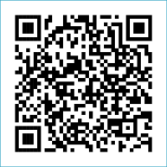
Scan to Donate

ST MARY’S PARISH NEWSLETTER - TARBERT

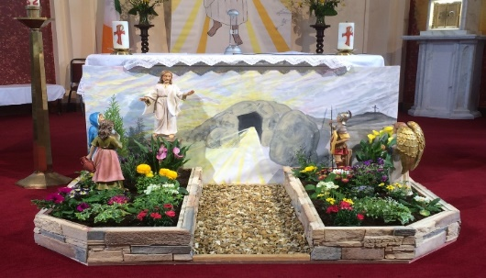
Parish Office Opening Hours:
Mon. 10.30am -2.30pm. Wed. 10.30am-2.30pm Priests :
Phone ; 068-36111. Fr. Sean Hanafin 087-8341083

Email: tarbert@dioceseofkerry.ie Fr. John Buckley 087-2409624
Notices for Parish Newsletter have to be in on Safeguarding Children: 087-6362780 Wednesday by 12 Noon. Defib. Emergency No. 999 or 112
Webpage: www.stmarystarbert.com (Outside Surgery Hours)

Sixth Sunday of Easter
10th May 2026
R.I.P. Bernie Reilly, Connecticut. Marie Behan ( née Carey ), Moyvane.
Day/Date | Time | Intention
Saturday 9th | 6pm | Michael and Peggy & Darragh Lanigan, Tarbert.  Bridget and Cathy O’ Neill, Woodview Place.  John Kennedy, Church St.
Sunday 10th | 11.30am | Michael J. Coolahan, Main St.  Deceased Keane Family Members, Coolnanoonagh.
Monday 11th | ______ | No Mass.
Tuesday 12th | ______ | No Mass.
Wednesday 13th | 7pm | Mass in Tarbert.  Bernie Reilly, Connecticut.
Thursday 14th | 10am | Mass in Asdee.
Friday 15th | 7pm | Mass in Ballylongford.
Saturday 16th | 11am  6pm | First Holy Communion.  Johnny, Mikie and Martin O’ Connell, Ballydonoghue.
Sunday 17th | 11.30am | Frank Kelly, Carhoonakilla. ( Months Mind )  Michael, Margaret, Bill and Mary O’ Carroll, Pulleen.
PRIEST ON DUTY THIS WEEKEND: Fr. Seán Hanafin 087-8341083 / 068-27102.
PARISH OFFERTORY COLLECTION Sunday 3rd May - € 1,123 Míle Buíochas.
DIOCESAN COLLECTION - for the Education of Clergy will be held this weekend Sat. 9th / Sun. 10th May. You may use one of the Special Collection envelopes if you wish.
ROSARY AT THE GROTTO – the rosary will be prayed every Monday, Tuesday, Thursday and Friday evening during the month of May at 7pm at the Marian Shrine in the Square. All are welcome.

TRÓCAIRE – Just a reminder that the Trócaire Collection is due to be sent away. If anyone has any box or envelope for Trócaire please return it to the Sacristy or to the Parish Office. Thank you.

All our Masses at St. Mary’s Church, Tarbert can be viewed online at www.stmarystarbert.com
A Prayer to the Holy Spirit

Come, Holy Spirit, fill my heart with your holy gifts.
Let my weakness be penetrated with your strength this very day,
that I may fulfil all the duties of my state conscientiously,
that I may do what is right and just.
Let my charity be such as to offend no one and hurt no one’s feelings;
so generous as to pardon sincerely any wrong done to me.
Assist me, O Holy Spirit, in all my trials of life, enlighten me in my ignorance,
advise me in my doubts, strengthen me in my weakness,
help me in all my needs, protect me in temptations and console me in afflictions.
Graciously hear me, O Holy Spirit and pour your light
into my heart, my soul and my mind.
Assist me to live a holy life and to grow in goodness and grace. Amen.

Exam Prayer

‘Lord, as I take this exam, I ask for Your peace and clarity of mind. Calm my nerves, help me to focus and guide my memory to recall what I have studied. Give me the wisdom to understand the questions and the ability to express my answers clearly. I trust in You. Amen.

TARBERT ACTIVE RETIREMENT – (over 55’s) meet in Tarbert Bridewell every Friday between 10.30am and 12 Noon. We have different activities every week followed by refreshments. New Members are welcome.

CLOTHES COLLECTION – The Shannonside Women’s Group will hold a clothes collection on next Tuesday 12th May from 8am to 10.30am in the Church car park, in aid of Tarbert GAA Club’s Redevelopment of Facilities. Bags may also be dropped off at Tarbert Community Centre on Monday 11th May from 6pm to 7pm.
RECOVERY HAVEN KERRY - are now offering a new peer support group for those living with a diagnosis of Multiple Myeloma - offering people a chance to meet with others on the same journey, whether you are recently diagnosed or dealing with the condition for some time. They get together at Recovery Haven Kerry 5 Haig’s Terrace, Tralee (V92TN35). For more information please phone us on 066-7192122.

THANK YOU - for your continuing support and financial donations that underpin the smooth running of St. Mary’s Parish Church. Please continue to donate what you can on a weekly basis at any of our Masses on Wednesday, Saturday or Sunday. Donations can also be made by bank transfer – our bank details are as follows :

IBAN No- IE76 AIBK 9354 3380 3050 83, Account Name – Tarbert Church Account,
Bank - AIB, The Square, Listowel, Co. Kerry.

