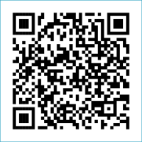
Scan to Donate

ST MARY’S PARISH NEWSLETTER - TARBERT
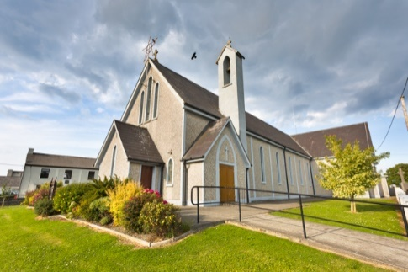
Parish Office Opening Hours:
Mon. 10.30am -2.30pm. Wed. 10.30am-2.30pm Priests :
Phone ; 068-36111. Fr. Sean Hanafin 087-8341083

Email: tarbert@dioceseofkerry.ie Fr. John Buckley 087-2409624
Notices for Parish Newsletter have to be in on Safeguarding Children: 087-6362780 Wednesday by 12 Noon. Defib. Emergency No. 999 or 112
Webpage: www.stmarystarbert.com (Outside Surgery Hours)

Pentecost Sunday 24th May 2026
Day of Prayer for the Church in China

R.I.P. Eileen O’ Connor ( née Healy ), Sallowglen. Michael ( Mike ) Stackpoole, Lixnaw.
Day/Date | Time | Intention
Saturday 23rd | _______ | No Mass.
Sunday 24th | 11.30am | Seamus and Paddy Griffin, Shanaway.  Kitty and Michael Finucane, Piermount.  Margaret Carmody, New York / Chapel St.  Nora and Jacky Shanley, Dooncaha.
Monday 25th | ______
Tuesday 26th | _______
Wednesday 27th | 7pm | Mass in Tarbert.  Private Intention.
Thursday 28th | ______
Friday 29th | ______
Saturday 30th | ______ | No Mass.
Sunday 31st | 11.30am | John ( Johnny ) Coolahan, Dublin / Main St.  Annie, Tom, Margaret, Thomas and Michael O’ Hanlon,  St. Patrick’s Tce.
PRIEST ON DUTY THIS WEEKEND: Fr. Anthony O’ Sullivan 087-2461749 / 066-7132111.
PARISH OFFERTORY COLLECTION Sunday 17th May - € 1,032 Míle Buíochas.
ROSARY AT THE GROTTO – the rosary will be prayed every Monday, Tuesday, Thursday and Friday evening during the month of May at 7pm at the Marian Shrine in the Square. All are welcome.

FIRST HOLY COMMUNION – Congratulations to all the girls and boys who made their First Holy Communion last weekend.
TRÓCAIRE – Just a reminder that the Trócaire Collection is about to be sent away. If anyone has any box or envelope for Trócaire please return it to the Sacristy or to the Parish Office. Thank you.

All our Masses at St. Mary’s Church, Tarbert can be viewed online at www.stmarystarbert.com
A Prayer to the Holy Spirit

Come, Holy Spirit, Fill my heart with your holy gifts.
Let my weakness be penetrated with your strength this very day,
that I may fulfil all the duties of my state conscientiously,
that I may do what is right and just.
Let my charity be such as to offend no one and hurt no one’s feelings;
so generous as to pardon sincerely any wrong done to me.
Assist me, O Holy Spirit, in all my trials of life, enlighten me in my ignorance,
advise me in my doubts, strengthen me in my weakness,
help me in all my needs, protect me in temptations and console me in afflictions.
Graciously hear me, O Holy Spirit and pour your light
into my heart, my soul and my mind.
Assist me to live a holy life and to grow in goodness and grace. Amen.

Exam Prayer
Dear Lord, as I take these exams,
I thank you that my life is
enfolded in the embrace of
Your great love for me.
Help me with all the testing
challenges of life that will come my way.

Holy Spirit, guide me with the
gifts of Wisdom, Knowledge,
Understanding and right Judgement.

Holy Mary, pray for us
and all our young people.
May they know the touch
of your loving caress. Amen.

TARBERT ACTIVE RETIREMENT – (over 55’s) meet in Tarbert Bridewell every Friday between 10.30am and 12 Noon. We have different activities every week followed by refreshments. New Members are welcome.

KNOCK SHRINE PILGRIMAGE – will take place this year on Wed. 1st July. The bus pick up’s are in Listowel, Knockanure, Moyvane, Tarbert and Glin. For more details please contact - Margaret on 087-2976304 or Nuala on 068-36166.

THANK YOU - for your continuing support and financial donations that underpin the smooth running of St. Mary’s Parish Church. Please continue to donate what you can on a weekly basis at any of our Masses on Wednesday, Saturday or Sunday. Donations can also be made by bank transfer – our bank details are as follows :

IBAN No- IE76 AIBK 9354 3380 3050 83, Account Name – Tarbert Church Account,
Bank - AIB, The Square, Listowel, Co. Kerry.

