Kilcummin Parish Newsletter
Fr. Kieran O’Brien, Fr. Joe Begley,
Fr. Jim Lenihan, Fr. Padraig Kennelly,
Fr. Vitalis Barasa, Fr. Noel Spring.
For a priest in an emergency at any time call
064 6631014 / mobile 087 6501998
www.kilcumminparish.com. Eircode V93 K22T
Email: kilcummin@dioceseofkerry.ie
Priest on duty this weekend:
Killarney 064 6631014 Mobile 087 6501998

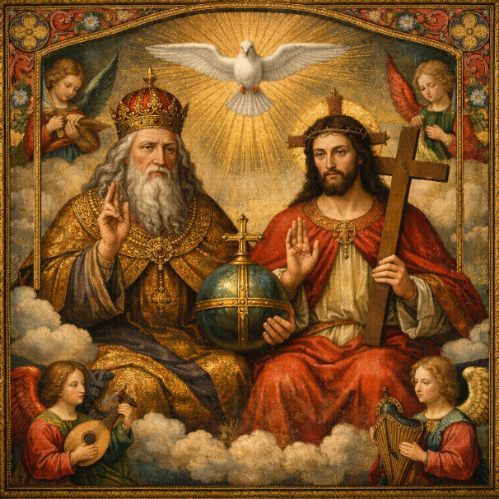

The first sentence of today’s gospel is probably the most well known of sacred scripture. It affirms that it was out love that God the Father acts towards the world and that the way that God expressed this love most was by giving his Son. The purpose then is that all may have eternal life.

This weekend’s response to the Responsorial Psalm is:
To you glory and praise for evermore.
The Most Holy Trinity 31/05/2026
Please pray for Sheila (Julia) Fitzgerald (née O’Driscoll), Charleville and late of Clydine; Joan Phillips (née O’Connor), Pinewood and Glounonea; Brian O’Regan, Countess Grove; Sarah Egan, Coolick; Joan Foley, Killorglin. May they rest in peace.
Priest on duty this weekend: Fr. Kieran O’Brien 064 6631014/ Mobile 087 6501998 (for emergencies only).
Masses for the coming week

Sat 30th May | 11.00am  7.30pm | Holy Communion for our Parish Children  Eileen Healy (1st Anniv) R.I.P. Clashnagarrane  Bridey, Pat Joe & Mike Teehan R.I.P. Buddihans
Sun 31st May | 11.30am | Johnny & Mai O’Rourke R.I.P. Rathanane  Rosarie & Jackie O’Connor R.I.P. Tralee & Farranfore  Mary Flynn R.I.P. Killarney
Tues 2nd June | 9.30am  10-6pm 6-7pm | Special Mass for all Exam Students  Adoration  Legion of Mary Meeting (Sacristy)
Fri 5th June  (First Friday) | 7.00pm  7.30pm | Rosary & Benediction  All deceased members of the McSweeney, O’Leary & O’Sullivan families R.I.P. Leam & Tournanough
Sat 6th June | 7.30pm | Mary Ann O’Leary R.I.P. Ballinamanagh  Noreen Culhane R.I.P. Glebe
Sun 7th June | 11.30am | Sr. Abbie O’Sullivan R.I.P. Ballinamanagh and Columbian Sisters  Corpus Christi Procession immediately after Mass (more details next weekend)

6th & 7th June | Readers | Eucharistic  Ministers | Altar Servers
Vigil  7.30pm | Sonya | K. Fleming  M. Lehane | A. McSweeney  L. O’Sullivan O’Rourke  C. Ahern
Sun  11.30am | L. O’Sullivan | G. O’Sullivan  N. O’Sullivan | C. Blake  E. Nagle  T. O’Donoghue

Offertory Collection: €690.00. Míle Buíochas.
Second Collection takes place next weekend 6th/7th June on behalf of Peter’s Pence. This collection is directed toward supporting the ministry of the Pope in his task of uniting the many different strands of the Church and supports the many charitable initiatives promoted by the Holy Father.
Church Collectors Rota for June: Saturday’s 7.30pm: M. O’Sullivan & S. O’Sullivan. Sunday’s 11.30am: M. O’Donoghue & J. Moriarty.
Parish Office: Open: Tues, Wed & Fri 10.00am – 12 noon. Tel: 064
6643176 / Mobile: 087 1339732, e-mail kilcummin@dioceseofkerry.ie
Church Events Over the Coming Months:
* Novena to the Sacret Heart from 4th to 12th June.
Novena Prayer and Reflection leaflets available in the Church Porch.
* Corpus Christi Procession on Sunday, 7th June after the 11.30am Mass.
* The 50th Anniversary of our Lady of Lourdes Mass on Sat, 20th June.
* Holy Cross Graveyard Mass on Wednesday, 1st July @ 7.30pm.
* Old Kilcummin Graveyard Mass on Wednesday, 5th August @ 7.30pm.
Best Wishes: We want to wish all the children who will receive their Holy Communion this Saturday grace and blessings along with their families and teachers a very happy and joyful day.
Exam Mass: We wish all students the very best of luck with all their exams, mass will be offered on Tuesday, 2nd June at 9.30am.
St. Anthony’s Novena will take place in Franciscan Friary from Thursday 4th June to Saturday 13th June. Weekdays/Saturday Masses 10am & 7pm, Sunday 7th June 11.30am Mass; Student Mass Thursday 4th June @ 8.30pm (after Corpus Christy Procession). Healing Service & Adoration Sunday 7th June @ 7pm; Reconciliation Services Monday 8th June, after both 10am & 7pm Masses. Feast of St. Anthony, Saturday 13th June, Masses with Blessing of the Lilies 10am & 7pm. Blessing of the children & families @ 4pm.
Kilcummin Looking Good are hosting a Coffee Morning on Sunday, June 14th at 12pm in Kilcummin Recreation Hall to support Kilcummin Looking Good. Donations of home baking & confectionary items will be gratefully appreciated can be dropped to the Recreational Hall the evening before from 7-8pm and Sunday morning from 11am. All welcome.
Fundraising Walk Along the Old Kenmare Road will take place on 11th June 2026 in aid of My Canine Companion Autism & Therapy Services. Donations may be sent to Unit 1, Cregane Industrial Estate, Station Rd, Creggane, Buttevant, Co. Cork, P51 WTK5.
The Annual Diocesan Pilgrimage to Knock takes place on Sat. 22nd August, the Feast Day of the Queenship of Mary. Many people look forward to this day each year, a day of faith, community, and friendship. Many parishes choose to combine and arrange a bus as a pastoral area. If any parish wishes to supply choir or solo singers, it will be much appreciated. Otherwise, Knock will supply the music. Thank you to the choir from Killorglin who were with us last year. If you have parish flags, bring them along. Our diocesan pilgrimage to Lourdes from June 10th to 15th is almost three months earlier than usual. It will involve assisted pilgrims and their support team, the youth section and ordinary pilgrims, almost 200 in all.
O’Callaghan Coach Holidays will be travelling to Lourdes in France on October 2nd. Contact: 064 6631095 or holidays@ocallaghancoaches.com.

A Student’s Prayer

Let us pray for all students undergoing examinations;
Lord, pour out your Spirit of wisdom on these students;
Help them to remain calm,
To attend carefully to the questions asked,
To think clearly, to remember accurately,
And to express themselves well.
Grant that they may reflect the best
of the work they have done
and the best of the teaching they have received.
Accept their best efforts in these examinations and in the great test of life on earth.
May your love be upon them, O Lord,
As they place all their trust in you,
We ask this through Christ our Lord.


Amen

