Kilcummin Parish Newsletter
Fr. Kieran O’Brien, Fr. Joe Begley,
Fr. Jim Lenihan, Fr. Padraig Kennelly,
Fr. Vitalis Barasa. Fr. Noel Spring,
For a priest in an emergency at any time call
064 6631014 / mobile 087 6501998
www.kilcumminparish.com. Eircode V93 K22T
Email: kilcummin@dioceseofkerry.ie
Priest on duty this weekend:
Glenflesk 064 7754008 Mobile 087 6554655

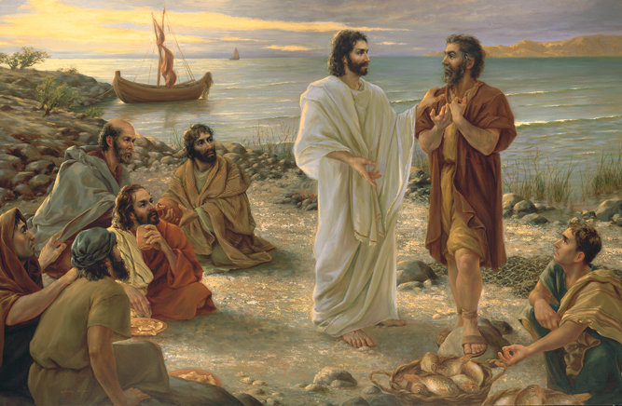

Today’s Gospel is an extract from the Last Supper conversation of Jesus and his disciples. After an initial call not to lose heart the reading goes on to consider how God and Jesus are related. In this passage they are closely identified with each other. When Jesus is speaking, it is the Father who is addressing us. And in coming to know Jesus who was seen by many we come to know the Father who has never been seen.

This weekend’s response to the Responsorial Psalm is:
May your love be upon us, O Lord,
as we place all our hope in you.
Fifth Sunday of Easter 3/05/2026
Please pray for Dermot Brosnan, Inch, Kilcummin and Peggy Corrigan (née) Gallivan, Co. Mayo and formerly Knocknaskeha, Killarney. May they rest in peace.
Priest on duty this weekend: Fr. Jim Lenihan 064 7754008/ Mobile 087 6554655 (for emergencies only).
Masses for the coming week

Sat 2nd May | 7.30pm | Patrick Dunlea (1st Anniversary) and deceased family members R.I.P. Toremore
Sun 3rd May | 11.30am | Denis Horgan R.I.P. Countess Grove & Knockataggle  Joan O’Sullivan R.I.P. Ballinamanagh
Tues 5th May | 9.30am  10-6pm 6-7pm | Special Intention  Adoration  Legion of Mary Meeting (Sacristy)
Wed 6th May | 7.30pm | Anabla Stations in Anabla N.S.
Thur 7th May | 7.30pm | Dan & Julia Kerrisk and deceased family members R.I.P. Knockancore
Sat 9th May | 7.30pm | Michael & Julia O’Neill R.I.P. Mastergeeha  Willie, Noreen & Jerry Teehan R.I.P. Cockhill
Sun 10th May | 11.30am | Breda Pigott (Month’s Mind) R.I.P. Cockhill

9th & 10th May | Readers | Eucharistic  Ministers | Altar Servers
Vigil  7.30pm | K. Friel | M. O’Sullivan  B. O’Sullivan | E. O’Mahony  A. Sheehan  E.R. Lyne
Sun  11.30am | E. Fleming | B. McSweeney  J. Moriarty | E. O’Riordan  S. O’Callaghan  C. O’Riordan
Offertory Collections: €1,131.00. Míle Buíochas.
Second Collection takes place next weekend 9th/10th May on behalf of Education of the Clergy. This fund provides for the education of a future generation of priests whose ministry will continue to be vital in Diocese of Kerry in the 21st Century.
Multi Area Station Mass for Mastergeeha/Glounonea area will take place at 7.30pm in the Mastergeeha Clubhouse on Monday, 18th May.
Church Collectors Rota for May: Saturdays 7.30pm: L. Fleming &
G. Guilfoyle. Sunday 11.30am: K. O’Leary & P. Cahill.
Baptism: We would like to welcome baby Jack Conor Griffin, Milltown and Millie Grace Corcoran, Aghadoe into God’s family with joy. Congratulations to their parents and wishing them many years of health and happiness.
May the Month of Our Lady: Every Monday, the Rosary is recited in the church sacristy @ 7.30pm and in Glounonea Grotto @ 8pm. All welcome.
Multi Area Station Mass for Anabla Area will take place on Wednesday 6th May @ 7.30pm in Anabla School. Townlands include Anabla, Lyretough, Tournanough, Raheen, Milleen, Maulyarkane, Inch, and Knockmanaugh. Please spread the word.
Change of Date: The annual Parish Pilgrimage to Knock will take place on Saturday, 27th June. More details follow.
Medjugorie Pilgrimage: Due to demand, there will now be a second trip from Tuesday, 22nd to the 29th of September, ex Cork. Accompanied by Fr. John Keane as Spiritual Director. For further information, please contact Tom Dennehy on 087 468658.
First Holy Communion Children and their Parents are warmly invited to take the pilgrim statue of Our Lady into their homes in preparation and celebration of their special day. Further details for delivery/collection, contact 087 9408215/087 2106281.
Cancer Support Charity - Recovery Haven Kerry is now offering a new peer support group for those living with a diagnosis of multiple myeloma - offering people a chance to meet with others on the same journey, whether you are recently diagnosed or dealing with the condition for some time. The first get-together takes place at Recovery Haven Kerry, 5 Haig’s Terrace, Tralee (V92TN35) on Tue, May 5th from 2.30pm to 4pm. For more information, please phone us on 066 7192122 or pop along on the day!
Kilcummin Historical Group are holding an open meeting on Thursday, 7th May 2026 in Kilcummin Rural Development Office at 8pm. Subject: Census 1926. All welcome. For more information, please contact 087 1527050. Email: kilcumminhistoricalgroup@gmail.com.
A “Problem-Solving for Life”: One-day workshop for adults, learning creative-thinking tools to approach knotty decisions with fresh perspective and discover new possibilities - in your own way. Saturday, May 9th, 10am - 4pm, Croi Nua, Galway. €70. Advance booking required on eventbrite.ie. Contact Maria at 085 8357566, mariakingguidance@gmail.com.
ACCORD Needs You! ACCORD Catholic Marriage Care Service CLG is currently recruiting volunteers to train as marriage preparation programme facilitators to support couples preparing for the Sacrament of Marriage. The marriage preparation programmes have proven to be helpful and effective in helping couples prepare for marriage. Teams work from St. John’s Parish Centre Tralee or The Pastoral Centre Killarney. Contact tralee@accord.ie 066 7122280 and killarney@accord.ie 064 6633612. Closing date for receipt of completed applications is Wed. 27th May 2026.
Kerry ETB Literacy Support for Driver Theory Preparation: Do you need a little support in preparing for the Driver Theory Test? If so, you can apply for a free part-time course (one class per week in Liber House, Monavalley, Tralee on Thursdays from 12:30pm to 14:30pm). This course helps people who find reading difficult and need support to understand the written questions in the Driver Theory Test. Please contact Ed from Kerry Education and Training Board on 086 074 9786.
Reflection

All through life’s day, you walk with us, Lord
but often we don’t recognise you,
for we are blinded by work and worry,
doubt, confusion and fear,
and so you remain a stranger to us.

Before the day’s end we will ask many questions,
experience many sorrows and disappointments,
and then, suddenly, whether we are young,
middle-aged, or old,
we will find that night is approaching.

In that moment we pray,
that, like the disciples on the road to Emmaus,
our eyes will be opened,
and that we will recognise you.

And you will not vanish from our sight,
but stay with us to guide us
to the Father’s house.



