
Scan to Donate

ST MARY’S PARISH NEWSLETTER - TARBERT

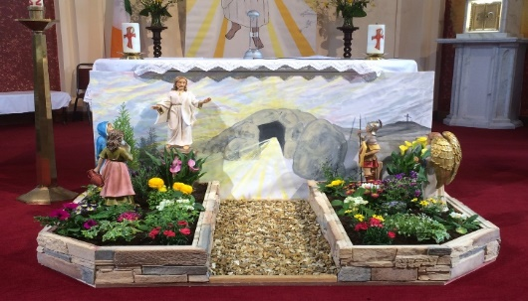
Parish Office Opening Hours:
Mon. 10.30am -2.30pm. Wed. 10.30am-2.30pm Priests :
Phone ; 068-36111. Fr. Sean Hanafin 087-8341083

Email: tarbert@dioceseofkerry.ie Fr. John Buckley 087-2409624
Notices for Parish Newsletter have to be in on Safeguarding Children: 087-6362780 Wednesday by 12 Noon. Defib. Emergency No. 999 or 112
Webpage: www.stmarystarbert.com (Outside Surgery Hours)

Third Sunday of Easter
19th April 2026

Day/Date | Time | Intention
Saturday 18th | 6pm | Emer Ward, Doonard Crescent.  Nell Heffernan, Ballydonoghue.
Sunday 19th | 11.30am | Pope Francis. ( 1st Anniversary )  Noreen and Stephen Lavery, Ballyline.
Monday 20th | ______ | No Mass.
Tuesday 21st | ______ | No Mass.
Wednesday 22nd | 7pm | Mass in Tarbert.  Mina Coolahan, Main St.
Thursday 23rd | 10am | Mass in Asdee.
Friday 24th | 7pm | Mass in Ballylongford.
Saturday 25th | 6pm | Siobhán White, Doonard Lower.  Bernard James, Dooncaha.
Sunday 26th | 11.30am | Patricia Anglim O’ Connor, Saleen House.  Sadie, Mary, Bob, Delia and Liam O’ Carroll, Pulleen.

PRIEST ON DUTY THIS WEEKEND: Fr. Jerry Keane 087-2844649 / 066-4018996.
PARISH OFFERTORY COLLECTION Sunday 12th April - € 1,051 Diocesan Collection - € 336 Míle Buíochas.
GRAVES – Families are asked to ensure that their graves are clean and tidy and to remove any unwanted items.
LIVE SERVICES – All Masses are now being live streamed from our Church. Just go to the Church website – www.stmarystarbert.com and you can watch on your phone, tablet, computer or smart T.V. When you log in and see the picture of the Altar, just underneath this, click on the mute button and you will then have the audio as well.

All our Masses at St. Mary’s Church, Tarbert
can be viewed online at www.stmarystarbert.com
Easter Prayer

Living Lord,
when we stand before the empty tomb
we don’t always feel the joy of resurrection.
We feel fear, doubt and distrust.
Our lives at times feel empty.
Help us to welcome new life.
Fill the emptiness with new light.
Call us to abundant new life.
Guide us in the light of your love. Amen.

Easter Greeting

May the resurrection of Jesus inflame our hearts with new hope.
May the risen Lord fill our hearts with joy
and make us courageous heralds of his Gospel.
And may the peace of God
who brought Jesus back from the dead be with us all.

TARBERT ACTIVE RETIREMENT – (over 55’s) meet in Tarbert Bridewell every Friday between 10.30am and 12 Noon. We have different activities every week followed by refreshments. New Members are welcome.

COFFEE MORNING & WOODLAND WALK – on Saturday 2nd May at Tarbert Bridewell, the walk at 10am is optional.
The coffee morning is from 11am to 2pm. All proceeds go to the Recovery Haven Kerry Cancer Support House.

ANNUAL NATIONAL APOSTOLATE OF EUCHARISTIC ADORATION PILGRIMAGE TO KNOCK – is on Sunday 19th April. A coach will be travelling from Killarney, going by Farranfore, Castleisland and Abbeyfeale. For further details you can contact - Breeda on 087-6742306 or Margaret on 087-2976304.

ARD CHÚRAM DAY CARE - provides a welcoming day service for people aged 65 and over in Greenville, Listowel. This service operates Monday to Friday from 10am until 3pm. Each day includes a range of enjoyable activities in a friendly, social environment. Guests are welcomed with tea and scones on arrival, followed by a freshly prepared full lunch.
If you or a loved one would like to attend, please get in touch and contact us on 068-22986.

THANK YOU - for your continuing support and financial donations that underpin the smooth running of St. Mary’s Parish Church. Please continue to donate what you can on a weekly basis at any of our Masses on Wednesday, Saturday or Sunday. Donations can also be made by bank transfer – our bank details are as follows :

IBAN No- IE76 AIBK 9354 3380 3050 83, Account Name – Tarbert Church Account,
Bank - AIB, The Square, Listowel, Co. Kerry.

