
Scan to Donate

ST MARY’S PARISH NEWSLETTER - TARBERT

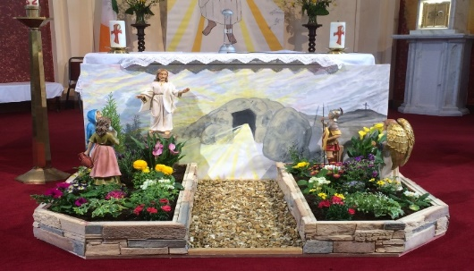
Parish Office Opening Hours:
Mon. 10.30am -2.30pm. Wed. 10.30am-2.30pm Priests :
Phone ; 068-36111. Fr. Sean Hanafin 087-8341083

Email: tarbert@dioceseofkerry.ie Fr. John Buckley 087-2409624
Notices for Parish Newsletter have to be in on Safeguarding Children: 087-6362780 Wednesday by 12 Noon. Defib. Emergency No. 999 or 112
Webpage: www.stmarystarbert.com (Outside Surgery Hours)

Second Sunday of Easter
12th April 2026
Divine Mercy Sunday
R.I.P. Phil O’ Connell ( née Keating ), Listowel.
Day/Date | Time | Intention
Saturday 11th | 6pm | Joan and Pat Brennan & Margaret Gammell,  St. Patrick’s Tce.
Sunday 12th | 11.30am | Michéal Hayes and Pat Considine, St. Patrick’s Tce.  Josie, Thomas and Bartley O’ Connell, Carhoona.
Monday 13th | ______ | No Mass.
Tuesday 14th | ______ | No Mass.
Wednesday 15th | 7pm | Mass in Tarbert.  Bernadette Taylor, Huddersfield.
Thursday 16th | ______ | No Mass.
Friday 17th | 7pm | Mass in Ballylongford.
Saturday 18th | 6pm | Emer Ward, Doonard Crescent.  Nell Heffernan, Ballydonoghue.
Sunday 19th | 11.30am | Pope Francis. ( 1st Anniversary )  Noreen and Stephen Lavery, Ballyline.
PRIEST ON DUTY THIS WEEKEND: Fr. Brendan Walsh 087-7913271 / 068-49308.
PARISH OFFERTORY COLLECTION Sunday 5th April - € 921 Maintenance Fund - € 700
Online Banking - € 120 Míle Buíochas.
DIVINE MERCY DEVOTIONS – will take place here in St. Mary’s Church, Tarbert on this Sunday from 12.30pm to 2.30pm. Fr. Buckley will also be hearing confessions during the Devotions.
DIOCESAN COLLECTION - for Family Services & Accord will be held this weekend Sat. 11th / Sun. 12th April. You may use one of the Special Collection envelopes if you wish.

All our Masses at St. Mary’s Church, Tarbert can be viewed online at www.stmarystarbert.com
Easter Prayer

Living Lord,
when we stand before the empty tomb
we don’t always feel the joy of resurrection.
We feel fear, doubt and distrust.
Our lives at times feel empty.
Help us to welcome new life.
Fill the emptiness with new light.
Call us to abundant new life.
Guide us in the light of your love. Amen.

Easter Greeting

May the resurrection of Jesus inflame our hearts with new hope.
May the risen Lord fill our hearts with joy
and make us courageous heralds of his Gospel.
And may the peace of God
who brought Jesus back from the dead be with us all.

TARBERT ACTIVE RETIREMENT – (over 55’s) meet in Tarbert Bridewell every Friday between 10.30am and 12 Noon. We have different activities every week followed by refreshments. New Members are welcome.

COFFEE MORNING & WOODLAND WALK – on Saturday 2nd May at Tarbert Bridewell, the walk at 10am is optional.
The coffee morning is from 11am to 2pm. All proceeds go to the Recovery Haven Kerry Cancer Support House.

ANNUAL NATIONAL APOSTOLATE OF EUCHARISTIC ADORATION PILGRIMAGE TO KNOCK – is on Sunday 19th April. A coach will be travelling from Killarney, going by Farranfore, Castleisland and Abbeyfeale. For further details you can contact - Breeda on 087-6742306 or Margaret on 087-2976304.

THANK YOU - for your continuing support and financial donations that underpin the smooth running of St. Mary’s Parish Church. Please continue to donate what you can on a weekly basis at any of our Masses on Wednesday, Saturday or Sunday. Donations can also be made by bank transfer – our bank details are as follows :

IBAN No- IE76 AIBK 9354 3380 3050 83, Account Name – Tarbert Church Account,
Bank - AIB, The Square, Listowel, Co. Kerry.

