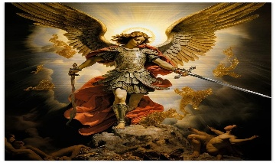
St Michael’s Church
Allihies/Cahermore Parish
April/May 2026
Priest on duty 26th April Fr. Niall Howard 087-9365370
Mass Every Thurs evening @ 7pm Cahermore: Every Friday evening @ 6.30pm Allihies Every second Sunday Cahermore @10.00am: Every second Saturday Allihies @ 6.30pm.
Fr. John Kerin may be contacted on 086-1918246.
We remember in our prayers all who have died recently, we remember especially Catherine O’Leary, Barness, who passed away during the week and all those whose anniversaries occur at this time. We extend our sincere sympathy to all who are bereaved. May they rest in eternal peace.

Mass Intentions for Weekend 25th & 26th April 2026 – 4th Sunday of Easter.
April
Thursday | 23rd April | Cahermore | NO MASS
Friday | 24th April | Allihies | NO MASS
Saturday | 25th Apr | Allihies @ 11am | First Holy Communion Mass
Saturday | 25th Apr | Allihies @ 2pm | Funeral Mass for Catherine O’Leary, Barness
Sunday | 26th April | Cahermore | Jimmy Holland, Cahermore  Anniversary Mass
Monday | 27th Apr | Allihies @3.30pm | Confirmation for 5th & 6th Classes at Cahermore National School

Mass Intentions for Weekend 02nd & 03rd May 2026 – 5th Sunday of Easter.
April/May
Thursday | 30th Apr | Cahermore | No Mass
Friday | 01st May | Allihies | No Mass
Saturday | 02nd May | Allihies | Maureen Gately nee Murphy, New York and formerly of Canalmore
On Saturday, 2nd May, we will welcome a priest from the Spiritan Order. A second collection will be taken up on this occasion.
**2nd Collection 9th/10th May 2026 Education of Clergy**
Please contact Claire at the parish office to book Mass, Weddings, or Christenings, on 086-8344354 or email allihies@dioceseofkerry.ie
Parish Office opening hours 2pm to 5.15pm Tues & Thurs.
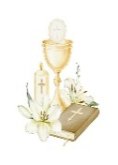
Our thoughts, prayers and good wishes go to the boys and girls of Cahermore N.S., who will celebrate two very special sacraments in the coming days. We remember in a particular way those who will receive their First Holy Communion on Saturday, April 25th, and those who will receive the Sacrament of Confirmation on Monday, April 27th.
We pray in thanksgiving for their youth-filled generosity to our parish and community, and we ask that these special days will be among many moments in which they experience the love of Jesus in the Eucharist and the strength and guidance of the Holy Spirit in their lives.
We thank all those who have prepared the children so well over these past weeks.
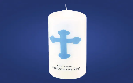
We welcome to our faith community Baby Darragh O’Dwyer, Cluin, Allihies who was christened last weekend. God Bless him and his family.

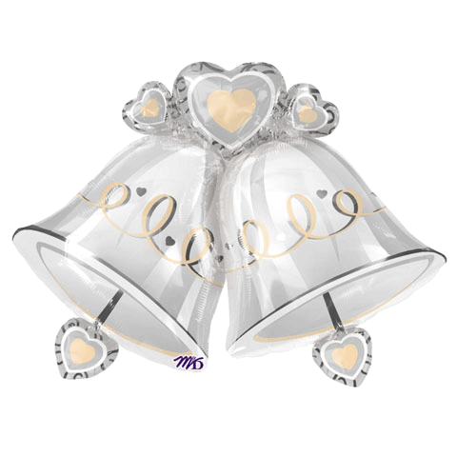
Congratulations to Sharon Mullins Killaugh & Aaron Harrington, Bantry, who were married in Cahermore Church recently. We wish them a long and happy life together with Gods Blessings
This Photo by Unknown Author is licensed under CC BY-SA-NC
This Photo by Unknown Author is licensed under CC BY-SA-NC

COMMUNAL FIRST SATURDAY (CFS)For those who would like to fulfil the second of Our Lady’s requests in Fatima for obtaining a period of peace in the world and salvation of souls.
The Communal First Saturday devotions will be held on Saturday the 2nd May commencing at 9.20 am in the Church of the Sacred Heart, Castletownbere. It will begin with introductory prayers followed by the Rosary at 9.30am. Mass is at 10.00 with 15 minutes meditation immediately after Mass. Confession will begin at 9.20 am.

Beara West Resource Centre: Alive in Local History Part Two: Guided Walk at Dunboy Castle - Thursday May 14th at 2pm. Paddy O’Sullivan will lead a guided history walk at Dunboy Castle, exploring the castle and its stories. Meet at the main entrance at 2pm on Thursday May 14th. Everyone is welcome. Come along, learn something new, and enjoy local history in good company. To book your place, please phone 027 70998. Alive in Local History is a 3-part series of shared stories of our local past and tales brought to life. Parts 2 and 3 are taking place in May & June on the second Thursday of each month.

Beara West Resource Centre: Women’s Group, Craft and Chat Get Together – Monday April 27th, 7pm to 8.30pm Bring your own crafts, share some ideas, and have a cuppa together. Women of all ages welcome and we ask for a small €3 donation.

Reflection:
This Sunday, our parish shares in great joy as the children of Cahermore N.S. celebrate the Sacraments of First Holy Communion and Confirmation.
In the Eucharist, they receive Jesus for the first time, beginning a lifelong friendship with Him. In Confirmation, they are strengthened by the Holy Spirit to live their faith with courage and joy.
Their special days remind us all to renew our own faith and to recognise God’s presence in our lives. May we continue to support them with our prayers and example.

