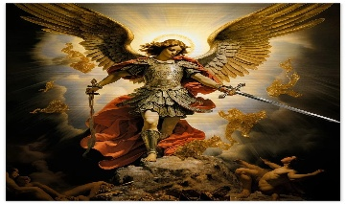
St Michael’s Church
Allihies/Cahermore Parish
April 2026
Priest on duty 05th April Fr. Amos. 087-1085431
Mass Every Thurs evening @ 7pm Cahermore: Every Friday evening @ 6.30pm Allihies Every second Sunday Cahermore @10.00am: Every second Saturday Allihies @ 6.30pm.
Fr. John Kerin may be contacted on 086-1918246.
We remember in our prayers all who have died recently, we remember especially Mary O’Neill, Lichbarrahan who passed away during the week, and all those whose anniversaries occur at this time. We extend our sincere sympathy to all who are bereaved. May they rest in eternal peace.
** 2nd Collection this weekend for Easter Dues **
Mass Intentions for Weekend 04th & 05th Apr 2026 – Easter Sunday of the Lord’s Resurrection.
April
Holy Thurs | 02nd Apr | Allihies @ 6.30 | 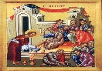  The Mass of the Lords Supper
  Good Friday  This Photo by Unknown Author is licensed under CC BY-NC-ND | 03rd Apr | Allihies @ 6.30 | Stations of the Cross led by Fr John
Easter Sunday | 05th Apr   | Cahermore @10 | Mass for the People of the Parish  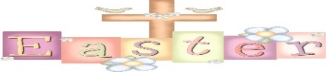
Mass Intentions for Weekend 11th & 12th April 2026 – 2nd Sunday of Easter.
April
Thursday | 09thApril | Allihies @ 6.30 | 100th Birthday Mass for Patricia Swenson nee Harrington Reentrisk.
Friday | 10th April | Allihies | No Mass
Sunday | 12th April | Cahermore | PJ O’Sullivan Ballinacarriga, also remembering his parents Pete & Christina, Laura Petermann & Gerry Forde  James and Julianna O’Sullivan, Kilkinihan
Please contact Claire at the parish office to book Mass, Weddings, or Christenings, on 086-8344354 or email allihies@dioceseofkerry.ie
Parish Office opening hours for the next two weeks 10am to 1:15pm Tues & Thurs.
Please see the notice Board to see the Schedule of Easter Ceremonies in the Beara Deanery.

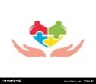
Allihies Community Care: Our next gathering will take place at O’Neill’s Bar on Tuesday, : Tuesday, 21st April 2026. with Mass at 12:30pm. If you wish to attend, please contact Theresa on 087 9562616 before Sunday 19th April. The gathering includes Mass, dinner, and costs €25.00 per person. We warmly welcome all parishioners to join us and look forward to seeing you there!


Garnish Gaa are hosting their annual Easter egg hunt on Easter Sunday morning at 11 sharp @ Gaa pitch. Everyone welcome. Loads of eggs to be found. Eggs & great fun guaranteed for all. Refreshments served in the clubhouse.
Lehanmore Community Centre will hold their annual AGM on Thursday 2nd April at 8 pm, everyone is welcome to attend. New members are always welcome to join.

Beara West Resource Centre: Young Hearts Facing Loss Join John Douglas as he explores the experience of grief and loss—from natural to unexpected deaths—offering a supportive space for young people and families to understand, share, and find guidance. Monday, 20th April at 7:00 pm. To book your place, please call 027-70998. Suitable for ages 10 years and above. Parents welcome to attend

Beara West Resource Centre Citizens Information Talk Series: There are two very informative talks coming up on Friday 24th April. 11am–1pm Adapting Your Home: Accessing Support and 2pm – 4pm Housing Help: From Renting to Building the Citizens Information Talk Series continues at Beara West Resource Centre with a range of FREE, informative talks open to everyone. Each session focuses on a specific topic and offers practical advice and up-to-date information. Booking is essential, and a minimum of 10 attendees is required for each session. For more information, or to book your place, phone the Centre on 027 70998.
.
The next meeting of the Bantry and Surrounding Areas Cardiac Support Group will be held on Tuesday 7th April at 8 p.m. in the Bantry Primary Care Centre (The South Doc Building), P75 T611. At this meeting, Clare O’Sullivan, PHN Diabetes and CVD Prevention Nurse will be our speaker. Blood pressure from 7.30. Refreshments and discussion after.

Easter Reflection: Through His suffering, we have redemption. Through His death, we are forgiven of our sins. Through His Resurrection, we have hope of eternal life. On Easter morning, the stone is rolled away, the tomb is empty, and light prevails over darkness—signalling that death does not have the final word.


