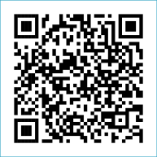
Scan to Donate

ST MARY’S PARISH NEWSLETTER - TARBERT

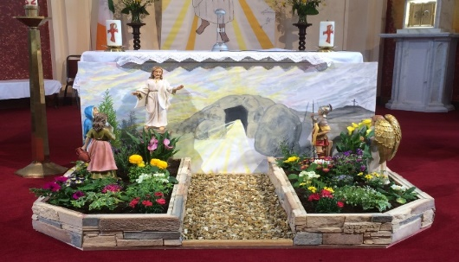
Parish Office Opening Hours:
Mon. 10.30am -2.30pm. Wed. 10.30am-2.30pm Priests :
Phone ; 068-36111. Fr. Sean Hanafin 087-8341083

Email: tarbert@dioceseofkerry.ie Fr. John Buckley 087-2409624
Notices for Parish Newsletter have to be in on Safeguarding Children: 087-6362780 Wednesday by 12 Noon. Defib. Emergency No. 999 or 112
Webpage: www.stmarystarbert.com (Outside Surgery Hours)

Easter Sunday
5th April 2026

Day/Date | Time | Intention
Saturday 4th  Holy Saturday. | 6pm | Celebration of the Easter Vigil.
Sunday 5th  Easter Sunday. | 11.30am | Easter Day of the Lord’s Resurrection.
Monday 6th | ______ | No Mass.
Tuesday 7th | ______ | No Mass.
Wednesday 8th | 7pm | Mass in Tarbert.  Mike Holly and Mary Meskell Holly, The Square.
Thursday 9th | 10am | Mass in Asdee.
Friday 10th | 7pm | Mass in Ballylongford.
Saturday 11th | 6pm | People of the Parish.
Sunday 12th | 11.30am | Michéal Hayes and Pat Considine, St. Patrick’s Tce.  Josie, Thomas and Bartley O’ Connell, Carhoona.
PRIEST ON DUTY THIS WEEKEND: Fr. Declan O’ Connor 087-0908949 / 068-21188.
PARISH OFFERTORY COLLECTION Sunday 29th March - € 599 Míle Buíochas.
DIOCESAN COLLECTION - for Family Services & Accord will be held next weekend Sat. 11th / Sun. 12th April. You may use one of the Special Collection envelopes if you wish.
All our Masses at St. Mary’s Church, Tarbert can be viewed online at www.stmarystarbert.com
A very happy Easter to everyone
from Fr. John, Fr. Seán,
Fr. Brendan, Fr. Martin
and Fr. John.
Easter Greeting

May the resurrection of Jesus inflame our hearts with new hope.
May the risen Lord fill our hearts with joy
and make us courageous heralds of his Gospel.
And may the peace of God
who brought Jesus back from the dead be with us all.

An Easter Message from Pope Leo

This is the peace of the Risen Christ, a disarming and humble and preserving peace. It comes from God. God who loves all of us, without any limits or conditions. Let us keep in our ears the weak but always brave voice of Pope Francis, who blessed Rome – the Pope who blessed Rome and the world that day on the morning of Easter.
Allow me to continue that same blessing. God loves us, all of us, evil will not prevail. We are all in the hands of God. Without fear, united, hand in hand with God and among ourselves, we will go forward. We are disciples of Christ, Christ goes before us and the world needs His light. Humanity needs Him like a bridge to reach God and His love. You help us to build bridges with dialogue and encounter so we can all be one people always in peace.

Prayer to the Virgin Mary at Easter

Blessed are you, O Mary, silent witness of Easter! You, O Mother of the Crucified One now risen, who at the hour of pain and death kept the flames of hope burning, teach us also to be, amongst the incongruities of passing time, convinced and joyful witnesses of the eternal message of life and love brought to the world by the Risen Redeemer.

TARBERT ACTIVE RETIREMENT – (over 55’s) meet in Tarbert Bridewell every Friday between 10.30am and 12 Noon. We have different activities every week followed by refreshments. New Members are welcome.

COFFEE MORNING & WOODLAND WALK – on Saturday 2nd May at Tarbert Bridewell, the walk at 10am is optional.
The coffee morning is from 11am to 2pm. All proceeds go to the Recovery Haven Kerry Cancer Support House.

ANNUAL NATIONAL APOSTOLATE OF EUCHARISTIC ADORATION PILGRIMAGE TO KNOCK – is on Sunday 19th April. A coach will be travelling from Killarney, going by Farranfore, Castleisland and Abbeyfeale. For further details you can contact - Breeda on 087-6742306 or Margaret on 087-2976304.

THANK YOU - for your continuing support and financial donations that underpin the smooth running of St. Mary’s Parish Church. Please continue to donate what you can on a weekly basis at any of our Masses on Wednesday, Saturday or Sunday. Donations can also be made by bank transfer – our bank details are as follows :

IBAN No- IE76 AIBK 9354 3380 3050 83, Account Name – Tarbert Church Account,
Bank - AIB, The Square, Listowel, Co. Kerry.

