Kilcummin Parish Newsletter
Fr. Kieran O’Brien, Fr. Joe Begley,
Fr. Jim Lenihan, Fr. Padraig Kennelly,
Fr. Vitalis Barasa. Fr. Noel Spring,
For a priest in an emergency at any time call
064 6631014 / mobile 087 6501998
www.kilcumminparish.com. Eircode V93 K22T
Email: kilcummin@dioceseofkerry.ie
Priest on duty this weekend:
Killarney 064 6631014 Mobile 087 6501998

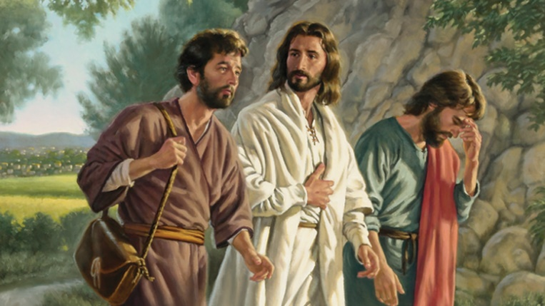

There are two journeys at the heart of today’s reading. The first is that of the two disciples out of Jerusalem. The second is their journey away from being disciples of Christ as a result of his recent suffering and death. As a result of recognising him at the breaking of the bread they decide to reverse the direction of both journeys.

This weekend’s response to the Responsorial Psalm is:
Show us, Lord,
the path of life.
Third Sunday of Easter 19/04/2026
Please pray for Daniel J. Myers, Barleymount West and Killarney. May he rest in peace.
Priest on duty this weekend: Fr. Kieran O’Brien 064 6631014/ Mobile 087 6501998 (for emergencies only).
Masses for the coming week

Sat 18th Apr | 7.30pm | Sean & Mary O’Riordan and their grandson Ian R.I.P. Ballydribbeen
Sun 19th Apr | 11.30am | Séamus O’Connor R.I.P. Clyddaugh  Joseph Clarke R.I.P. Whitebridge  Sheila Healy R.I.P. Mastergeeha  Nell & Paddy O’Leary and Michael Daly R.I.P. Knocklebede
Tues 21st Apr | 9.30am  10-6pm 6-7pm | People of the Parish  Adoration  Legion of Mary Meeting (Sacristy)
Wed 22nd Apr | 7.30pm | Stations in Coolick School (see townlands)
Thur 23rd Apr | 7.30pm | Jackie & Kitty McSweeney R.I.P. Toremore
Sat 25th Apr | 7.30pm | Denis & Catherine Casey R.I.P. Ballinamanagh  Jeremiah and Margaret Mangan and their son Donie R.I.P. Milleen
Sun 26th Apr | 11.30am | Tim, Bernard & Gretta O’Callaghan and their grandson Brian R.I.P. Clashnagarrane

25th & 26th April | Readers | Eucharistic  Ministers | Altar Servers
Vigil  7.30pm | M. O’Sullivan | M. O’Connor  B. Fleming | A. McSweeney  L. O’Sullivan O’Rourke  C. Ahern
Sun  11.30am | P.O’Donoghue | A. Murray  M. O’Sullivan | C. Blake  E. Nagle  T. O’Donoghue

Offertory Collections: €745.00. Míle Buíochas.
Second Collection: €310.00. Míle Buíochas.
Parish Office: Open: Tues, Wed & Fri 10.00am – 12 noon. Tel: 064
6643176 / Mobile: 087 1339732, e-mail kilcummin@dioceseofkerry.ie
Appreciation: Thank you all for your Easter priest offerings. They can still be handed in to the Parish Office for whoever didn’t do so already. All offerings are greatly appreciated.
Trócaire: Thanks to all who have handed in your offering. You can still hand it in to the Parish Office whoever hasn’t done so already.
Masses can be viewed on webcam: https://www.churchservices.tv/kilcummin
Kilcummin Church Webcam Service: Please NOTE that the Live Streaming in Kilcummin Church will be turned on at Mass Time Only, this is due to GDPR requirements and Protocol. There will be no Live Streaming during the day so as to protect and honour the Sacred Building of the Kilcummin Church and to allow one’s own individual privacy, prayer and adoration. Family Funerals, Weddings and other Celebrations: Going forward, we will need to request Permission from Family Members only to turn on our Live Streaming so those, who are unable to attend the Funeral Mass, Wedding or any other Celebration in Kilcummin Church, can view the ceremonies online.
Save the Date: Saturday, 9th May, from 10.30am to 12.30pm, Bishop Ray warmly invites all Prayer Group leaders from across the diocese to a meeting at the diocesan rooms adjacent to Bishop’s House, Killarney. This presents a real opportunity for all of us to gather as one, to share our experience of church, and listen to each other. We invite you to register no matter how big or small your prayer meeting is. To register and for more information, please ring Deacon Thady O’Connor (Diocesan Chaplin to Prayer groups) on 087 2626187 or email: thadyoc1@gmail.com.
Stations for the Coolick School Area takes place on Wednesday, 22nd April @7.30pm in Coolick School. Townlands include Coolick, Coolbane, Dunrine, Coolnagarrihy, Gortnatona, Cloonteens, Lisroe, Knockeenalicka, Knocklebede, Buddihans, Dromadeesirt, Dooneen, Ballydunlea and Ardagh. This Mass is for all the families in these areas. Please spread the word.
Multi Area Station Mass for Mastergeeha/Glounonea area will take place at 7.30pm in the clubhouse on Monday, 27th April.
“Cozy Cow Cafe” opening on Saturday, 18th of April at 9am. Located adjacent to the Village Inn. Open 7 days a week: 8:30am-4pm (weekdays), 8:30am-5pm (weekends) where you can enjoy everything from your full Irish to a delicious roast! We look forward to welcoming you all. For more information see Instagram: Thecozycowcafe.
First Holy Communion Children and their Parents are warmly invited to take the pilgrim statue of Our Lady into their homes in preparation and celebration of their special day. Further details for delivery/collection, contact 087 9408215/087 2106281.
National Epilepsy Week 2026 takes place on 18th May - 25th May. For further information, please visit www.epilepsy.ie/content/national-epilepsy-week-2026-epilepsyweek.
Kerry Priory Youth Club welcomes teenagers aged (13-17 yrs). Date: April 29th at 7pm, Tralee CDP, Upper Rock Street, Tralee. V92 WR9P. For more info contact 087 6941316.
Kerry Diocesan Pilgrimage To Fatima on the 11th of May, 6 nights from Shannon to Porto Direct, 4* half board. For further information, please contact Barters Travelnet 021 4851700.
Mabs Advice & Budgeting Service: Mabs helpline is 0818 072000 or WhatsApp 086 0353141, they can be reached Mon – Fri, 9am-8pm.
Reflection

Heavenly Father, walk with me today,
and grant that I hear Your footsteps
and gladly follow where they lead.
Talk with me today and grant that I may hear
Your tender Voice,
and quicken to its counsel.
Stay with me today and grant that I may feel
Your gentle presence in all I do and think.
Be my strength when I an weak,
my courage when I fear.
Help me to know that it is Your hand holding mine,
through all the hours of this day,
and when night falls grant that I may know,
I rest in Your Sacred Heart.

