Kilcummin Parish Newsletter
Fr. Kieran O’Brien, Fr. Joe Begley,
Fr. Jim Lenihan, Fr. Padraig Kennelly,
Fr. Vitalis Barasa. Fr. Noel Spring,
For a priest in an emergency at any time call
064 6631014 / mobile 087 6501998
www.kilcumminparish.com. Eircode V93 K22T
Email: kilcummin@dioceseofkerry.ie
Priest on duty this weekend:
Fossa 064 6631996 Mobile 087 2935969

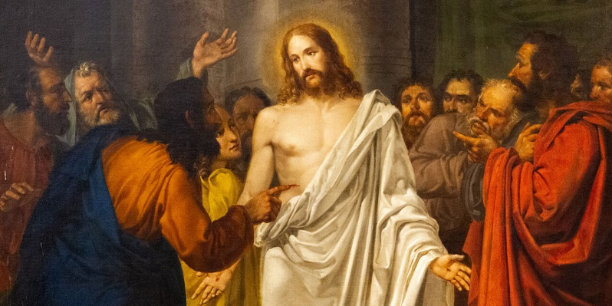

The second part of today’s Gospel is set one week after the day of resurrection. It appears immediately after Jesus has granted the gift to forgive to those who are assembled. And for the author of this Gospel the real sin is lack of faith. The focus moves from Thomas’ disbelief to his finding faith and from that to those who believe who have never seen the Lord.

This weekend’s response to the Responsorial Psalm is:
Give thanks to the Lord for he is good,
for his love has no end.
Divine Mercy Sunday 12/04/2026
Please pray for Breda Pigott (née Griffin), Cockhill; Patrick Martin O’Connor, Fossa; Tommy Heelan, Knocknagree. May they rest in peace.
Priest on duty this weekend: Fr. Noel Spring 064 6631996/ Mobile 087 2935969 (for emergencies only).
Masses for the coming week

Sat 11th Apr | 7.30pm | Denis & Hannah Mai O’Sullivan R.I.P. Ballinamanagh
Sun 12th Apr | 11.30am | Dan Cronin and deceased family members R.I.P. Cockhill  Paddy & Nora Casey R.I.P. Tournanough  Joan & Jack O’Leary R.I.P. Knocklebede
Tues 14th Apr | 9.30am  10-6pm | Memorial Mass for Joseph Tangney R.I.P. Cockhill and Australia  Adoration
Thur 16th Apr | 7.30pm | Johnny, Noni and Brendan O’Leary; baby Gavin Hegarty and Valarie O’Leary R.I.P. Mastergeeha
Sat 18th Apr | 7.30pm | Sean & Mary O’Riordan and their grandson Ian R.I.P. Ballydribbeen
Sun 19th Apr | 11.30am | Séamus O’Connor R.I.P. Clyddaugh  Joseph Clarke R.I.P. Whitebridge  Sheila Healy R.I.P. Mastergeeha  Nell & Paddy O’Leary and Michael Daly R.I.P. Knocklebede

18th & 19th April | Readers | Eucharistic  Ministers | Altar Servers
Vigil  7.30pm | E. Fitzgerald | M. O’Connor  B. Fleming | E. O’Mahony  A. Sheehan E. R. Lyne
Sun  11.30am | M. Doyle | A. Murray  M. O’Sullivan | E. O’Riordan  S. O’Callaghan  C. O’Riordan

Offertory Collections: €1,065.00. Míle Buíochas.
Second Collection this weekend in aid of Family Services and Accord.
Church Collectors Rota for April: Saturdays 7.30pm: T. Sugrue & H. Kerins. Sunday 11.30am: T. Brosnan & J. Moriarty.
Parish Office: Open: Tues, Wed & Fri 10.00am – 12 noon. Tel: 064
6643176 / Mobile: 087 1339732, e-mail kilcummin@dioceseofkerry.ie
Divine Mercy Sunday will be celebrated in St. Mary’s Cathedral on Sunday, April 12th @ 3pm preceded by the Rosary at 2.40pm.
Appreciation: Thank you all for your Easter Priest offerings. They can still be handed in to the Parish Office for whoever didn’t do so all ready. All offerings greatly appreciated.
Trócaire: Many thanks for handing in your offering for this very worthy cause; whoever didn’t get a chance can still hand it in at the weekend Masses or to the Parish Office. Around the world, the children, women, and men that Trócaire work with are very much like you. They want to stand on their own two feet. Thanks as always for your generous contributions.
This June our Church marks its 50th Anniversary: This is a very special milestone in the life of our Parish and we look forward to celebrating it together as a community. In preparation for this occasion our Church has been painted and decorated both inside and out and it’s looking particularly well. As we plan for this important celebration we would greatly welcome your input, if you have any ideas how you would like this Anniversary to be marked, example, special Mass, social gathering, please let us know. We would also be grateful if anyone has old photographs, newspaper clippings or memorabilia connected to the Church over the last 50 years. We already have some pictures given to us and we are most grateful, please feel free to contact the Parish Council through the Parish Office with any suggestions or ideas.
National Epilepsy Week 2026 takes place on 18th May - 25th May. For further information, please visit www.epilepsy.ie/content/national-epilepsy-week-2026-epilepsyweek.
Kerry Priory Youth Club welcomes teenagers aged (13-17 yrs.).
Upcoming dates are April 15th and 29th at 7pm, Tralee CDP, Upper Rock
Street, Tralee. V92 WR9P. For more info contact 087 6941316.
County Clean Up: The Kilcummin County Clean Up takes place on Saturday, 11th April. Red bags are now available in the Rural Development Office for volunteers who wish to clean around their area. Please be mindful of your safety in doing so, bags can be brought to the Rural Development Office or collection of bags can also be arranged, please contact 064 6643357 (Office Hours).
Blood Donation Clinic will be returning to Killarney from Monday 13th – Thursday 16th April in The Heights Hotel. All past & present donors who have donated in the last 5 years will receive a text message letting them know we are back, but we are always looking to welcome new donors. The blood supply is currently low and with a high demand for blood from our hospitals nationally, it is imperative that we continue to maintain the blood supply. Your help is very much appreciated.
Kerry Diocesan Pilgrimage To Fatima on the 11th of May, 6 nights from Shannon to Porto Direct, 4* half board. For further information, please contact Barters Travelnet 021 4851700.
Peggy Lynch’s Knock & Lough Derg Tour (overnight trip) takes place on Sunday, May 3rd 2026. Please contact O’Callaghan Coach Holidays on 064 6631095 for more information.
TFI-LOCAL LINK Kerry: You can check out TFI Local Link Kerry’s bus services into the town of Killarney by visiting our dedicated Killarney page on www.locallinkkerry.ie/killarney/ or phoning 066 714 7002. Office hours.

Reflection

A Lifetime
It takes a lifetime to learn to live,
How to share and how to give,
How to face tragedy that comes your way,
How to find courage to face each new day,
How to smile when your heart is sore,
How to go on when you can take no more,
How to laugh when you want to cry,
How to be brave when you say goodbye,
How to forgive when you want to hate,
How to be sure that God’s really there,
How to find him – seek Him in prayer.

