Kilcummin Parish Newsletter
Fr. Kieran O’Brien, Fr. Joe Begley,
Fr. Jim Lenihan, Fr. Padraig Kennelly,
Fr. Vitalis Barasa. Fr. Noel Spring,
For a priest in an emergency at any time call
064 6631014 / mobile 087 6501998
www.kilcumminparish.com. Eircode V93 K22T
Email: kilcummin@dioceseofkerry.ie
Priest on duty this weekend:
Killarney 064 6631014 Mobile 087 6501998

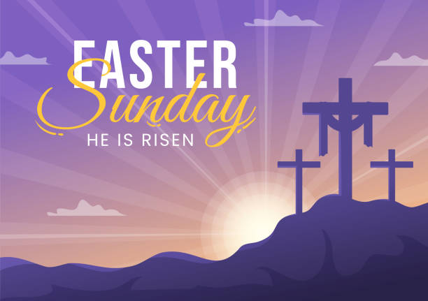

This is John’s account of the empty tomb. The absence of the corpse of Jesus which is reported by Mary of Magdala is intended to reinforce the truth that Jesus is risen. This is further witnessed to by Peter and the other disciple.

Holy Week Ceremonies
Good Friday 3rd April: Celebration of the Lord’s Passion @ 3.00pm.
Holy Saturday 4th April: Easter Vigil Mass @6.00pm.
Easter Sunday 5th April: Mass @ 11.30am

This weekend’s response to the Responsorial Psalm is:
This day was made by the Lord; we rejoice and are glad.
Easter Sunday 5/04/2026
Please pray for Judy Desmond (née Murphy) Rathmore & Barraduff.
May she rest in peace.
Priest on duty this weekend: Fr. Vitalis Barasa 064 6631014/ Mobile 087 6501998(for emergencies only).
Masses for the coming week

Fri 3rd Apr  Good Friday | 3.00pm | Celebration of the Lord’s Passion
Sat 4th Apr  Easter Vigil | 6.00pm | Holy Saturday Night (Private intention).  Please note change of Mass time
Sun 5th Apr  Easter Sunday | 11.30am | Fr. John Lucid R.I.P. Our former Parish priest of Kilcummin  John Breda & Denny O’Connor and deceased family members R.I.P. Glounonea
Tues 7th Apr | 9.30am  10-6pm | Margaret & John Cahill R.I.P. Knockmanaugh  Adoration
Thur 9th Apr | 7.30pm | Derry O’Leary R.I.P. Muckross Road & Inch  Donie, Sr. Nora and Treasa Foley and deceased family members R.I.P. Cockhill
Sat 11th Apr | 7.30pm | Denis & Hannah Mai O’Sullivan R.I.P. Ballinamanagh
Sun 12th Apr | 11.30am | Dan Cronin R.I.P. Cockhill  Paddy & Nora Casey R.I.P. Tournanough  Joan & Jack O’Leary R.I.P. Knocklebede

11th & 12th April | Readers | Eucharistic  Ministers | Altar Servers
Vigil  7.30pm | B. Fleming | B. Lenihan  G. Pigott | C. Fleming  R. Griffin C. O’Mara
Sun  11.30am | L. O’Sullivan | K. Fitzgerald  G. Fitzgerald | A.M. O’Sullivan  M. O’Sullivan

Offertory Collections: €1,345.00. Míle Buíochas.
Second Collection next weekend in aid of Family Services and Accord.
Easter Offering Envelopes (Easter Dues) are available in your yearly boxes and also available in the Church porches. Second Collection this weekend after Holy Communion is part of the Priests salary.
Your generosity is very much appreciated.
Church Collectors Rota for April: Saturdays 7.30pm: T. Sugrue & H. Kerins. Sunday 11.30am: T. Brosnan & J. Moriarty.
Divine Mercy Sunday will be celebrated in St. Mary’s Cathedral on Sunday, April 12th @ 3pm preceded by the Rosary at 2.40pm.
Parish Office: Open: Tues, Wed & Fri 10.00am – 12 noon. Tel: 064
6643176 / Mobile: 087 1339732, e-mail kilcummin@dioceseofkerry.ie
An Appreciation: As we celebrate Easter, the Kilcummin Pastoral Council would like to thank the many people who have shared their time and talent. Thanks to all volunteers who give their time so generously throughout the year; church cleaners, collectors, counters, music ministry, altar servers, readers and Eucharistic ministers. Thanks to Helen and all the staff in the Rural Dev. office who publish the newsletter every week and who keep the church & presbytery ground’s in great shape.
To the Parish Council; parish finance; liturgy group who do beautiful sacred space for the different occasions and much more.
To the staff and management of our three schools, to Mike & Mary O’Connor who open and close our church every day of the year. To our parish secretary and sacristan Siobhán who is so committed to our parish-Míle Buíochas. We would like to thank our dedicated priests who minister in our parish Fr. Kieran, Fr. Joe, Fr. Jim, Fr. Vitalis and Fr. Noel. You are very much appreciated. We would like to wish you and all our parishioners a very Happy and Blessed Easter. Alleluia, Alleluia.
Trócaire Boxes: You are asked to change what is in your Trócaire Boxes into notes and put it into an envelope marked Trócaire. Please place the envelope in the weekly collection or the Parish office. Around the world, the children, women, and men that Trócaire work with are very much like you. They want to stand on their own two feet. Thanks as always for your generous contributions.
Parish Safeguarding Audit: The Diocesan Safeguarding Committee would like to thank all Parish Safeguarding Representatives, Priests and Parish Secretaries for taking the time to complete the annual Parish Safeguarding Audit. Results from the audit are included in the most recent Safeguarding Newsletter which is available on the diocesan website.
Kerry’s Cumann na Sagart invite clergy to concelebrate Aifreann Dé I ndhíl chuimhne Fr. Pádraig Sugrue P.E late Uachtarán of our branch, in the chapel of St. Brendan’s College on Wed 8th of Apr at 3pm. “Go méadaí Dia ar a ghlóir sna Flaithis”. A short meeting will take place afterwards.
Communal First Saturday, 4th April: Those who would like to fulfil the CFS in reparation to the Immaculate Heart of Mary, the Rosary and Scripture Meditation will take place in St. Bridget’s chapel in the Church of the Resurrection at 9.30am on the 4th April. Communion of Reparation can be received at the Saturday evening Vigil Mass or on Easter Sunday. Confession will be available in accordance with the parish plan for Easter.
Kilcummin Rural Development will be holding their A.G.M. on Tuesday, 7th April @ 8pm in the Rural Development Office. New members welcome.
County Clean Up: The Kilcummin County Clean Up will take place on Saturday, 11th April. Red bags are now available in the Rural Development Office for volunteers who wish to clean around their area. Please be mindful of your safety. Bags can be brought to the Rural Development Office or collection of bags can also be arranged, please contact 064 6643357 (Office Hours).

An Easter Prayer

God, give us eyes to see the beauty of the spring,
and to behold Your majesty in every living thing,
and we may see in lacy leaves and every budding flower
the hand that rules the universe with gentleness and power.
May this Easter Grandeur that Spring lavishly imparts
awaken faded flowers of faith lying dormant in our hearts.
Give us ears to hear, dear God,
the Springtime song of birds
with messages more meaningful
than man’s often empty words,
telling harried human beings
Who are lost in dark despair
“Be like us and do not worry
for God has you in His care”.

