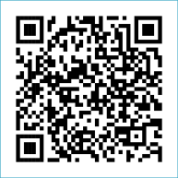
Scan to Donate

ST MARY’S PARISH NEWSLETTER - TARBERT

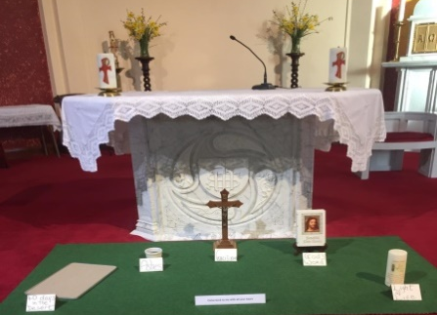
Parish Office Opening Hours:
Mon. 10.30am -2.30pm. Wed. 10.30am-2.30pm Priests :
Phone ; 068-36111. Fr. Sean Hanafin 087-8341083

Email: tarbert@dioceseofkerry.ie Fr. John Buckley 087-2409624
Notices for Parish Newsletter have to be in on Safeguarding Children: 087-6362780 Wednesday by 12 Noon. Defib. Emergency No. 999 or 112
Webpage: www.stmarystarbert.com (Outside Surgery Hours)

Third Sunday of Lent
8th March 2026
R.I.P. Karen Daly O’ Connell, Listowel.
Day/Date | Time | Intention
Saturday 7th | 6pm | Paddy Horan, Dooncaha.  Christina O’ Gorman, St. Patrick’s Tce.  Tom Barton, Faranawanna.
Sunday 8th | 11.30am | Bill and Josephine Walsh, Tarmons West.
Monday 9th | ______ | No Mass.
Tuesday 10th | ______ | No Mass.
Wednesday 11th | 7pm | Mass in Tarbert.  People of the Parish.
Thursday 12th | 10am | Mass in Asdee.
Friday 13th | 7pm | Mass in Ballylongford.
Saturday 14th | 6pm | Donal Finucane, Piermount.
Sunday 15th | 11.30am | Seán and Bridie Wren, Ballinoe.
PRIEST ON DUTY THIS WEEKEND: Fr. Pat Crean-Lynch 087-2200114 / 066-7134131.
PARISH OFFERTORY COLLECTION Sunday 1st March - € 905 Míle Buíochas.
DIOCESAN COLLECTION - for the Emigrant Services will be held next weekend Sat. 14th / Sun. 15th March.
GRAVES – Families are asked to ensure that their graves are clean and tidy and to remove any unwanted items.
LIVE SERVICES – All Masses are now being live streamed from our Church. Just go to the Church website – www.stmarystarbert.com and you can watch on your phone, tablet, computer or smart T.V. When you log in and see the picture of the Altar, just underneath this, click on the mute button and you will then have the audio as well.
All our Masses at St. Mary’s Church, Tarbert,
can be viewed online at www.stmarystarbert.com
Prayer for Lent

Bless me heavenly Father
forgive my erring ways.
Grant me the strength to serve Thee
put purpose in my days.
Give me understanding
enough to make me kind.
So I may judge all people
with my heart and not my mind.

Teach me to be patient
in everything I do.
Content to trust your wisdom
and to follow after You.
Help me when I falter
and hear me when I pray
and receive me in Thy kingdom
to dwell with Thee someday.
Reflection
Lent stimulates us,
to let the Word of God penetrate our life
and in this way to know the fundamental truth;
Who we are, where we come from,
where we must go,
what path we must take in life. Pope Benedict XV1

LORD JESUS GRANT PEACE TO OUR TROUBLED WORLD.
Lord Hear Us.

TARBERT ACTIVE RETIREMENT – (over 55’s) meet in Tarbert Bridewell every Friday between 10.30am and 12 Noon. We have different activities every week followed by refreshments. New Members are welcome.

POKER CLASSIC – 5 Card Draw – in Carmody’s Bar on this Friday 6th March at 8pm, entry €30. Usual buybacks and a Texas game later. This is a fundraiser for the New Astro Turf at the Tarbert Comprehensive School. Your support would be greatly appreciated.

ANNUAL NATIONAL APOSTOLATE OF EUCHARISTIC ADORATION PILGRIMAGE TO KNOCK – is on Sunday 19th April. A coach will be travelling from Killarney, going by Farranfore, Castleisland and Abbeyfeale. For further details you can contact - Breeda on 087-6742306 or Margaret on 087-2976304.

COMHALTAS CHURCH GATE COLLECTION - The annual church gate collection will be held on March 7th / 8th in aid of Fleadh Cheoil Chiarraí 2026. Your support is greatly appreciated.

THANK YOU - for your continuing support and financial donations that underpin the smooth running of St. Mary’s Parish Church. Please continue to donate what you can on a weekly basis at any of our Masses on Wednesday, Saturday or Sunday. Donations can also be made by bank transfer – our bank details are as follows :

IBAN No- IE76 AIBK 9354 3380 3050 83, Account Name – Tarbert Church Account,
Bank - AIB, The Square, Listowel, Co. Kerry.

