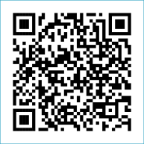
Scan to Donate

ST MARY’S PARISH NEWSLETTER - TARBERT

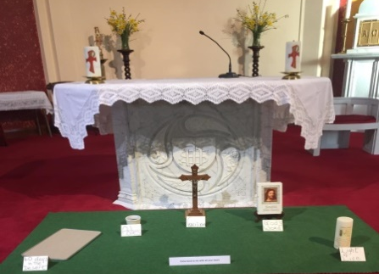
Parish Office Opening Hours:
Mon. 10.30am -2.30pm. Wed. 10.30am-2.30pm Priests :
Phone ; 068-36111. Fr. Sean Hanafin 087-8341083

Email: tarbert@dioceseofkerry.ie Fr. John Buckley 087-2409624
Notices for Parish Newsletter have to be in on Safeguarding Children: 087-6362780 Wednesday by 12 Noon. Defib. Emergency No. 999 or 112
Webpage: www.stmarystarbert.com (Outside Surgery Hours)

Palm Sunday of the Lord’s Passion
29th March 2026
R.I.P. Fr. Jack O’ Donnell, Duagh.
Day/Date | Time | Intention
Saturday 28th | 6pm | Marie and Martin Sweeney, Tarmons.
Sunday 29th | 11.30am | Batt and Josephine Flavin, Carhoonakilla.  Thomas and Michael O’ Connor, Ardmore.  Mickey and Jimmy Donovan, Tieraclea.  Sister Eileen Kiely, Magheramore / Main St.  Thomas Dillane, Doonard Upper.
Monday 30th | ______ | No Mass.
Tuesday 31st | ______ | No Mass.
Wednesday 1st | ______ | No Mass.
Thursday 2nd  Holy Thursday. | 8pm  In Asdee. | Evening Mass of the Lord’s Supper.
Friday 3rd  Good Friday. | 3pm  In Ballylongford. | Celebration of the Lord’s Passion.
Saturday 4th  Holy Saturday. | 6pm  In Tarbert. | Celebration of the Easter Vigil.  People of the Parish.
Sunday 5th  Easter Sunday. | 11.30am | Easter Day of the Lord’s Resurrection.
PRIEST ON DUTY THIS WEEKEND: Fr. Anthony O’ Sullivan 087-2461749 / 066-7132111.
PARISH OFFERTORY COLLECTION Sunday 22nd March - € 1,236 Míle Buíochas.
TIME CHANGE – Remember that the clock springs forward by one hour on this Sat. night 28th March.
GOOD FRIDAY IN TARBERT – At 3pm - The Readings of the Lord’s Passion - At 8pm- The Stations of the Cross.
LIVE SERVICES – All Masses are now being live streamed from our Church. Just go to the Church website – www.stmarystarbert.com and you can watch on your phone, tablet, computer or smart T.V. When you log in and see the picture of the Altar, just underneath this, click on the mute button and you will then have the audio as well.
Reflection for Good Friday

Why do we call this Friday ‘Good’ when so many bad things happened ?
It is a day of contrasts and of paradox, a day of contradictions.
It is a day of unparalleled evil but we strangely call it ‘Good’.
God came to earth so that we may go to heaven.
God became human so that we might become divine.
The Son of God became a slave so that we could be set free.
Jesus was rejected so that we might be accepted.
Jesus forgave so that we would forgive.
Jesus was convicted so that we might have conviction.
Jesus was sold so that we could be redeemed.
Jesus was hurt so that we could be healed.
Jesus was scourged – we were purged.
Jesus descended into hell so that we might ascend to heaven.
Jesus was crowned with thorns so that we might have the crown of eternal life.
The sky went dark so that we might see the light.
The earth shook so that we might be calm.
Jesus was condemned as guilty so that we might be found innocent.
Jesus carried his cross so that Satan’s plan would be crossed out.
Jesus’ heart was opened by a spear so that our hearts might be opened by love.
Jesus laid in a borrowed tomb for only three days.
This is a day of supreme contrasts, paradox and even contradiction.
Jesus suffered all those bad things, so that we might call This Friday ‘Good’.

TARBERT ACTIVE RETIREMENT – (over 55’s) meet in Tarbert Bridewell every Friday between 10.30am and 12 Noon. We have different activities every week followed by refreshments. New Members are welcome.

COFFEE MORNING & WOODLAND WALK – on Saturday 2nd May at Tarbert Bridewell, the walk at 10am is optional.
The coffee morning is from 11am to 2pm. All proceeds go to the Recovery Haven Kerry Cancer Support House.

ANNUAL NATIONAL APOSTOLATE OF EUCHARISTIC ADORATION PILGRIMAGE TO KNOCK – is on Sunday 19th April. A coach will be travelling from Killarney, going by Farranfore, Castleisland and Abbeyfeale. For further details you can contact - Breeda on 087-6742306 or Margaret on 087-2976304.

INVITATION- You are warmly invited to experience the prayerful reading of Scripture as we begin the Easter Season. Fr. Seamus O’Connell will guide us to recognise the voice of God deep within us on Saturday 28th March in Our Lady and St Brendan’s Pastoral Centre, Tralee from 10.30pm to 12.30pm. All are welcome. Donation €10

THANK YOU - for your continuing support and financial donations that underpin the smooth running of St. Mary’s Parish Church. Please continue to donate what you can on a weekly basis at any of our Masses on Wednesday, Saturday or Sunday. Donations can also be made by bank transfer – our bank details are as follows :

IBAN No- IE76 AIBK 9354 3380 3050 83, Account Name – Tarbert Church Account,
Bank - AIB, The Square, Listowel, Co. Kerry.

