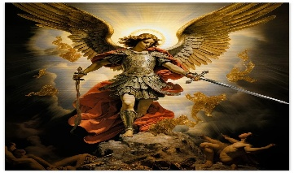
St Michael’s Church
Allihies/Cahermore Parish
March/April 2026
Priest on duty 29th March Fr. Sean Murphy. 087-6684971
Mass Every Thurs evening @ 7pm Cahermore: Every Friday evening @ 6.30pm Allihies Every second Sunday Cahermore @10.00am: Every second Saturday Allihies @ 6.30pm.
Fr. John Kerin may be contacted on 086-1918246.
We remember in our prayers all who have died recently, and all those whose anniversaries occur at this time. We extend our sincere sympathy to all who are bereaved. May they rest in eternal peace.
Mass Intentions for Weekend 28th & 29th Mar 2026 – Palm Sunday.
March
Thursday | 26th Mar | Cahermore | Donal O’Donovan, Derrymihian  Months Mind.
Friday | 27th Mar | Allihies | Terry & Maureen O’Sullivan, Cluin
Sunday | 29th Mar | 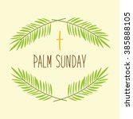  Cahermore | Oliver O’Sullvan, Killaugh, also remembering his wife, Betty.  Palm Sunday
Mass Intentions for Weekend 04th & 05th April 2026 – Easter Sunday of the Lord’s Resurrection.
April
Holy Thurs | 02nd Apr | Allihies @ 6.30 |   The Mass of the Lords Supper
  Good Friday  This Photo by Unknown Author is licensed under CC BY-NC-ND | 03rd Apr | Allihies @ 6.30 | Stations of the Cross led by Fr John
Easter Sunday | 05th Apr  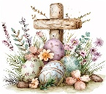 | Cahermore @10 | Mass for the People of the Parish  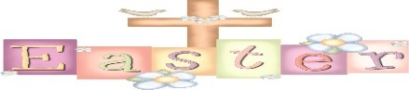
Confessions will be heard from Thurs 12th Mar at weekday masses in Cahermore from 6.15pm to 6.55pm and in Allihies on Fridays from 6.00pm to 6.25pm.

Please contact Claire at the parish office to book Mass, Weddings, or Christenings, on 086-8344354 or email allihies@dioceseofkerry.ie ** 2026 Diary Open **
Parish Office opening hours for the next two weeks 10am to 12:15pm Tues & Thurs.
Please see the notice Board to see the Schedule of Easter Ceremonies in the Beara Deanery.

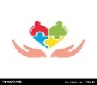
Allihies Community Care: Our next gathering will take place at O’Neill’s Bar on Tuesday, : Tuesday, 21st April 2026. with Mass at 12:30pm. If you wish to attend, please contact Theresa on 087 9562616 before Sunday 19th April. The gathering includes Mass, dinner, and costs €25.00 per person. We warmly welcome all parishioners to join us and look forward to seeing you there!

Lehanmore Community Centre will hold their annual AGM on Thursday 2nd April at 8 pm, everyone is welcome to attend. New members are always welcome to join.

Communal First Saturday 4th April: Please note special arrangement: As the Communal First Saturday coincides with Holy Saturday, permission for a special arrangement has been made with our parish priest in order that we can fulfil our First Saturday. Those who would like to fulfil the CFS in reparation to the Immaculate Heart of Mary, the Rosary and Scripture Meditation will take place in the Sacred Heart Church, Castletownbere at 10am on the 4th of April. Communion of Reparation can be received at the Saturday evening Vigil Mass or on Easter Sunday. Confession will be available in accordance with the parish plan for Easter.

Beara West Resource Centre : Alive in Local History - Shared stories of our local past and tales brought to life. A series of history talks and walks taking place in April, May & June on the second Thursday of each month. Stay tuned for more information.

Beara West Resource Centre Rhythm Room - Wednesdays 2.15pm to 3.30pm. The next Rhythm Room session will take place on April 1st followed by a two-week break for Easter. Sessions will resume again on April 22nd. All are welcome to come along and share in singing and stories. Phone us to book your place or visit www.bearawest.ie and complete the registration form in the Events section at the end of the homepage.

Castletownbere Youth Theatre: Saturday March 28th Castletownbere Youth Theatre presents ‘The Wizard of Castletownbere’ in Scoil an Chroi Ro Naofa at 7:30pm. Tickets at the door (cash only). See you there!

The Chrism Mass will take place on Tuesday evening 31st March at 7.00pm. There will be refreshments after the Mass in St. Brendan’s College refectory. Everyone is welcome.

Parish Safeguarding Audit: The Diocesan Safeguarding Committee would like to thank all Parish Safeguarding Representatives, Priests, and Parish Secretaries for taking the time to complete the annual Parish Safeguarding Audit. Results from the audit are included in the most recent Safeguarding Newsletter which is available on the diocesan website.
Reflection:
Palm Sunday reminds us how quickly joy can turn to rejection. As we welcome Jesus as King, we are also called to follow Him faithfully through the Cross. May this Holy Week strengthen our faith and prepare our hearts for the hope of the Resurrection.

