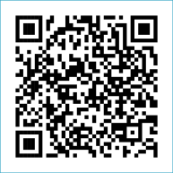
Scan to Donate

ST MARY’S PARISH NEWSLETTER - TARBERT

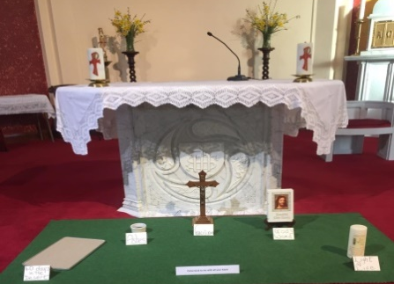
Parish Office Opening Hours:
Mon. 10.30am -2.30pm. Wed. 10.30am-2.30pm Priests :
Phone ; 068-36111. Fr. Sean Hanafin 087-8341083

Email: tarbert@dioceseofkerry.ie Fr. John Buckley 087-2409624
Notices for Parish Newsletter have to be in on Safeguarding Children: 087-6362780 Wednesday by 12 Noon. Defib. Emergency No. 999 or 112
Webpage: www.stmarystarbert.com (Outside Surgery Hours)

Fourth Sunday of Lent 15th March 2026
Laetare Sunday

Day/Date | Time | Intention
Saturday 14th | 6pm | Donal Finucane, Piermount.
Sunday 15th | 11.30am | Stan Foley, Tieraclea House. (Months Mind )  Seán and Bridie Wren, Ballinoe.  Thomas Dillane, Doonard Upper.  Deceased Members Moore and Kelly Families, Tarmons.
Monday 16th | ______ | No Mass.
Tuesday 17th  St. Patrick’s Day. | 11.30am | Pat Lynch, Shanaway.  Paddy Lavery, Ivy House.  Mary B. Hayes, Doonard Upper.
Wednesday 18th | ______ | No Mass.
Thursday 19th | ______ | No Mass.
Friday 20th | ______ | No Mass.
Saturday 21st | 6pm | John, Elizabeth and Pat Nolan, Kanturk.
Sunday 22nd | 11.30am | John Carrig, Doonard Upper. ( Months Mind )
PRIEST ON DUTY THIS WEEKEND: Fr. Seán Hanafin 087-8341083 / 068-27102.
PARISH OFFERTORY COLLECTION Sunday 8th March - € 818 Míle Buíochas.
DIOCESAN COLLECTION - for the Emigrant Services will be held this weekend Sat. 14th / Sun. 15th March.
GRAVES – Families are asked to ensure that their graves are clean and tidy and to remove any unwanted items.
LIVE SERVICES – All Masses are now being live streamed from our Church. Just go to the Church website – www.stmarystarbert.com and you can watch on your phone, tablet, computer or smart T.V. When you log in and see the picture of the Altar, just underneath this, click on the mute button and you will then have the audio as well.
All our Masses at St. Mary’s Church, Tarbert, can be viewed online at www.stmarystarbert.com
St. Patrick’s Day

St Patrick, whose feast we celebrate next Tuesday was an emigrant worker. On our national feast day, we pray for all our emigrants abroad. We send our good wishes and prayers, and hope that life will be good to them. We pray they will use their gifts and talents for good, and they will have a positive impact on those they meet.
As we remember our own emigrants abroad we also think of immigrants in our own country who may be experiencing the same struggles to fit into a new culture. Are we still the land of the ‘Céad Míle Fáilte’? Perhaps we could use the beautiful words of St Patrick’s Breastplate, a prayer attributed to our patron saint to reflect today on our interactions with others.
Christ with me, Christ before me,
Christ behind me, Christ in me…
Christ in the heart of everyone who thinks of me,
Christ in the mouth of everyone who speaks of me,
Christ in every eye that sees me,
Christ in every ear that hears me.

And so we pray

May the flame of faith, which St. Patrick
lit at Tara never be extinguished,
and may God, in his goodness,
grant the Irish Church
a season of renewal and growth.

The St Patrick’s Day parade will take place after Mass on 17th March. This year the parade will commence at Tarbert Bridewell & finish at Tarbert Community Centre. Our parade will be led by Teddy Griffin.
A fundraiser will be held in the Community Centre after the parade with tea/coffee and treats for adults and a disco and face painting for children. All are welcome.
Everyone in the parish is encouraged to take part, get involved or come out to watch the parade.

Happy Mother’s Day

We pray on this day a blessing on all mothers
whose love, gentleness and untiring patience is so often taken for granted.
Pray also for mothers who have gone before us.
May they Rest In Peace and Rise In Glory.

TARBERT ACTIVE RETIREMENT – (over 55’s) meet in Tarbert Bridewell every Friday between 10.30am and 12 Noon. We have different activities every week followed by refreshments. New Members are welcome.

TARBERT COMMUNITY ALERT - A meeting of the Tarbert Community Alert Group will be held on Wednesday 18th March in the Community Centre at 7.30pm. All are welcome.

THANK YOU - for your continuing support and financial donations that underpin the smooth running of St. Mary’s Parish Church. Please continue to donate what you can on a weekly basis at any of our Masses on Wednesday, Saturday or Sunday. Donations can also be made by bank transfer – our bank details are as follows :

IBAN No- IE76 AIBK 9354 3380 3050 83, Account Name – Tarbert Church Account,
Bank - AIB, The Square, Listowel, Co. Kerry.

