
Scan to Donate

ST MARY’S PARISH NEWSLETTER - TARBERT

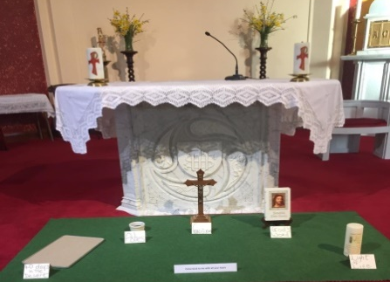
Parish Office Opening Hours:
Mon. 10.30am -2.30pm. Wed. 10.30am-2.30pm Priests :
Phone ; 068-36111. Fr. Sean Hanafin 087-8341083

Email: tarbert@dioceseofkerry.ie Fr. John Buckley 087-2409624
Notices for Parish Newsletter have to be in on Safeguarding Children: 087-6362780 Wednesday by 12 Noon. Defib. Emergency No. 999 or 112
Webpage: www.stmarystarbert.com (Outside Surgery Hours)

Fifth Sunday of Lent 22nd March 2026

R.I.P. Bernadette Timmons, Huddersfield. Teresa Mullins, Donegal.
Day/Date | Time | Intention
Saturday 21st | 6pm | John, Elizabeth and Pat Nolan, Kanturk.
Sunday 22nd | 11.30am | John Carrig, Doonard Upper. ( Months Mind )
Monday 23rd | ______ | No Mass.
Tuesday 24th | ______ | No Mass.
Wednesday 25th | 7pm | Mass in Tarbert.  Private Intention.
Thursday 26th | 10am | Mass in Asdee.
Friday 27th | 7pm | Mass in Ballylongford.
Saturday 28th | 6pm | Marie and Martin Sweeney, Tarmons.
Sunday 29th | 11.30am | Batt and Josephine Flavin, Carhoonakilla.  Thomas and Michael O’ Connor, Ardmore.  Mickey Donovan, Tieraclea.  Sister Eileen Kiely, Magheramore / Main St.
PRIEST ON DUTY THIS WEEKEND: Fr. John Buckley 087-2409624 / 068-43110.
PARISH OFFERTORY COLLECTION Sunday 15th March - € 833 Diocesan Collection - € 358 Míle Buíochas.
GRAVES – Families are asked to ensure that their graves are clean and tidy and to remove any unwanted items.
LIVE SERVICES – All Masses are now being live streamed from our Church. Just go to the Church website – www.stmarystarbert.com and you can watch on your phone, tablet, computer or smart T.V. When you log in and see the picture of the Altar, just underneath this, click on the mute button and you will then have the audio as well.
All our Masses at St. Mary’s Church, Tarbert,
can be viewed online at www.stmarystarbert.com
Prayer For Lent

Bless me heavenly Father
forgive my erring ways.
Grant me the strength to serve Thee
put purpose in my days.
Give me understanding
enough to make me kind.
So I may judge all people
with my heart and not my mind.

Teach me to be patient
in everything I do.
Content to trust your wisdom
and to follow after You.
Help me when I falter
and hear me when I pray
and receive me in Thy kingdom
to dwell with Thee someday.

TARBERT ACTIVE RETIREMENT – (over 55’s) meet in Tarbert Bridewell every Friday between 10.30am and 12 Noon. We have different activities every week followed by refreshments. New Members are welcome.

SHANNONSIDE WOMEN’S GROUP – are meeting on Thursday 26th March at 3pm in the Community Centre. New members welcome.

ANNUAL NATIONAL APOSTOLATE OF EUCHARISTIC ADORATION PILGRIMAGE TO KNOCK – is on Sunday 19th April. A coach will be travelling from Killarney, going by Farranfore, Castleisland and Abbeyfeale. For further details you can contact - Breeda on 087-6742306 or Margaret on 087-2976304.

INVITATION- You are warmly invited to experience the prayerful reading of Scripture as we begin the Easter Season. Fr. Seamus O’Connell will guide us to recognise the voice of God deep within us on Saturday 28th March in Our Lady and St Brendan’s Pastoral Centre, Tralee from 10.30pm to 12.30pm. All are welcome. Donation €10

THANK YOU - for your continuing support and financial donations that underpin the smooth running of St. Mary’s Parish Church. Please continue to donate what you can on a weekly basis at any of our Masses on Wednesday, Saturday or Sunday. Donations can also be made by bank transfer – our bank details are as follows :

IBAN No- IE76 AIBK 9354 3380 3050 83, Account Name – Tarbert Church Account,
Bank - AIB, The Square, Listowel, Co. Kerry.

