Kilcummin Parish Newsletter
Fr. Kieran O’Brien, Fr. Joe Begley,
Fr. Jim Lenihan, Fr. Padraig Kennelly,
Fr. Vitalis Barasa. Fr. Noel Spring,
For a priest in an emergency at any time call
064 6631014 / mobile 087 6501998
www.kilcumminparish.com. Eircode V93 K22T
Email: kilcummin@dioceseofkerry.ie
Priest on duty this weekend:
Killarney 064 6631014 Mobile 087 6501998

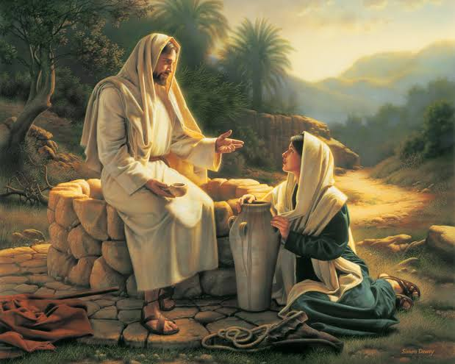

Today’s story is set in Samaria, the central province of Palestine which separated the other two. Jesus is moving from Judaea to Galilee. The Samaritans were not regarded as real Jews and Jesus is presented as the saviour of all the peoples of the world, here represented by the Samaritans, who respond in faith.

3RD WEEK OF LENT: FOCUSING ON STATIONS OF THE CROSS
Mon: Jesus is condemned to death, Jesus takes up his Cross, Jesus falls for the first time.
Tues: Jesus meets his Mother, Simon of Cyrene helps Jesus, Veronica wipes the face of Jesus.
Wed: Jesus falls for the second time, Jesus meets the women of Jerusalem.
Jesus falls for a third time.
Thurs: Jesus is stripped of his clothes, Jesus is nailed to the Cross.
Fri:Jesus dies on the Cross, Jesus is taken down from the Cross, Jesus is laid in the tomb.
Sat: Jesus is raised from the dead.

This weekend’s response to the Responsorial Psalm is:
O that today you would listen to his voice:
‘Harden not your hearts’.
Third Sunday of Lent 8/03/2026
Please pray for Bridie Evans (née O’Connor), Castlemaine; Pat Doherty, Aghadoe; Mark Anthony O’Connor, Killarney & London. May they rest in peace.
Priest on duty this weekend: Fr. Kieran O’Brien 064 6631014/ Mobile 087 6501998 (for emergencies only).
Masses for the coming week

Fri 6th Mar  (First Friday) | 7.00pm  7.30pm | First Friday Stations of the Cross  Michael, Ann & Batt Fleming and all deceased family members R.I.P. Milleen
Sat 7th Mar | 7.30pm | Sean O’Connor (1st Anniversary) R.I.P. Cloonteens
Sun 8th Mar | 11.30am  12.15pm | Michael & Kate Brosnan and their daughter Doreen and her husband Jack O’Connor R.I.P. Tournanough & Scartaglen  Baptism
Tues 10th Mar | 9.30am  10-6pm | People of the Parish  Adoration
Thur 12th Mar | 7.30pm | Stations for the Clashnagarrane Area
Sat 14th Mar | 7.30pm | Peter & Mary Horgan and their daughter Patricia R.I.P. Knockataggle More
Sun 15th Mar | 11.30am | Noranne O’Sullivan R.I.P. Cockhill  Ger Healy R.I.P. Knockancore
Mon 16th Mar  (Eve of St. Patrick’s Day) | 7.30pm | Nora McSweeney R.I.P. Anabla  Mary & John Breen R.I.P. Cockhill  Dan, Julianne & Fr. Pat Courtney R.I.P. Knockataggle
Tues 17thMar | 11.30am | St. Patrick’s Day Mass for all our families at home and abroad

14th & 15th March | Readers | Eucharistic  Ministers | Altar Servers
Vigil  7.30pm | D. Kelly | E. Walsh  P. Healy | A. McSweeney  L. O’Sullivan O’Rourke  C. Ahern
Sun  11.30am | E. Fleming | K. O’Donoghue  N. Fleming  G. Fleming | C. Blake  E. Nagle  T. O’Donoghue

Offertory Collections: €757.00. Míle Buíochas.
Confessions this Saturday evening 7th March after 7.30pm Mass.
Church Collectors Rota for March: Saturdays 7.30pm: P. Walsh &
M. Horan. Sunday 11.30am: K. O’Leary & P. Cahill.
First Saturday Devotions will take place on 7th March in the Church of the Resurrection: Rosary at 9am, followed by Mass at 9.30am.
Multi Area Station Mass for the Clashnagarrane Area takes place in the Parish Church Centre on Thursday 12th March @ 7.30pm. Townlands include Clashnagarrane, Pairc Chuimin, Mountain View, Rathanane, Knockancore, Clydine, Knockataggle, Glebe, Ballinamanagh, Cockhill and Inchicullane.
Comhaltas: Fleadh Cheoil Chiarraí Church Gate Collection takes place this weekend 7th & 8th March. Your support would be greatly appreciated.
First Holy Communion and Confirmation Children & their Parents are warmly invited to take the pilgrim statue of Our Lady into their homes for 3 to 4 days in preparation and celebration of their special day. Further details for delivery/collection, please contact 087 2106281 or 087 9408215.
Special Olympics Sports Club are holding a quiz night to raise funds for our 4 athletes to attend the Special Olympics Summer Games in June. Quiz will take place on Friday, 13th March in Kilcummin GAA Hall. Quiz starts @ 7.30pm, €10 per person, teams of 4. Raffle, Spot Prizes and €100 Cash Prize for Winning Team. For more information, please contact 087 2365664.

Rambling House at Heritage Centre, Scartaglen will take place on Monday 9th March at 8pm. Admission free, refreshments served. All are welcome.
Kilcummin Community Alert would like to thank all those who contributed to their Church Gate Collection last weekend.
Kilcummin Community Games would like to enter this year’s Chess Competition. Please contact Ellen (m) 087 6754160 with your child/children’s Name, Address, DOB by Monday 9th March. Teams of 6 will be entered U11 & U13. The Chess competition is expected to take place on Saturday 28th March in Listowel. Kilcummin Community Games Art/Handwriting competitions for ages U8 to U16 will take place on Thursday 19th March in Kilcummin N.S. from 5.30pm to 7.30pm. Please note your child/children must reside in Kilcummin Parish. All updates and more information on our events will be on our Facebook page.
Raised Beds: Kilcummin Looking Good is delighted to offer raised planting beds to individuals, families or groups in our community who would like to grow their own flowers, herbs or vegetables. These beds provide a fantastic opportunity to connect with nature, enjoy some fresh air, and contribute to the beauty of our village. Whether you’re a seasoned gardener or just starting out, we welcome you to take part in this community initiative. By adopting a bed, you can grow your own fresh produce or flowers. Enjoy a rewarding outdoor activity. Meet like-minded people and build community spirit. Help make Kilcummin an even greener and more beautiful place. Interested? To find out more or to reserve a bed, contact Kilcummin Rural Development Office on 064 6643357 (Office Hrs.)
Castleisland Blood Donation Clinic will take place in Castleisland Community Centre on Wednesday 11th & Thursday 12th March 4:50pm - 8:10pm. Phone 1800 222 111 for appointment. New Donors welcome at all clinics. Former UK residents now welcome to donate.
Comfort for Chemo: Huge thanks to everyone who supported “Pink Night” and the “Dermot Moynihan” Memorial Cards Night. The amount raised from both events was €8,615, which will be spent locally.

Dear God,
During the sacred season of Lent,
bring me closer to you.

Prepare a place in my home and
heart for silence and solitude,
so that I may re-discover the grace
of a prayer-full life.

Enlarge my heart so that I give to
those in need and, in doing so
re-discover the grace of
gratitude and generosity.

Help me fast from those things
That threaten the well-being of body
and soul, and remind me of the
grace and simplicity.

May this season be a grace-filled
time to rekindle my
Love for and Faith in You.
Amen.



