Kilcummin Parish Newsletter
Fr. Kieran O’Brien, Fr. Joe Begley,
Fr. Jim Lenihan, Fr. Padraig Kennelly,
Fr. Vitalis Barasa. Fr. Noel Spring,
For a priest in an emergency at any time call
064 6631014 / mobile 087 6501998
www.kilcumminparish.com. Eircode V93 K22T
Email: kilcummin@dioceseofkerry.ie
Priest on duty this weekend:
Killarney 064 6631014 Mobile 087 6501998

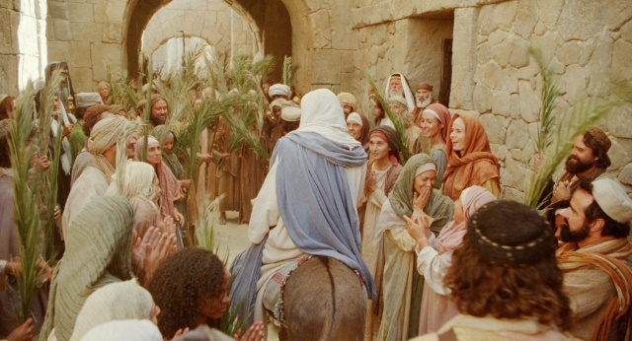

Today’s Mass is dominated by reading of the Passion that is the gospel narrative of the Lord’s capture suffering and death. The passion, death and resurrection of the Lord are a constant reminder that if we wish to share in the glory of the risen Saviour, we must first work to resemble him in humility, meekness and self-denial.

5TH WEEK OF LENT: Family
Mon: We pray for the gift of Family.
Tues: We pray for our own role in the family.
Wed: We pray for legislators that they protect the family.
Thurs: We pray for healing of the broken families.
Fri: We pray for families who are carrying the burden of illness.
Sat: We pray for all emigrant families who have come amoung us.

This weekend’s response to the Responsorial Psalm is:
My God, my God, why have you forsaken me?
Palm Sunday 29/03/2026
Please pray for Mary O’Sullivan (née Nagle) Ardgroom and Killorglin; Mary (Mim) P. Connor (née Corcoran) New Hampshire and late of Milleen. May they rest in peace.
Priest on duty this weekend: Killarney 064 31014/ Mobile 087 6501998(for emergencies only).
Masses for the coming week

Fri 27th Mar | 11.00am | Confirmation Mass
Sat 28th Mar | 7.30pm | Mary & Paddy Fleming R.I.P. their daughter Bridey & her husband Con, Scartaglen  Christy, Nancy & Con O’Leary and deceased family members R.I.P. Dooneen
Sun 29th Mar  Palm Sunday | 11.30am | Patrick & Joan Lynch R.I.P. Inchicullane  Donal & Maud O’Sullivan R.I.P. Inchicullane
Tues 31st Mar | 10-6pm | No Mass Today  Adoration  Chrism Mass in the Cathedral @ 7pm
Thur 2nd Apr  Holy Thursday | 7.30pm | Mass of the Lord’s Supper  Adoration until 11pm  New and continuing Eucharistic ministers will renew their ministry during this Mass
Fri 3rd Apr  Good Friday | 3.00pm | Celebration of the Lord’s Passion
Sat 4th Apr  Easter Vigil | 6.00pm | Holy Saturday Night (Private intention).  Please note change of time
Sun 5th Apr  Easter Sunday | 11.30am | Fr. John Lucid R.I.P. Our former Parish priest of Kilcummin  John Breda & Denny O’Connor and deceased family members R.I.P. Glounonea

4th & 5th April | Readers | Eucharistic  Ministers | Altar Servers
Vigil  7.30pm | M. Healy | B. Lenihan  G. Pigott | A.M. & M. O’Sullivan  A. McSweeney  L.O ’Sullivan O’Rourke  C. Ahern
Sun  11.30am | T. Counihan | K. Fitzgerald  G. Fitzgerald | C. Blake E. Nagle  T.O’ Donoghue

Offertory Collections: €1,495.00. Míle Buíochas.
Easter Offering envelopes (Easter Dues) are available in your yearly boxes and also available in the Church porches. Second Collection on Easter weekend after Holy Communion is part of the Priests salary. Your generosity is very much appreciated.
Confessions this weekend both Saturday and Sunday, after masses.
Blessed Palms available in the Church porch this weekend.
Congratulations: We warmly congratulate the children of our Parish who will receive the sacrament of Confirmation this Friday. May the Holy Spirit guide and bless you always, wishing you and your families a joyful and special day, you are remembered in our prayers.

Holy Week Ceremonies
Tuesday 31st March: Chrism Mass in the Cathedral @ 7pm.
Holy Thursday 2nd April: Evening Mass of the Lord’s Supper @ 7.30pm.
Good Friday 3rd April: Celebration of the Lord’s Passion @ 3.00pm.
Holy Saturday 4th April: Easter Vigil Mass @6pm.
Easter Sunday 5th April: Mass @ 11.30am

Word Of Thanks: During the past few weeks, I have been humbled by the support if so many people. Illness can be life changing and your thoughtfulness is much appreciated. Míle Buíochas for your Prayers, Kindness and Good Wishes. May God Bless us, as we begin our Holy Week of Ceremonies. Fr Joe Begley.
Communal First Saturday, 4th April: Please note special arrangement.
As the Communal First Saturday coincides with Holy Saturday, permission for a special arrangement has been made with our parish priest in order that we can fulfil our First Saturday. Those who would like to fulfil the CFS in reparation to the Immaculate Heart of Mary, the Rosary and Scripture Meditation will take place in St. Bridget’s chapel in the Church of the Resurrection at 9.30am on the 4th April. Communion of Reparation can be received at the Saturday evening Vigil Mass or on Easter Sunday. Confession will be available in accordance with the parish plan for Easter.
The Chrism Mass will take place on Tuesday evening, 31st March at 7.00pm.There will be refreshments after the Mass in St. Brendan’s College refectory. Everyone is welcome.
The 21st Kilcummin Hospice Walk takes place Good Friday, April 3rd.
Starting from the Recreation Hall at 10.00am, there is a choice of two routes, 4km or 8km. Donations will be accepted on the day and all money raised will be donated to Kerry Hospice Foundation. Refreshments will be provided and free Easter Egg draw in the hall after the walk. Your support would be greatly appreciated.
Kilcummin Rural Development will be holding their A.G.M. on Tuesday, 7th April @ 8pm in the Rural Development Office. New members welcome.
Sliabh Luachra Workshop takes place in Kilcummin Recreational Hall on Saturday, 28th March. Workshop @ 3pm, all instruments and all levels welcome, with Paudie O’Connor & Aoife Ní Chaoimh. Free of Charge. Tutors Recital at 4.20pm; Sliabh Luachra session at 4.45pm. All welcome.
Summer time: Don’t forget that clocks go forward one hour this weekend.

Palm Sunday

On this day of great rejoicing,
Lord Jesus Christ, when we welcome
You as our King and Saviour,
we also walk in the shadow of Your cross.
Hosanna! We cry.
Blessed are You who come
in God’s name to save us.
Hosanna!
Strengthen our faith on this Palm Sunday
so that when the time comes
to carry the cross we might still
call out to You with heartfelt praise.
Give us the grace and the courage
To follow you this Holy Week
from death to resurrection,
from darkness to the fullness of light.
We need you,
Lord Jesus Christ our Saviour
Hosanna!



