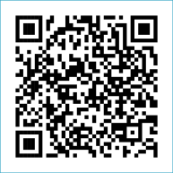
Scan to Donate

ST MARY’S PARISH NEWSLETTER - TARBERT
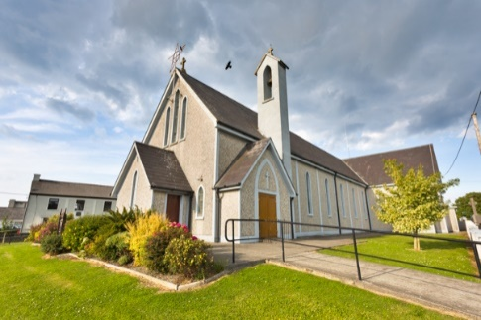
Parish Office Opening Hours:
Mon. 10.30am -2.30pm. Wed. 10.30am-2.30pm Priests :
Phone ; 068-36111. Fr. Sean Hanafin 087-8341083

Email: tarbert@dioceseofkerry.ie Fr. John Buckley 087-2409624
Notices for Parish Newsletter have to be in on Safeguarding Children: 087-6362780 Wednesday by 12 Noon. Defib. Emergency No. 999 or 112
Webpage: www.stmarystarbert.com (Outside Surgery Hours)

Sixth Sunday in Ordinary Time
15th February 2026
Day of Prayer for Temperance

R.I.P. Stan Foley,Tieraclea House.
Day/Date | Time | Intention
Saturday 14th | 6pm | Ita Gormley, Tieraclea Park.  Joe, Mary and Helen Mackessy, Tarmons.
Sunday 15th | 11.30am | John Lavery, Toronto / Ivy House.  Amos, Winnie and John Murray, Chapel St.
Monday 16th | ______ | No Mass.
Tuesday 17th | ______ | No Mass.
Wednesday 18th  ^{Ash Wednesday} | 7pm | Mass in Tarbert.  Blessing and Distribution of Ashes.  Day of Fast and Abstinence.
Thursday 19th | 10am | Mass in Asdee.
Friday 20th | 7pm | Mass in Ballylongford.
Saturday 21st | 6pm | Thomas Mulvihill, Woodview Place.  Eoin Fitzgerald, Barragougeen.  Jerry Scanlon, Tieraclea and  Maurice and Nora O’ Connor, Lenamore.
Sunday 22nd | 11.30am | Bríd O’ Connor Tarbert Island and  Donal O’ Connor, Tarbert Island. ( Months Mind )  Noreen ( Dolly ) O’ Hanlon, Dooncaha.
PRIEST ON DUTY THIS WEEKEND: Fr. Brendan Walsh 087-7913271 / 068-49308.
PARISH OFFERTORY COLLECTION Sunday 8th February - € 1,385 Diocesan Collection - € 432
Online Banking - € 510 Míle Buíochas.
LIVE SERVICES – All Masses are now being live streamed from our Church. Just go to the Church website – www.stmarystarbert.com and you can watch on your phone, tablet, computer or smart T.V. When you log in and see the picture of the Altar, just underneath this, click on the mute button and you will then have the audio as well.
All our Masses at St. Mary’s Church, Tarbert, can be viewed online at www.stmarystarbert.com
Prayer

Lord God,
whose days are without end
and whose mercies beyond counting,
keep us mindful
that life is short and the hour of death unknown.
Let your Spirit guide our days on earth
in the ways of holiness and justice,
that we may serve you
in union with the whole Church,
sure in faith, strong in hope, perfect in love.
And when our earthly journey is ended,
lead us rejoicing into your kingdom,
where you live for ever and ever. Amen.

TARBERT ACTIVE RETIREMENT – (over 55’s) meet in Tarbert Bridewell every Friday between 10.30am and 12 Noon. We have different activities every week followed by refreshments. New Members are welcome.

THE MOTHER AND BABY INSTITUTIONS PAYMENT SCHEME - is open for applications. It was launched in March 2024 following the Government agreed actions arising from the Commission of Investigation into Mother and Baby homes and certain related matters. See details on diocesan webpage.

IRISH CITIZENS - with degrees from designated 3rd level colleges are eligible to vote in the 'Higher Education' constituency which replaces the NUI and Trinity panels in Seanad Éireann. Thousands of previous voters are unaware that they have been removed from the register. To secure your vote, go to www.seanadvoter.ie before February 26th. Evidence of a passport is needed or else email applications@seanadvoter.ie

EPILEPSY IRELAND - over 45,000 people live in Ireland with epilepsy. Purple Day (or Epilepsy Awareness Day) will take place on Thursday 26th March. For further information, please visit www.epilepsy.ie
OUTREACH CLINIC IN LISTOWEL – on Thursday 19th February from 12 Noon to 3pm at the Listowel Family Resource Centre, John B Keane Rd. V31 EC62. This is a free and confidential support service on all aspects of deafness and hearing loss. Information and resources, assistive technologies, minor hearing aid repairs, and hearing aid batteries for sale for €3 a card. Call or text Lorraine on 086-0105200 to make an appointment.
THANK YOU - for your continuing support and financial donations that underpin the smooth running of St. Mary’s Parish Church. Please continue to donate what you can on a weekly basis at any of our Masses on Wednesday, Saturday or Sunday. Donations can also be made by bank transfer – our bank details are as follows :

IBAN No- IE76 AIBK 9354 3380 3050 83, Account Name – Tarbert Church Account,
Bank - AIB, The Square, Listowel, Co. Kerry.

