Local Priest: Fr. Jim Lenihan, P.P.
Parish Office: St. Agatha's Parish Centre, Headford, Killarney. V93 X0C2.
Office Hours : Mon/Tues 10am to 3pm to book Masses, Baptisms, Weddings.
Email: glenflesk@dioceseofkerry.ie Phone: 064 7754008 Mobile: 087 108 1588.
GBC Radio: 98.6fm for all Masses from Glenflesk Church.
Masses: Saturday 14th to Sunday 22nd February
St. Agatha's, Glenflesk:
Saturday 14th 6.00pm Sarah O'Donoghue, Barraduff & Gortacoosh
(1st Anni)
Wednesday 18th 9.30am ASH WEDNESDAY
Saturday 21st 6.00pm Mass
Our Lady of the Wayside, Clonkeen:
Sunday 15th 9.30am Michael O'Donoghue, Killeen, Clonkeen (Anni)
Sunday 22nd 9.30am Michael McSweeney, Coomacullen (1st Anni)
Sacred Heart, Barraduff:
Sunday 15th 11.00am Mary McCarthy, Rathmore (Anni)
Wednesday 18th 7.30pm ASH WEDNESDAY
Friday 20th 7.00pm Patrick O'Connell, Barraduff, London &
Blackwater, his parents Patrick & Ellen,
his brother Donal & sister-in-law Tess.
Sunday 22nd 11.00am Thomas Daly, Kilquane (Anni) & deceased of
the Daly family.
Eileen Daly (née Cahalane), Skibbereen &
Union Hall, Cork & Knockysheehane, Headford.
PRIEST ON DUTY THIS WEEKEND: Fr. Joe Begley 087 6501998
PRIEST ON DUTY WEEKDAYS: Monday Fr. Kieran O'Brien 087 6501998
Tuesday to Friday Fr. Jim Lenihan 087 1081588
NOTICES:
ADORATION: Every Monday in the Sacred Heart Church from 10 am to 1 p.m.
St. Agathas 2 p.m. to 5 p.m. and Our Lady of the Wayside 7 p.m. to 8 p.m.
KERRY DIOCESAN PILGRIMAGE TO FATIMA: 11th May 2026 for 6 nights from Shannon. Led by Fr. Noel Spring. For more details contact Barter's Travelnet on 021 485 1700 or email kcallaghan@travelnet.ie
KERRY DIOCESAN PILGRIMAGE TO LOURDES: 10th to 15th June, 2026. For more details see Church Notice Boards or contact Nora 087 931 8976 or email pilgrimage@dioceseofkerry.ie
EPILEPSY AWARENESS: "In Ireland today, over 45,000 people live with epilepsy. For further information, please visit www.epilepsy.ie. Purple Day (or Epilepsy Awareness Day) will take place on Thursday 26th March."
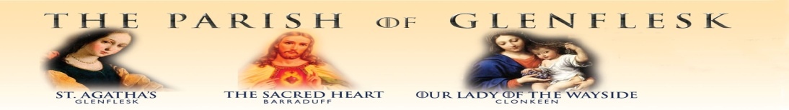
THE MOTHER AND BABY INSTITUTIONS PAYMENT SCHEME: is open for applications. It was launched in March 2024 following the Government agreed actions arising from the Commission of Investigation into Mother and Baby homes and certain related matters. See details on diocesan webpage.
KILLARNEY FOR PALESTINE: presents the only Kerry screening of the Oscar-nominated film. The Voice of Hind Rajab, the true story of a 5-year-old girl in Gaza. Join us at the Brehon Hotel on Sun., Feb 22nd at 6.30pm for this free community event. Tickets must be booked in advance - no admission/booking fee.
THE KILLARNEY/SOUTH KERRY BRANCH OF THE IRISH CANCER SOCIETY are holding their Annual Coffee Morning on Friday 20th February in The Killarney Towers Hotel from 10.30am-12.00pm. Guest speaker and raffle prizes on the day.
A NOTE FROM FR. JIM.........
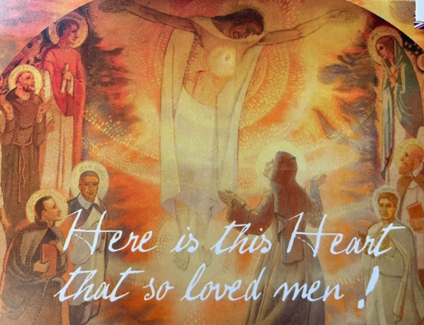
During the week, I had the privilege of travelling with twenty-five priests from different parts of Ireland to the shrine of the Sacred Heart of Jesus in the French town of Paray-le-Monial. It was here that Saint Margaret Mary Alacoque, a young Visitation nun, received many visions of Jesus, in which He revealed to her the intimate and burning love He has for her and for all humanity. The image of the Sacred Heart has always been very dear to me. As a child growing up at home, we used to call the Sacred Heart picture simply “Holy God.” I remember being slightly scared of Jesus, especially because His eyes seemed to follow me no matter where I stood in the room. At the time, I felt He was looking at me in a critical way. With time, prayer, study, and faith, I have come to understand something much deeper: Jesus never takes His eyes off us because He loves us. His gaze is not one of judgment, but of mercy, tenderness, and compassion. It has been a great privilege to make a retreat in this beautiful place. As priests, we have spent time meditating on the Heart of Jesus, which is truly the Heart of God—a heart on fire with love for humanity, and with love for you personally. As the Parish of Glenflesk, we are honoured to have one of our churches named after this beautiful devotion in Barradubh. As a people, may we come close to the Heart of God in Jesus and meditate on this revealed image: a Heart burning with love and mercy. Jesus said to Saint Margaret Mary, “Behold this Heart which has loved humanity so much….. and is so little loved in return.” May we take time this week to reflect on the unfathomable love of Jesus and ask ourselves how we are responding to that love. May we show our appreciation of His mercy by extending it to others—especially to those who may have wounded us in any way.

