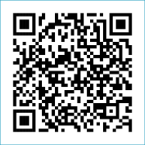
Scan to Donate

ST MARY’S PARISH NEWSLETTER - TARBERT

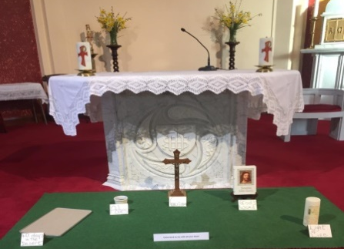
Parish Office Opening Hours:
Mon. 10.30am -2.30pm. Wed. 10.30am-2.30pm Priests :
Phone ; 068-36111. Fr. Sean Hanafin 087-8341083

Email: tarbert@dioceseofkerry.ie Fr. John Buckley 087-2409624
Notices for Parish Newsletter have to be in on Safeguarding Children: 087-6362780 Wednesday by 12 Noon. Defib. Emergency No. 999 or 112
Webpage: www.stmarystarbert.com (Outside Surgery Hours)

First Sundy of Lent
22nd February 2026
R.I.P. John Carrig, Doonard Upper.
Day/Date | Time | Intention
Saturday 21st | 6pm | Thomas Mulvihill, Woodview Place.  Eoin Fitzgerald, Barragougeen. ( 1st Anniversary )  Jerry Scanlon, Tieraclea and  Maurice and Nora O’ Connor, Lenamore.
Sunday 22nd | 11.30am | Donal O’ Connor, Tarbert Island. ( Months Mind ) and  Bríd O’ Connor, Tarbert Island.  Noreen ( Dolly ) O’ Hanlon, Dooncaha.
Monday 23rd | ______ | No Mass.
Tuesday 24th | ______ | No Mass.
Wednesday 25th | 7pm | Mass in Tarbert.
Thursday 26th | 10am | Mass in Asdee.
Friday 27th | 7pm | Mass in Ballylongford.
Saturday 28th | 6pm | Kitty Kissane, Tarmons West. ( Months Mind )  Johanna Fitzgerald and Deceased Family, Tieraclea.  William and Mary Cullinane and  Deceased Family Members, Listowel.
Sunday 1st | 11.30am | Jackie and Nuala Egan and Deceased Family Members,  Tarmons East.
PRIEST ON DUTY THIS WEEKEND: Fr. Jerry Keane 087-2844649 / 066-4018996.
PARISH OFFERTORY COLLECTION Sunday 15th February - € 673 Míle Buíochas.
LENT – has arrived now – What are we doing for Lent ?
LIVE SERVICES – All Masses are now being live streamed from our Church. Just go to the Church website – www.stmarystarbert.com and you can watch on your phone, tablet, computer or smart T.V. When you log in and see the picture of the Altar, just underneath this, click on the mute button and you will then have the audio as well.
All our Masses at St. Mary’s Church, Tarbert,
can be viewed online at www.stmarystarbert.com
Prayer for Lent

Bless me heavenly Father
forgive my erring ways.
Grant me the strength to serve Thee
put purpose in my days.
Give me understanding
enough to make me kind.
So I may judge all people
with my heart and not my mind.

Teach me to be patient
in everything I do.
Content to trust your wisdom
and to follow after You.
Help me when I falter
and hear me when I pray
and receive me in Thy kingdom
to dwell with Thee someday.
Reflection
Fasting is the soul of prayer,
mercy is the lifeblood of fasting.
So if you pray, fast ; if you fast, show mercy,
if you want your petition to be heard,
hear the petition of others.
If you do not close your ear to others,
you open God’s ear to yourself. St. Peter Chrysologus.

TARBERT ACTIVE RETIREMENT – (over 55’s) meet in Tarbert Bridewell every Friday between 10.30am and 12 Noon. We have different activities every week followed by refreshments. New Members are welcome.

ANNUAL NATIONAL APOSTOLATE OF EUCHARISTIC ADORATION PILGRIMAGE TO KNOCK – is on Sunday 19th April. A coach will be travelling from Killarney, going by Farranfore, Castleisland and Abbeyfeale. For further details you can contact - Breeda on 087-6742306 or Margaret on 087-2976304.

THE MOTHER AND BABY INSTITUTIONS PAYMENT SCHEME - is open for applications. It was launched in March 2024 following the Government agreed actions arising from the Commission of Investigation into Mother and Baby homes and certain related matters. See details on diocesan webpage.

IRISH CITIZENS - with degrees from designated 3rd level colleges are eligible to vote in the 'Higher Education' constituency which replaces the NUI and Trinity panels in Seanad Éireann. Thousands of previous voters are unaware that they have been removed from the register. To secure your vote, go to www.seanadvoter.ie before February 26th. Evidence of a passport is needed or else email applications@seanadvoter.ie

EPILEPSY IRELAND - over 45,000 people live in Ireland with epilepsy. Purple Day (or Epilepsy Awareness Day) will take place on Thursday 26th March. For further information, please visit www.epilepsy.ie

THANK YOU - for your continuing support and financial donations that underpin the smooth running of St. Mary’s Parish Church. Please continue to donate what you can on a weekly basis at any of our Masses on Wednesday, Saturday or Sunday. Donations can also be made by bank transfer – our bank details are as follows :

IBAN No- IE76 AIBK 9354 3380 3050 83, Account Name – Tarbert Church Account,
Bank - AIB, The Square, Listowel, Co. Kerry.

