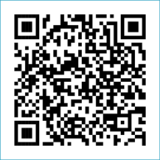
Scan to Donate

ST MARY’S PARISH NEWSLETTER - TARBERT
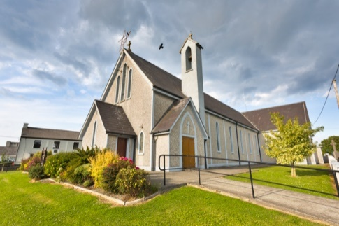
Parish Office Opening Hours:
Mon. 10.30am -2.30pm. Wed. 10.30am-2.30pm Priests :
Phone ; 068-36111. Fr. Sean Hanafin 087-8341083

Email: tarbert@dioceseofkerry.ie Fr. John Buckley 087-2409624
Notices for Parish Newsletter have to be in on Safeguarding Children: 087-6362780 Wednesday by 12 Noon. Defib. Emergency No. 999 or 112
Webpage: www.stmarystarbert.com (Outside Surgery Hours)

Third Sunday in Ordinary Time
25th January 2026
Sunday of the Word of God
R.I.P. Donal O’ Connor, Tarbert Island.
Day/Date | Time | Intention
Saturday 24th | 11am  6pm | Funeral Mass for Donal O’ Connor, Tarbert Island.  Billy and Tessie Holly, Tarmons Hill.
Sunday 25th | 11.30am | Eileen Holly, Woodlands.
Monday 26th | ______ | No Mass.
Tuesday 27th | ______ | No Mass.
Wednesday 28th | 7pm | Mass in Tarbert.  People of the Parish.
Thursday 29th | 10am | Mass in Asdee.
Friday 30th | 7pm | Mass in Ballylongford.
Saturday 31st | 6pm | Jim Finucane, Tralee & Deceased Tarbert F.G. Members.  John Carrig, St. Patrick’s Tce.
Sunday 1st | 11.30am | Breda O’ Neill, Kilpadogue. ( Months Mind )  Danny Enright, Doonard Upper.
PRIEST ON DUTY THIS WEEKEND: Fr. John Buckley 087-2409624 / 068-43110.
PARISH OFFERTORY COLLECTION Sunday 18th January - € 744 Diocesan Collection - € 269 Míle Buíochas.
FIRST HOLY COMMUNION FAMILY MASS – will take place on this Sunday 25th Jan.
LIVE SERVICES – All Masses are now being live streamed from our Church. Just go to the Church website – www.stmarystarbert.com and you can watch on your phone, tablet, computer or smart T.V. When you log in and see the picture of the Altar, just underneath this, click on the mute button and you will then have the audio as well.

All our Masses at St. Mary’s Church, Tarbert, can be viewed online at www.stmarystarbert.com
Healing The Wounds Of The Heart

All of us are wounded by sin.
The part of us which is most deeply damaged by sin is the heart.
The heart is so beautiful, so innocent,
but it can be betrayed, scorned and broken.
Darkness of the heart is the blackest night of all.
Emptiness of the heart is the greatest poverty of all.
A heavy heart is the most wearisome burden of all.
A broken heart is the most painful wound of all.
Only love can heal the wounds of the heart.
Lord, send your Holy Spirit to us,
to heal the wounds of the heart,
so that we may produce the fruits of love.

CHURCH ENVELOPES - All the boxes of Church envelopes have now been delivered around the Parish, if there is anyone who did not get a box and would like to have one, you may call the Parish Office on 068-36111 during office hours and James will arrange to have one delivered to you.
DIOCESAN MISSION 2026 - The diocesan mission, Peace be with you all, will take place from Sunday Feb 8th – Wednesday Feb 11th. Each day, you are invited to join in the Mission Talk, Prayer, Mass, Video Reflection, Prayer Petition and Family Time. Speakers include Sr. Finola Cunnane, Jim Deeds, Dr. John Lannon and Gemma Mulligan. To participate in the Mission, register through the diocesan website, www.dioceseofkerry.ie

TARBERT ACTIVE RETIREMENT – (over 55’s) meet in Tarbert Bridewell every Friday between 10.30am and 12 Noon. We have different activities every week followed by refreshments. New Members are welcome.
NORTH KERRY COMMUNITY CHOIR – meet every Tuesday from 11.30am to 12.30pm St Patrick’s Hall, Upper William St,Listowel. New members are very welcome. €50 per 5 week term. Contact Mary on 087-9222753 to book your place.
QUESTIONS - about God and Jesus, or about the Synodal reform of the Church. Why not consider studying some theology - join us online at 6pm on Tuesday 10th February for an information session and to hear from some of our students. See our website to register https://www.tcd.ie/loyola-institute/ or email loyola@tcd.ie
LISTOWEL DANCE CLASSES – have started last Monday 19th January at the Plaza Hall, Listowel from 7.30pm to 9pm. Waltzing, jiving, quick steps, foxtrots, line dancing etc. For more information, please contact 087-7541631.

THANK YOU - for your continuing support and financial donations that underpin the smooth running of St. Mary’s Parish Church. Please continue to donate what you can on a weekly basis at any of our Masses on Wednesday, Saturday or Sunday. Donations can also be made by bank transfer – our bank details are as follows :

IBAN No- IE76 AIBK 9354 3380 3050 83, Account Name – Tarbert Church Account,
Bank - AIB, The Square, Listowel, Co. Kerry.

