
Scan to Donate

ST MARY’S PARISH NEWSLETTER - TARBERT
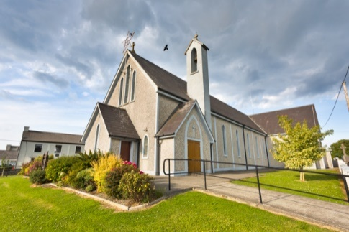
Parish Office Opening Hours:
Mon. 10.30am -2.30pm. Wed. 10.30am-2.30pm Priests :
Phone ; 068-36111. Fr. Sean Hanafin 087-8341083

Email: tarbert@dioceseofkerry.ie Fr. John Buckley 087-2409624
Notices for Parish Newsletter have to be in on Safeguarding Children: 087-6362780 Wednesday by 12 Noon. Defib. Emergency No. 999 or 112
Webpage: www.stmarystarbert.com (Outside Surgery Hours)

Second Sunday in Ordinary Time
18th January 2026

R.I.P. Tess (Teresa) Geary ( née Cussen ), Kilmeedy.
Day/Date | Time | Intention
Saturday 17th | 6pm | Jackie Henchey, Kilpadogue. ( 1st Anniversary )
Sunday 18th | 11.30am | Deceased O’ Brien, Conway and Carmody Families,  Shanaway.
Monday 19th | ______ | No Mass.
Tuesday 20th | ______ | No Mass.
Wednesday 21st | 7pm | Mass in Tarbert.  Private Intention.
Thursday 22nd | 10am | Mass in Asdee.
Friday 23rd | 7pm | Mass in Ballylongford.
Saturday 24th | 6pm | Billy and Tessie Holly, Tarmons Hill.
Sunday 25th | 11.30am | Eileen Holly, Woodlands.
PRIEST ON DUTY THIS WEEKEND: Fr. Seán Hanafin 087-8341083 / 068-27102.
PARISH OFFERTORY COLLECTION Sunday 11th January - € 1,263 Crib Donation - € 205 Míle Buíochas.
DIOCESAN COLLECTION - for the Needs of the Holy Land will be held this weekend Sat. 17th / Sun. 18th January.
LIVE SERVICES – All Masses are now being live streamed from our Church. Just go to the Church website – www.stmarystarbert.com and you can watch on your phone, tablet, computer or smart T.V. When you log in and see the picture of the Altar, just underneath this, click on the mute button and you will then have the audio as well.
All our Masses at St. Mary’s Church, Tarbert,
can be viewed online at www.stmarystarbert.com
Prayer for Families

Jesus, Lord and Saviour, you have shown us your love
in your care for all, especially those in need.
We ask you to show this love for our family,
those sick and well, at home and away.
May we live in your heart, young and old in our family,
as we make your home in the heart of each of us.
Make strong our faith in you and in each other.
Enliven our hope and make us joyful in love.
Protect us all and welcome home
those who have gone before us.
We pray this, in gratitude for our family life,
and with the prayers of Mary, our Mother. AMEN.

CHURCH ENVELOPES - All the boxes of Church envelopes have now been delivered around the Parish, if there is anyone who did not get a box and would like to have one, you may call the Parish Office on 068-36111 during office hours and James will arrange to have one delivered to you.
TARBERT ACTIVE RETIREMENT – (over 55’s) meet in Tarbert Bridewell every Friday between 10.30am and 12 Noon. We have different activities every week followed by refreshments. New Members are welcome.
NORTH KERRY COMMUNITY CHOIR – meet every Tuesday from 11.30am to 12.30pm St Patrick’s Hall, Upper William St,Listowel. New members are very welcome. €50 per 5 week term. Contact Mary on 087-9222753 to book your place.
QUESTIONS - about God and Jesus, or about the Synodal reform of the Church. Why not consider studying some theology - join us online at 6pm on Tuesday 10th February for an information session and to hear from some of our students. See our website to register https://www.tcd.ie/loyola-institute/ or email loyola@tcd.ie
LISTOWEL DANCE CLASSES – are starting on Monday 19th January at the Plaza Hall, Listowel from 7.30pm to 9pm. Waltzing, jiving, quick steps, foxtrots, line dancing etc. For more information, please contact 087-7541631.

THANK YOU - for your continuing support and financial donations that underpin the smooth running of St. Mary’s Parish Church. Please continue to donate what you can on a weekly basis at any of our Masses on Wednesday, Saturday or Sunday. Donations can also be made by bank transfer – our bank details are as follows :

IBAN No- IE76 AIBK 9354 3380 3050 83, Account Name – Tarbert Church Account,
Bank - AIB, The Square, Listowel, Co. Kerry.

