Kilcummin Parish Newsletter
Fr. Kieran O’Brien, Fr. Joe Begley,
Fr. Jim Lenihan, Fr. Padraig Kennelly,
Fr. Vitalis Barasa. Fr. Noel Spring,
For a priest in an emergency at any time call
064 6631014 / mobile 087 6501998
www.kilcumminparish.com. Eircode V93 K22T
Email: kilcummin@dioceseofkerry.ie
Priest on duty this weekend:
Fossa 064 6631996 Mobile 087 2935969

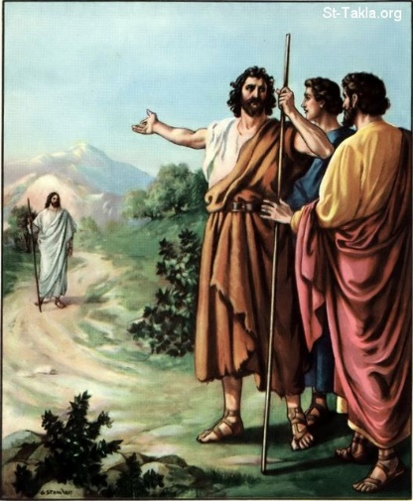

Jesus is the Chosen One of God. John the Baptist has no exaggerated ideas about his own role, he knows he is called to make Jesus known, John prepares the people for the One who will take away their sins.

This weekend’s response to the Responsorial Psalm is:
Here I am, Lord!
I come to do your will.
2nd Sunday in Ordinary Time 18/01/2026
Please pray for Breda Moynihan (née 0’Connor), Minish Gates & Woodlawn. May she rest in peace.
Priest on duty this weekend: Noel Spring 064 6631996/ Mobile 087 2935969 (for emergencies only).
Masses for the coming week

Sat 17th Jan | 7.30pm | Batt & Nora McGlynn and their daughter Sheila R.I.P. Milleen  Johnny Kenny and his niece Eileen Herlihy and deceased family members R.I.P. Glounonea
Sun 18th Jan | 11.30am  12.15pm | John Joe Lyne and Bill Falvey R.I.P. Knocklebede  Baptism
Tues 20th Jan | 9.30am  10-6pm | People of the Parish  Adoration
Thu 22nd Jan | 7.30pm | All deceased members of the McGillicuddy family R.I.P. Anablaha
Sat 24th Jan | 7.30pm | Thomas & Margaret Groves and deceased family members R.I.P. Glebe  Jerome O’Connor R.I.P. Cloonteens
Sun 25th Jan | 11.30am | Donie O’Sullivan R.I.P. Dooneen  Kathleen O’Sullivan (née O’Leary) R.I.P. Inch & Celbridge

24th & 25th  January | Readers | Eucharistic  Ministers | Altar Servers
Vigil  7.30pm | B. Fleming | M. O’Sullivan  B. O’Sullivan | E. O’Mahony A. Sheahan  E.R. Lyne
Sun  11.30am | M.B. O’Driscoll | B. McSweeney  J. Moriarty | E. O’Riordan  S. O’Callaghan C. O’Riordan

Offertory Collections: €1,605.00. Míle Buíochas.
Second Collection on this weekend in aid of Needs of the Holy Land. This collection provides assistance to those in need in the Holy Land and helps fund 36 Dispensaries, 21 Charitable Institutes, 120 Centres of Education and also housing projects for the deprived.
A Day of Healing through the Eucharist and Word will be held at Our Lady of Lourdes Church, Scartaglen on next Sunday, Jan. 18th starting at 2.30 pm. Deacon Thady O’Connor and Jannice Carrig warmly invite you to join them for this special day accompanied by an anointed music ministry by Paddy Sheehan, Pat Buck, Richard Curran, Pat Power and others. This is accompanied by individual blessings at your request. We look forward to meeting you there.
Parish Office: Open Tues, Wed & Fri 10.00am – 12 noon. Please contact: 064 6643176 / Mobile: 087 1339732, e-mail kilcummin@dioceseofkerry.ie
Kilcummin Comhaltas are delighted to announce that we will be holding Comhrá Gaeilge classes for 4 weeks in Kilcummin National School from 4.30pm to 5.15pm on Thursday’s (22nd Jan, 29th Jan, 5th Feb, 12th Feb). These classes are aimed at Primary School children who wish to improve their oral Irish skills and conversational Irish. €5 per child per class and a concession rate is available for siblings. For more information please contact 087 0938946 or 087 6764368.
Samaritans Ireland: Your very generous support of our Annual Christmas Church Gate collection is deeply appreciated. Mile Buíochas to all. Samaritans Freephone No. is 116 123.
Kilcummin Men’s Shed continues at Mastergeeha F.C. Kilcummin, Killarney V93 T276 every Friday from 10am-12pm, aligns with the Gneeveguilla-Killarney TFI R 57 bus schedule. Please contact 0872422299 or www.kilcumminmensshed.ie kilcumminmensshed@gmail.com
Junior Set Dancing: Junior Set Dancing will commence on Friday 23rd January from 7 to 8pm for beginners and intermediates and 8 to 9pm for advanced. These classes are also open to children from outside Kilcummin parish. For further information, contact Mary on 087 9620135.
Kilcummin Community Games: Anyone interested in Community Games and would like to know more, please go to Kilcummin Community Games Facebook page where all upcoming events & activities will be posted. Please note you must reside in Kilcummin parish to participate.
31 Card Drive: Memorial Tournament will be held in the Klub Bar in memory of Dermot “Brady” Moynihan on Sunday 1st of February @4pm. (31 card partners). Trophies for winners and lots of spot prizes. All proceeds donated to the Comfort for Chemo.
Kilcummin Community Care meet every Tuesday from 11am to 2pm in the G.A.A. hall. Hot dinner provided, free transport available. Anybody interested please contact Mary Doyle on 086 1550803.
Kilcummin GAA: Ireland Lights Up & Irish Life GAA Healthy Clubs Steps Challenge is back for 2026. Members of the public are welcome to join us at the Kilcummin GAA Walking Track each Wednesday night between 7.30-8.30pm to walk safely with the flood lights on. You don't have to be a member of the club to take part. All welcome. Please note - On health and safety grounds, only therapy or assistance dogs are permitted on the walking track and GAA grounds. Ireland Lights Up lasts for 5 weeks and ends on the 11th February.
Newsletters: You might like to take a newsletter for someone you know who is housebound or it can be viewed online at www.kilcumminparish.com and on Facebook @ Kilcummin Rural Dev.
ST VINCENT DE PAUL: svdpkillarney@eircom.net or 06466 22668.
Mabs Advice & Budgeting Service: Mabs helpline is 0818 072000 or Whatts App 086 0353141, they can be reached Mon – Fri, 9am-8pm.

Reflection
Blessings be with you today
and every day to come.
Through caring acts
may your life be lit with love
through kindness.
May contentment be your reward
with gentleness.
May you journey well
with truth and beauty.
May you follow a path
that wherever you go
whatever you do
may grace and joy
abide with you.



