Kilcummin Parish Newsletter
Fr. Kieran O’Brien, Fr. Joe Begley,
Fr. Jim Lenihan, Fr. Padraig Kennelly,
Fr. Vitalis Barasa. Fr. Noel Spring,
For a priest in an emergency at any time call
064 6631014 / mobile 087 6501998
www.kilcumminparish.com. Eircode V93 K22T
Email: kilcummin@dioceseofkerry.ie
Priest on duty this weekend:
Killarney 064 6631014 Mobile 087 6501998

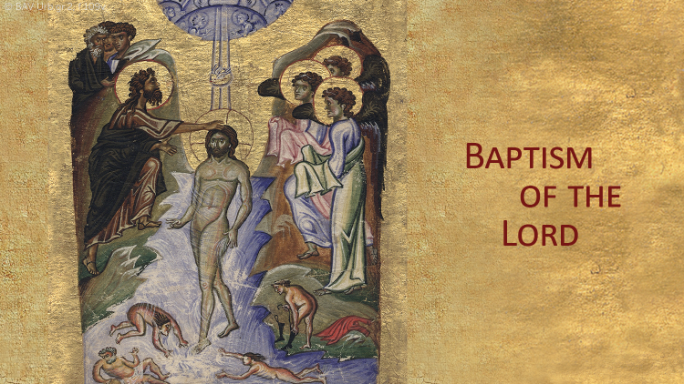

In this dialogue between Jesus and John, Matthew makes it clear that Jesus has the greater understanding. John’s objection to his being baptised is probably based on the fact that Jesus does not need to be made righteous before God as all others do. Jesus’ acceptance of baptism underlines the fact that he knows he is in such a state.

This weekend’s response to the Responsorial Psalm is:
The Lord will bless his people with peace.
The Baptism of the Lord 11/01/2026
Please pray for Brian Cronin, Rathmore; Patrick O’Flaherty, Killarney. May they rest in peace.
Priest on duty this weekend: Contact Killarney 064 6631014 / Mobile 087 6501998 (for emergencies only).
Masses for the coming week

Sat 10th Jan | 7.30pm | Sheila Pigott (1st Anniv) R.I.P. Rock Field, Tralee Rd.
Sun 11th Jan | 11.30am | Peggy O’Callaghan R.I.P. Cloonteens  Kathleen Doolan R.I.P. Ballinamanagh  Kathleen Guerin R.I.P. Church View  Dan & Maria Guerin R.I.P. Glounacopple  Noreen Culhane R.I.P. Glebe
Tues 13th Jan | 9.30am  10-6pm | People of the Parish  Adoration
Thur 15th Jan | 7.30pm | Dan & Darren Sullivan R.I.P. Tournanough
Sat 17th Jan | 7.30pm | Batt & Nora McGlynn and their daughter Sheila R.I.P. Milleen  Johnny Kenny and his niece Eileen Herlihy and deceased family members R.I.P. Glounonea
Sun 18th Jan | 11.30am | John Joe Lyne and Bill Falvey R.I.P. Knocklebede

17th & 18th  January | Readers | Eucharistic  Ministers | Altar Servers
Vigil  7.30pm | M. Healy | M. O’Connor  B. Fleming | C. Fleming R. Griffin  C. O’Mara
Sun  11.30am | E. Fleming | A. Murray  M. O’Sullivan | A.M. O’Sullivan  M. O’Sullivan

Offertory Collections: €1,470.00. Míle Buíochas.
Second Collection on the 17th/18th Jan. in aid of Needs of the Holy Land.
Parish Office: Open Tues, Wed & Fri 10.00am – 12 noon. Please contact: 064 6643176 / Mobile: 087 1339732, e-mail kilcummin@dioceseofkerry.ie
Church Collectors Rota for January: Saturday 7.30pm: L. Fleming & G. Guilfoyle; Sunday 11.30am: K. O’Leary & P. Cahill.
A Day of Healing through the Eucharist and Word will be held at Our Lady of Lourdes Church, Scartaglen on next Sunday, Jan 18th starting at 2.30 pm. Deacon Thady O’Connor and Jannice Carrig warmly invite you to join them for this special day accompanied by an anointed music ministry by Paddy Sheehan, Pat Buck, Richard Curran, Pat Power and others. This is accompanied by individual blessings at your request. We look forward to meeting you there.
Pink Night Rescheduled: The Ladies’ Committee of Kilcummin GAA Club would like to announce the rescheduling of its annual Pink Night, taking place in The Klub Bar, it will now take place on Saturday, January 10th. Now in its twelfth year—and supporting Comfort for Chemo for the fifth year running—this much-loved event promises a fantastic evening of fun and fundraising for all. While everyone is encouraged to wear pink, dressing up is completely optional—the true spirit of the night is community, enjoyment, and support for a great cause. Prizes will be awarded for Best Dressed Female and Best Dressed Male. The festivities begin at 8pm, with entertainment from Derry and Rosie Healy from 8 to 10:00pm, followed by Barry McGrath playing late into the night, your continued support is deeply appreciated.
The Kilcummin Parents Association would like to thank all who supported their School Memory Tree over Christmas. We would also like to thank Fr Noel Spring for saying a beautiful Mass in loving memory of all named on the Memory list. Míle Buíochas.
Kilcummin Men’s Shed are looking forward to getting back on Jan 9th at Mastergeeha F.C. Kilcummin, Killarney V93 T276 every Friday 10am-12pm aligns with the Gneeveguilla-Killarney TFI R 57 bus schedule. Please contact 0872422299 or www.kilcumminmensshed.ie kilcumminmensshed@gmail.com
Junior Set Dancing: Registration for junior set dancing will take place on Friday, 16th January from 7 to 7.45pm in Kilcummin Recreational Hall. Dancing will commence on Friday 23th January from 7 to 8pm for beginners and intermediates and 8 to 9pm for advanced. These classes are also open to children from outside Kilcummin parish. Further information contact Mary on 087 9620135.
Computer Class: Information Technology Skills QQI Level 4 is starting on Monday 12th January, 2026 from 7pm - 10pm, for 18 weeks. Topics covered are: Theory, Data Entry, File Management, Word Processing, Email & Internet. For more details contact Mary 0860749756 on Monday or Tuesday 10am to 5pm. Places are limited, booking is essential.
Kilcummin Community Care will return on Tuesday 13th January. New members welcome, we meet every Tuesday from 11 am to 1.45 pm in the G.A.A. hall. Hot dinner provided, free transport available. Anybody interested please contact Mary Doyle on 086 1550803.
Rambling House will take place in the Heritage Centre, Scartaglen on Monday, 12th January. Refreshments served, all are welcome.
Kilcummin Community Games: Anyone interested in Community Games and would like to know more, please go to Kilcummin Community Games Facebook page where all upcoming events & activities will be posted. Please note you must reside in Kilcummin parish to participate.
St. Vincent de Paul: On behalf of Killarney St. Vincent de Paul Conference we wish to thank you for your generous contributions to the Christmas 2025 Appeal and for your continuing support throughout the year. Wishing you a Happy, Peaceful and Healthy 2026.

Reflection

Lord Jesus, touch our eyes
so that we may see signs of your presence
in our lives and in the world.
Touch our ears so that we may hear your word.
Touch our tongues so that we may profess our faith.
Touch our hands so that we may give and receive.
Touch our feet so that we may walk in your paths.
Touch our minds so that we may
understand your ways.
Touch our wills so that they may be in
tune with your will.
Touch our hearts so that we may bring your love
to our brothers and sisters,
to the praise and glory of God.
Amen.


