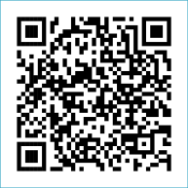
Scan to Donate

ST MARY’S PARISH NEWSLETTER - TARBERT
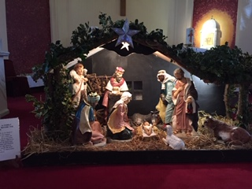
Parish Office Opening Hours:
Mon. 10.30am -2.30pm. Wed. 10.30am-2.30pm Priests :
Phone ; 068-36111. Fr. Sean Hanafin 087-8341083

Email: tarbert@dioceseofkerry.ie Fr. John Buckley 087-2409624
Notices for Parish Newsletter have to be in on Safeguarding Children: 087-6362780 Wednesday by 12 Noon. Defib. Emergency No. 999 or 112
Webpage: www.stmarystarbert.com (Outside Surgery Hours)

The Holy Family of Jesus, Mary and Joseph
28th December 2025
R.I.P. Eilish McGinley, Brighton.
Day/Date | Time | Intention
Saturday 27th | 6pm | Elizabeth ( Lila ) Kissane, St. Patrick’s Tce.  Der O’ Connor, Ballinoe.  Henry and Margaret O’ Donnell, The Square.  Dan and Kathleen O’ Connor, Tieraclea.  Eileen Steel, Kilpadogue and Patsy Carmody, Kilelton.
Sunday 28th | 11.30am | Dan and Gretta Flavin, Doonard Lower.  Stephen, Margaret, Michael and John Denihan and  Hannah Keegan, Dooncaha / New York.
Monday 29th | _____ | No Mass.
Tuesday 30th | _____ | No Mass.
Wednesday 31st | ______ | No Mass.
Thursday 1st | ______ | No Mass.
Friday 2nd | ______ | No Mass.
Saturday 3rd | 6pm | Liam Meade, Doonard Crescent.  Irene,Tommy and Michael Brassil, Shanaway.  Danny Enright, Doonard Crescent and  Deceased Family Members, Glin.
Sunday 4th | 11.30am | Moss Mulvihill, Dooncaha. ( Months Mind )  Jack, Myra and Thérése Downey, The Square.
PRIEST ON DUTY THIS WEEKEND: Fr. Jerry Keane 087-2844649 / 066-4018996.
PARISH OFFERTORY COLLECTION Sunday’s 21st and 28th December amounts will be published in two weeks. Míle Buíochas.
ABSENT FAMILY AND FRIENDS – You are invited to write the names of family members and friends who cannot be home for Christmas on the cards provided & place them on the tree. They will be remembered at Masses here throughout the Holy Season.

All our Masses at St. Mary’s Church, Tarbert,
can be viewed online at www.stmarystarbert.com
Reflection

We cannot see the stars in the bright light of day,
but only in the darkness of night.
The Magi saw the star only because
they were not afraid to travel in the dark.
In a sense, all of us are night-time travellers.
However, we need no longer fear the darkness,
because with the coming of Christ
a light has come into the world,
a light that shines in the dark,
a light that no darkness can overpower.

NEW YEAR’S BLESSINGS TO YOU

Fr. John, Fr. Seán
Fr. Brendan, Fr. Martin
and Fr. John
take this opportunity to wish you
a Happy, Peaceful and Safe New Year.

May the blessings of the Divine Child
and the love of His Holy Mother
be yours now and forever.

THANK YOU - for your continuing support and financial donations that underpin the smooth running of St. Mary’s Parish Church. Please continue to donate what you can on a weekly basis at any of our Masses on Wednesday, Saturday or Sunday. Donations can also be made by bank transfer – our bank details are as follows :

IBAN No- IE76 AIBK 9354 3380 3050 83, Account Name – Tarbert Church Account,
Bank - AIB, The Square, Listowel, Co. Kerry.

