This Christmas we have a new Pope, Leo XIV. We pray for him and for his shepherding of the church in the years ahead. Let us remember Pope Francis fondly. Recall the heroic effort he made on Easter Sunday to show the world his faith and joy in the Resurrection of Jesus, and how he died early the next morning.

2023 was the 800th anniversary of St Francis having the first Christmas crib in Greccio, Italy. In his crib St Francis had live people and animals, - an event that is now seen as the beginning of the worldwide tradition of the crib, - a model of the stable with figures of all the people, animals and objects. At the start of Advent 2019, looking forward to 2023 Pope Francis wrote an apostolic letter entitled “The meaning and importance of the nativity scene”.

What follows are two paragraphs, from the middle and the end of Pope Francis’ letter, two paragraphs that can help us reflect and pray about the birth of Jesus, Emmanuel, God with us.

“Why does the Christmas crib arouse such wonder and move us so deeply? First, because it shows God’s tender love: the Creator of the universe lowered himself to take up our littleness. The gift of life, in all its mystery, becomes all the more wondrous as we realize that the Son of Mary is the source and sustenance of all life.
In Jesus, the Father has given us a brother who comes to seek us out whenever we are confused or lost, a loyal friend ever at our side. He gave us his Son who forgives us and frees us from our sins.”
“Dear brothers and sisters, the Christmas crib is part of the precious yet demanding process of passing on the faith. Beginning in childhood, and at every stage of our lives, it teaches us:
- to contemplate Jesus,
- to experience God’s love for us,
- to feel and believe that God is with us
- and that we are with him, his children, brothers and sisters all, thanks to that Child who is the Son of God and the Son of the Virgin Mary.
- And to realize that in that knowledge we find true happiness.
Like Saint Francis, may we open our hearts to this simple grace, so that from our wonderment a humble prayer may arise: a prayer of thanksgiving to God, who wished to share with us his all, and thus never to leave us on our own.”
Le gach dea-ghuí, í gcomhair na Nollag.
Every Christmas blessing on all in our communities.

May your love be upon us O’ Lord
As we place all our Hope in you. (Ps 33:22)

Our Lady, Queen of Peace, pray for the whole world.

+ Ray Browne
Diocese of Kerry
Christmas 2025
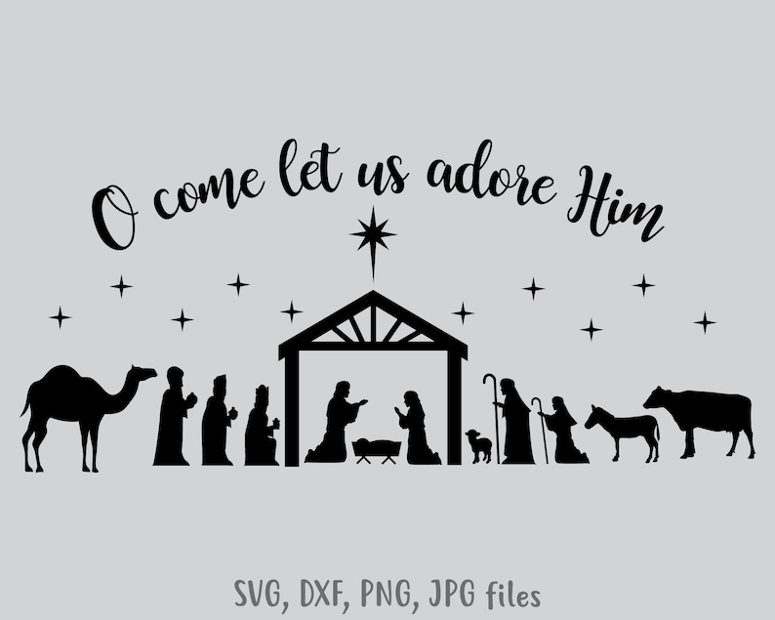

Christmas Message Diocese of Kerry 2025

These lines from a religious poem in the Divine Office capture the meaning and the Spirit of our celebration of Christmas:

Where true love is dwelling, God is dwelling there;
Love’s own loving Presence, love does ever share.

Give Him joyful welcome, love Him and revere;
Cherish one another with a love sincere.

A happy and a faith-centred Christmas to one and all, to all homes, all families and all people living alone. It is wonderful that Christmas in Ireland remains so family centred for most people: ‘Home for Christmas’, ‘Together for Christmas’. For homes and families all year-round every week can be pressurized and busy, Christmas is almost the only time most people are at home with their family, a few days to unwind and catch up, time to see the bigger picture of their lives and to count their blessings. I pray God’s blessing on every home in the diocese.

If it has been a difficult year or if you are troubled today draw strength from the fact that Mary and Joseph relied on the innkeeper, and all he could provide was a stable, and their baby Jesus was born. What joy and happiness! Everything does not have to be perfect for life to be fulfilling.

A word of encouragement. Have time to turn to God over the Christmas days. Pause and gaze at the crib in the home, or at a simple crib-picture on a Christmas card. Visit the crib in local churches. Bring the children. Especially at the crib talk to children about the birth of Jesus, - and the love God the Father has for us all. Speak to children of the love of God, and of all of us putting our Hope in God. Join in the celebration of Mass. Proclaim Christ Jesus as your Hope as you enter the New Year. Share and nourish your own faith over the days of Christmas.

Continued overleaf……

