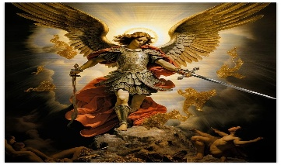
St Michael’s Church
Allihies/Cahermore Parish
November 2025
Priest on duty 09th Nov 2025 Fr. Niall Howard. 087-9365370
Mass Every Thurs evening @ 7pm Cahermore: Every Friday evening @ 6.30pm Allihies Every second Sunday Cahermore @10.00am: Every second Saturday Allihies @ 6.30pm.
Fr. John Kerin may be contacted on 086-1918246.
Please pray for all those who died recently, and for all those whose anniversaries occur at this time. We offer our sympathy to all who are bereaved.
Mass Intentions for Weekend 08th & 09th Nov 2025 – Dedication of the Lateran Basilica in Rome.
November
Thursday | 06th Nov | Allihies | Mass for The Holy Souls @6.30pm
Friday | 07th Nov | Allihies | NO MASS
Sunday | 09th Nov | Cahermore | Bernie O’Sullivan, Cahermore
**2nd Collection for Irish Church Commission & Agencies Sun 9th Nov **

Mass Intentions for Weekend 15th & 16th Nov 2025 – 33rd Sunday in Ordinary time.
November
Thursday | 13th Nov | Cahermore | Enrolment mass for 1st Holy Communion
Friday | 14th Nov | Allihies | Noreen O’Connor nee O’Sullivan-Brohill Cluin & Dublin
Saturday | 15th Nov | Allihies | Mary R Kelly, Lehanmore  Donal & Margaret Hanley Lichbarrahan also remembering their sons Michael & Donal
Please contact Claire at the parish office to book Mass, Weddings, or Christenings, on 086-8344354 or email allihies@dioceseofkerry.ie
Parish Office opening hours 2pm to 5.15pm Tues & Thurs. ** 2026 Diary Open **

Fr. John wants to thank all of you who have given the Autumn & November dues. Your generosity is much appreciated.

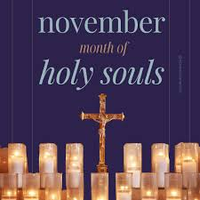
Allihies Parish: Remembrance Altar – Month of the Holy Souls Throughout November, parishioners are invited to bring a photo of a departed loved ones to place on our new Remembrance Altars in Allihies & Cahermore Churches. This special space will be available all month as we prayerfully remember and honour those who have gone before us. "Eternal rest grant unto them, O Lord."
First Holy Communion Enrolment Please pray for the children preparing for their First Holy Communion as we welcome them and their families to the 7pm mass on Thurs 13th November in Cahermore.

Allihies Men’s Shed: Allihies Men’s Shed would like to extend a very warm welcome to all. Our winter 2025/26 schedule has started, and we have many interesting new projects in the pipeline. Open every Tuesday night 7.30pm till late and every Thursday midday until 3.30pm. Please always feel welcome.
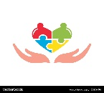
Allihies Community Care: Our next gathering will take place at O’Neill’s Bar on Tuesday, 18th November, with Mass at 12:30pm. We warmly welcome all parishioners to join us. If you are interested in attending, please contact any member of the Community Care Committee. We look forward to seeing you there! Upcoming dates: Tuesday, 16th December.

Beara West Resource Centre: Beara West Needs Volunteers. Make a difference close to home. We are looking for helping hands — especially relief Meals-on-Wheels drivers and a Care Ring volunteer. Even a little of your time can brighten someone’s day. Call 027 70998 to learn more.

Beara West Resource Centre: One Good Coach Online Workshop. The “One Good Coach” programme, developed by Jigsaw and Laois GAA, highlights the important role coaches play in supporting young people’s mental health. This free online workshop focuses on building resilience and confidence in young people while helping coaches become approachable, supportive figures for their players. It is delivered online and is approx. 40 minutes. If interested contact Joanne on 083 1135077 or joshea@bearawest.ie for further details.

Beara West Resource Centre: Rhythm Room is coming back! The Rhythm Room is taking a midterm break and returning on Wednesday, 5th November. We’re looking forward to seeing old and new faces! Booking is recommended to make sure you get a seat — spaces are limited. Please phone the centre on 027 70998 to book your spot.

Lay people to take up leadership roles in the Diocese of Kerry: The volunteer Ministry of the Pastoral Leader was introduced as a response to the changing needs of parish communities. The pastoral leaders work alongside the clergy and other volunteers in their parishes and pastoral areas, co-ordinating and supporting different aspects of parish life. If you are interested, for more information, check out www.dioceseofkerry.ie or contact Frances Rowland, francesrowland@dioceseofkerry.org, or phone Diocesan Pastoral Centre 064 6632644.

Reflection – Month of the Holy Souls
November invites us to pray for the Holy Souls, remembering that love and prayer unite us beyond death.
May our prayers bring them peace and draw us closer to the hope of eternal life.

