Kilcummin Parish Newsletter
Fr. Kieran O’Brien, Fr. Joe Begley, Fr. Jim Lenihan, Fr. Padraig Kennelly, Fr.Vitalis Barasa. Fr. Noel Spring,
For a priest in an emergency at any time call
064 6631014 / mobile 087 6501998
www.kilcumminparish.com. Eircode V93 K22T
Email: kilcummin@dioceseofkerry.ie
Priest on duty this weekend:
Killarney 064 6631014 Mobile 087 6501998

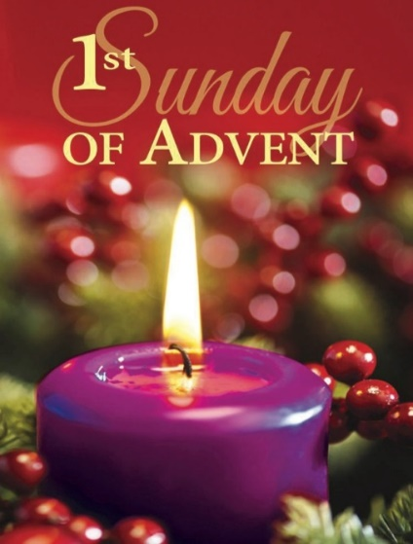

The thrust of the Gospel reading today is a warning not to be caught off guard, as the people were by the flood or the person of the house by the thief. It is this more than the idea that the coming of the Lord is something to fear that the writer wishes to underline.

This weekend’s response to the Responsorial Psalm is:
I rejoiced when I heard them say:
‘Let us go to God’s house’.
First Sunday of Advent 30/11/2025
Please pray for Eileen Joy (née Noonan), Muckross & Limerick. May she rest in peace.
Priest on duty this weekend: Fr. Vitalis Barasa 064 6631014 / Mobile 087 6501998 (for emergencies only).
Masses for the coming week
Sat 29th Nov | 11.30am  7.30pm | Sheila Fleming R.I.P. Clydine and her parents John & Mary and her brother Sheamus Fogarty R.I.P. Pinewood Estate
Sun 30th Nov  1st Sunday of Advent | 11.30am  12.15pm | Mary Francis O’Connor ( 1st Anniversary) R.I.P. Glounonea  Baptism
Tue 2nd Dec | 9.30am  10-6pm | People of the Parish  Adoration
Fri 5th Dec  (First Friday) | 7.00pm  7.30pm | Rosary & Benediction  Abina O’Sullivan R.I.P. Tournanough
Sat 6th Dec | 7.30pm | Jackie Healy Rae R.I.P. Kilgarvan  Liam Fitzgerald R.I.P. Knockeenalicka
Sun 7th Dec | 11.30am | Pat Fleming (1st Anniversary) R.I.P. Currow and Countess Grove
Mon 8th Dec | 11.30am | Feast of the Immaculate Conception  Dan Tom and Catherine Fleming and deceased family members R.I.P. Inch  Catherine & William Healy & deceased family members R.I.P. Dooneen  Dan & Daniel Healy R.I.P. Rockfield
6th & 7th  December | Readers | Eucharistic  Ministers | Altar Servers
Vigil  7.30pm | K. Friel | E. Walsh  P. Healy | C. Fleming  R. Griffin  C. O’Mara
Sun  11.30am | M. Janot | K. O’Donoughue  N. Fleming  G. Fleming | A.M. O’Sullivan  M. O’Sullivan
Offertory Collection: €1,150. Míle Buíochas.
Second Collection next weekend will be in aid of The Diocesan Youth Service. Established in the Kerry Diocese, the Diocesan Youth Service provides an outreach and educational programme for young people and strives to promote creative support to vulnerable young people.
Church Collectors Rota for December: Saturday 7.30pm: T.Sugrue & H.Kerins; Sunday 11.30am: M.Brosnan & J.Moriarty.
Confessions will be held on Saturday Dec. 6th after the 7.30pm Mass.
First Saturday Devotions will take place on December 6th in the Church of the Resurrection. Rosary at 9am, followed by Mass at 9.30am.
First Advent Candle – Hope. It is sometimes called the “Prophecy Candle” in remembrance of the prophets, especially Isaiah, who foretold the birth of Christ. It represents the expectation felt in anticipation of the coming Messiah. The colour purple symbolizes royalty, repentance, and fasting.

The Annual Offertory Boxes will be ready for collection this weekend. We would like to thank those who use the boxes. It is very important that parishioners support our church and priests by their financial contributions. Please contact the parish office if you require a box.
Baptism: We would like to welcome babies Rian Daniel O’Leary, Milleen and Eadhla Maggie O’Leary, Knocklebede into God’s family with joy. Congratulations to their parents and wishing them many years of health and happiness.
Mass Celebrating all Nations in the Community will be held on Sunday 30th November (First Sunday of Advent) @12 noon in St. John’s Church, Castle Street, Tralee. All welcome.
Lay People to Take up Leadership Roles in the Diocese of Kerry: The Volunteer Ministry of the Pastoral Leader was introduced as a response to the changing needs of parish communities. The pastoral leaders work alongside the clergy and other volunteers in their parishes and pastoral areas. If you are interested, for more information: www.dioceseofkerry.ie email francesrowland@dioceseofkerry.org or 064 6632644.
Monthly Meetings Sept 2025 - May 2026 from 10am to 4pm for Young Women (18-40yrs) who are discerning a Vocation to Religious/Consecrated Life, monthly meetings are held in Charleville Retreat Centre, Cork. The day includes prayer, talks, Holy Mass, Adoration and a chance to meet and chat with religious sisters of different communities. If you are interested in attending please email womendiscern@corkandross.org.
O’Callaghan Coaches will be taking a coach to the annual All Night Vigil for the Feast of the Immaculate Conception in Knock on Sunday, 7th Dec.
Contact 064 6631095 or holidays@ocallaghancoaches.com for bookings.
The Sliabh Luachra Music Trail is coming to Kilcummin on Sat 13th Dec. @2pm at Kilcummin Recreational Hall. All ages & instruments welcome.
Save The Date: Annual Pink Night Fundraiser for “Comfort for Chemo” will take place on Saturday, 3rd January 2026 in the Klub Bar at 8pm. Everyone welcome, more details to follow.
Kilcummin Looking Good Christmas ‘Jingle & Mingle’ would like to acknowledge the support of Kerry County Council through the Community Support Fund relative to the delivery of our Christmas event to be held on Sunday the 14th of December 2025.
Fr. Tom Looney’s Book “Unbeatable”: The remarkable story of Fr. Tom Jones will be on sale in Kilcummin Post Office, price €15.
Be Safe Be Seen: Now that we have shorter evenings it is advisable to wear hi-vis vests & reflective armbands when out walking or cycling.
Advent Prayer

Lord Jesus,
Master of both the light and the darkness,
send your Holy Spirit upon our preparations for Christmas.
We who have so much to do
seek quiet spaces to hear your voice each day.
We who are anxious over many things,
look forward to your coming among us.
We who are blessed in so many ways,
long for the complete joy of your kingdom.
We whose hearts are heavy
seek the joy of your presence.
We are your people,
walking in darkness,
yet seeking the light.
To you we say, “Come Lord Jesus!”
Amen.
Henri J.M. Nouwen

