Kilcummin Parish Newsletter
Fr. Kieran O’Brien, Fr. Joe Begley, Fr. Jim Lenihan, Fr. Padraig Kennelly, Fr.Vitalis Barasa. Fr. Noel Spring,
For a priest in an emergency at any time call
064 6631014 / mobile 087 6501998
www.kilcumminparish.com. Eircode V93 K22T
Email: kilcummin@dioceseofkerry.ie
Priest on duty this weekend:
Glenflesk 064 7754008 Mobile 087 6554655

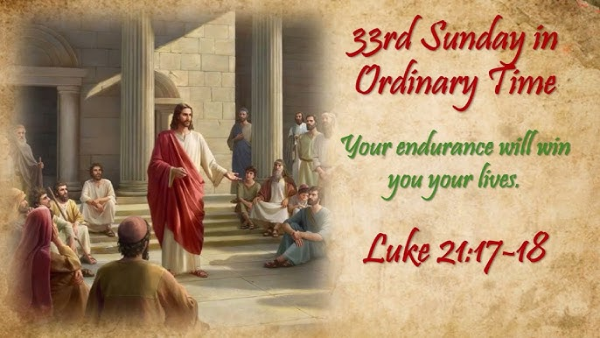

Earthquakes, plagues, famines and great signs from heavens are part of the stock-in-trade of apocalyptic writing. Behind this planetary and natural imagery, the fundamental message is that God does not abandon his people. Apocalyptic writers envisaged this truth in terns of God intervening in human affairs, not primarily to judge and condemn but to support and accompany.

Dates for November Masses for the Holy Souls
Especially for our dearly departed and all the names on our November list and Memory Tree.
Tuesday, Nov 18th @ 9.30am
Thursday, Nov 27th @ 7.30pm

This weekend’s response to the Responsorial Psalm is:
The Lord comes to rule the peoples with fairness.
33rd Sunday in Ordinary Time 16/11/2025
Please pray for Edward (Ted) Leizcyneski, Maulykevane, Headford; Margaret Kenny, Killarney; Rena Clifford (née Gallivan), Castlemaine, formerly of Knocknaskeha; Mary Spillane (née Healy) Kilbrean Mór, Killarney. May they rest in peace.
Priest on duty this weekend: Fr. Jim Lenihan 064 7754008 / Mobile 087 6554655 (for emergencies only).
Masses for the coming week
Sat 15th Nov | 7.30pm | Michael & Sheila Morrissey & their daughter in law Kathleen & granddaughter Breda R.I.P. Glounnacopple  Pat Moynihan R.I.P. Lacca
Sun 16th Nov | 11.30am | Tim & Mai Ryan R.I.P. Clydine
Tue 18th Nov | 9.30am  10-6pm | For All our loved ones on our November List  Adoration
Thur 20th Nov | 7.30pm | All Deceased members of Comhaltas, Kilcummin
Sat 22nd Nov | 7.30pm | Jackie, Timmy & Nora Lucey R.I.P. Mastergeeha  Jer O’Gorman & deceased family members R.I.P. Coolick
Sun 23rd Nov | 11.30am  12.15pm | John, Hans & Mary O’Leary & deceased family members R.I.P. Rathanane  Donal McGlynn R.I.P. Glounonea  Baptism
22nd & 23rd  November | Readers | Eucharistic  Ministers | Altar Servers
Vigil  7.30pm | M. O’Sullivan | K. Fleming  M. Lehane | E. O’Mahony  E. Sheahan  E. R. Lyne
Sun  11.30am | E. Fleming | G. O’Sullivan  N. O’Sullivan | E. O’Riordan  S. O’Callaghan  C. O’Riordan

Offertory Collection: €875. Second Collection: €465. Míle Buíochas.
40 Hours Adoration for our priests and peace in the world, 40 hours Adoration will take place in the Church of the Resurrection, Killarney from 6pm on the 14th Nov to 11am Mass on Sunday the 16th Nov. All will take place with the support of the many prayer groups in the parish. Please sign up to cover some of the hours. Tel 087 2259993, 087 6884124.
Music Celebration for Jubilee Year: The Diocese of Kerry will celebrate those who bring their gift of music & song to our liturgy with a special Mass on Tue Nov 18th@ 7.30pm in St Mary’s Cathedral, Killarney. All welcome!
The Annual Offertory Boxes will be ready for delivery shortly. We would like to thank those who use the boxes. It is very important that parishioners support our church and priests by their financial contributions. Please contact the parish office if you require a box.

Lay People to Take up Leadership Roles in the Diocese of Kerry: The volunteer Ministry of the Pastoral Leader was introduced as a response to the changing needs of parish communities. The pastoral leaders work alongside the clergy and other volunteers in their parishes and pastoral areas, co-ordinating and supporting different aspects of parish life. If you are interested, for more information, check out www.dioceseofkerry.ie email francesrowland@dioceseofkerry.org or 064 6632644.
Webinar for Parents of Confirmation Children: It is that time of year again – we are promoting our online Confirmation Talk, for parents and guardians of children preparing for the Sacrament of Confirmation. It will be online on Wednesday 26th November at 7.30pm. Our guest speaker is Dr. Dan O’Connell from Mary Immaculate College, Limerick. This webinar is designed to complement the pre-sacramental work that is already happening in schools and parishes. The registration link: https://us06web.zoom.us/webinar/register/WN_6tmq2arsSSO0z61gurhISQ
O’Callaghan Coaches will be taking a coach to the annual All Night Vigil for the Feast of the Immaculate Conception in Knock on Sun. Dec. 7th. Contact 064 6631095 or holidays@ocallaghancoaches.com for bookings.
Glenflesk Parish Bazaar 2025 will take place on Sunday, 23rd November at 3pm in Glenflesk Parish Hall. Please see Church Notice Board for more details. All welcome.
Kilcummin Looking Good would like to express its gratitude to Kerry County Council and the Department of Rural and Community Development for providing financial support under the Local Enhancement Programme 2025. It helped with the Biodiversity Park basic upkeep and tree care.
Chime will host an information session on fraud awareness on Monday 17th November from 12pm-3pm in the Killarney Library. An Garda Siochana will present this session, it will focus on how to stay safe online, protect your personal information and how to recognize and avoid scams and fraud accessibility. This will be an ISL(Irish Sign Language) event, welcoming everyone who is deaf, hard of hearing, has Tinnitus, and their families. An ISL interrupter will be present on the day. All are welcome to attend.
Mastergeeha Church Gate Collection takes place next weekend 22nd and 23rd November. Your support would be greatly appreciated.
Kilcummin Rural Development would like to extend their thanks and appreciation to Kerry County Council for funding received from the Community Support Fund 2025 to update its website and establish a social media presence in order to promote Kilcummin.
Fr. Tom Looney’s Book “Unbeatable”: The remarkable story of Fr. Tom Jones will be on sale in Kilcummin Post Office, price €15.

Psalm of Farewell

I leave my thoughts, my laughter, my dreams
to you whom I have treasured
beyond gold and precious gems.
I give you what no thief can steal,
the memories of our times together,
the tender love filled moments,
the successes we have shared,
the hard times that brought us closer together,
and the roads we have walked side by side.
Fear not nor grieve at my departure,
you whom I have loved so much,
for my roots and yours are forever intertwined.

