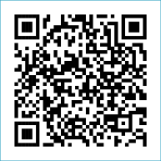
Scan to Donate

ST MARY’S PARISH NEWSLETTER - TARBERT
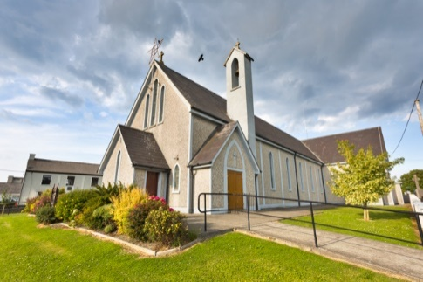
Parish Office Opening Hours:
Mon. 10.30am -2.30pm. Wed. 10.30am-2.30pm Priests :
Phone ; 068-36111. Fr. Sean Hanafin 087-8341083

Email: tarbert@dioceseofkerry.ie Fr. John Buckley 087-2409624
Notices for Parish Newsletter have to be in on Safeguarding Children: 087-6362780 Wednesday by 12 Noon. Defib. Emergency No. 999 or 112
Webpage: www.stmarystarbert.com (Outside Surgery Hours)

The Exaltation of the Holy Cross
14th September 2025
R.I.P. Sr. Irene ( Pearl ) Bouchier- Hayes, New Zealand / Doonard.
Nora Griffin ( née Enright ), Woodview Place.
Hannah Keegan ( née Denihan ), New York / Dooncaha.
Day/Date | Time | Intention
Saturday 13th | 6pm | Daniel ( Donie ) O’ Brien, Tieraclea. ( Months Mind )  Tim, Mai and Tom Mahony, Kilcolgan.  Paddy and Peggy Carrig, Kilpadogue.
Sunday 14th | 11.30am | Dan and Tessie Kiely and  Deceased Family Members, Main St.
Monday 15th | _____ | No Mass.
Tuesday 16th | _____ | No Mass.
Wednesday 17th | _____ | No Mass.
Thursday 18th | ______ | No Mass.
Friday 19th | _______ | No Mass.
Saturday 20th | 6pm | Tessie Holly, Tarmons Hill. ( Months Mind )  Brendan Cregan, Tieraclea.  Patrick and Mary Normile, Dooncaha.
Sunday 21st | 11.30am | Seán Ferris, Glencullare.
PRIEST ON DUTY THIS WEEKEND: Fr. Gerard Finucane 087-0554874 / 066-7148404.
PARISH OFFERTORY COLLECTION Sunday 31st August - € 715 Diocesan Collection - € 295 Míle Buíochas.
LIVE SERVICES – All Masses are now being live streamed from our Church. Just go to the Church website – www.stmarystarbert.com and you can watch on your phone, tablet, computer or smart T.V. When you log in and see the picture of the Altar, just underneath this, click on the mute button and you will then have the audio as well.

All our Masses at St. Mary’s Church, Tarbert,
can be viewed online at www.stmarystarbert.com
Prayer for our Earth

O God of the poor, help us to rescue the abandoned
and forgotten of this earth, so precious in your eyes.
Bring healing to our lives,
that we may protect the world and not prey on it,
that we may sow beauty, not pollution and destruction. Amen.

TARBERT ACTIVE RETIREMENT - is resuming on the 5th of Sept. (over 55’s) meet in Tarbert Bridewell every Friday between 10.30am and 12 Noon. Different activities every week followed by refreshments. New members welcome.

POKER CLASSIC - – 5 Card Draw – in Carmody’s Bar on Friday 19th September at 8pm, entry €30 with the usual buy backs. There will also be a Texas cash table. A donation will be made to St. Mary’s New Cemetery towards the new graveyard extension. Your support would be greatly appreciated.

THANK YOU – St. Mary’s Cemetery Committee would like to thank all those who contributed to the collection at the annual Graveyard Mass. The amount collected was € 1,055 and it will go towards the upkeep of the cemetery.

MASS OF THANKSGIVING - In this Jubilee Year, Pilgrims of Hope, the weekend of Saturday 22nd and Sunday 23rd November has been designated by the Vatican as a time to acknowledge the contribution of music at our Sunday celebrations. In advance of this special weekend, the diocese would like to celebrate the gift of singing and music at our parish liturgies and worship with a Mass of Thanksgiving in St Mary’s Cathedral, Killarney on Tuesday 18th Nov. at 7pm. It is hoped that the Mass will allow people to join with singers and musicians from across the diocese to pray and give praise through song and music. Music workshops to learn some new music and rehearse some familiar music will take place on Tuesday Sept 23rd and Thursday Sept 25th.

OUR LADY’S WISH - On this Saturday 13th September at 3pm, the Rosary and Divine Mercy Chaplet will be recited on Main Street Killarney in honour of Our Lady's wish in Fatima to pray the rosary for peace. A statue or Our Lady of Fatima will be present on the street and we invite you to come and join us.

WHY SUNDAY MATTERS - The Irish Catholic Bishops have published a Pastoral Letter on Why Sunday Matters – an invitation to reflect on Sunday Mass. It is available in parishes, or can be downloaded from the diocesan website, www.dioceseofkerry.ie. There is also an accompanying video series entitled Sunday Mass – Digging Deeper, which can be accessed also on the diocesan website.

TEACH SIAMSA FINUGE - was founded to serve the people of North Kerry. At the request of founder Pat Ahern, each parish is invited to have a representative on the committee now reviving its work. If you are interested in representing your parish, please contact teachsiamsafinuge@gmail.com

THANK YOU - for your continuing support and financial donations that underpin the smooth running of St. Mary’s Parish Church. Please continue to donate what you can on a weekly basis at any of our Masses on Saturday, Sunday. Donations can also be made by bank transfer – our bank details are as follows :
IBAN No- IE76 AIBK 9354 3380 3050 83, Account Name – Tarbert Church Account,
Bank - AIB, The Square, Listowel Co. Kerry.

