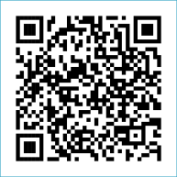
Scan to Donate

ST MARY’S PARISH NEWSLETTER - TARBERT
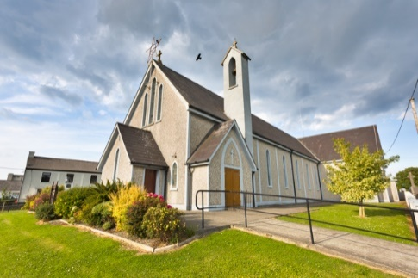
Parish Office Opening Hours:
Mon. 10.30am -2.30pm. Wed. 10.30am-2.30pm Priests :
Phone ; 068-36111. Fr. Sean Hanafin 087-8341083

Email: tarbert@dioceseofkerry.ie Fr. John Buckley 087-2409624
Notices for Parish Newsletter have to be in on Safeguarding Children: 087-6362780 Wednesday by 12 Noon. Defib. Emergency No. 999 or 112
Webpage: www.stmarystarbert.com (Outside Surgery Hours)

26th Sunday in Ordinary Time
28th September 2025
World Day of Migrants and Refugees

R.I.P. Tony O’ Sullivan, Doonard. Ger Moroney, Clarina. Seán Collins, Drimoleague.
Day/Date | Time | Intention
Saturday 27th | 6pm | John Coleman and Deceased Family, Chapel St.  Dick and Kitty Pattwell and  Deceased Family Members, Kilpadogue.
Sunday 28th | 11.30am | Con Holly, Chapel St. ( 1st Anniversary )  Jane Kiely, Main St.
Monday 29th | _____ | No Mass.
Tuesday 30th | _____ | No Mass.
Wednesday 1st | _____ | No Mass.
Thursday 2nd | ______ | No Mass.
Friday 3rd | _______ | No Mass.
Saturday 4th | 6pm | Johnny and Joan Mackessy, Ballyline.
Sunday 5th | 11.30am | Margaret and James Enright, Main St.
PRIEST ON DUTY THIS WEEKEND: Fr. Seán Hanafin 087-8341083 / 068-27102.
PARISH OFFERTORY COLLECTION Sunday 21st September - € 821 Míle Buíochas.
LIVE SERVICES – All Masses are now being live streamed from our Church. Just go to the Church website – www.stmarystarbert.com and you can watch on your phone, tablet, computer or smart T.V. When you log in and see the picture of the Altar, just underneath this, click on the mute button and you will then have the audio as well.

All our Masses at St. Mary’s Church, Tarbert, can be viewed online at www.stmarystarbert.com
An Immigrant Prayer for Migrants and Refugees
Dear Jesus,
Our journey through life is long and hard.
We cannot make this trip alone;
we must walk together on the journey.
You promised to send us a helper, your Spirit.
Help us to see your Spirit in those you send to journey with us.
In the refugee family, seeking safety from violence, let us see your Spirit.
In the migrant worker, bringing food to our tables, let us see your Spirit.
In the asylum seeker, seeking justice for himself and his family, let us see your Spirit.
In the unaccompanied child, travelling in a dangerous world, let us see your Spirit.
Teach us to recognise that as we walk with each other, you are present.
Teach us to welcome not only the strangers in our midst but the gifts they bring as well;
the invitation to conversion, communion and solidarity.
This is the help you have sent; we are not alone.
We are together on the journey and for this we give you thanks. Amen.

TARBERT ACTIVE RETIREMENT – (over 55’s) meet in Tarbert Bridewell every Friday between 10.30am and 12 Noon. We have different activities every week followed by refreshments. New Members are welcome.

WHY SUNDAY MATTERS - The Irish Catholic Bishops have published a Pastoral Letter on Why Sunday Matters – an invitation to reflect on Sunday Mass. It is available in parishes, or can be downloaded from the diocesan website, www.dioceseofkerry.ie. There is also an accompanying video series entitled Sunday Mass – Digging Deeper, which can be accessed also on the diocesan website.

MASS OF THANKSGIVING - In this Jubilee Year, Pilgrims of Hope, the weekend of Saturday 22nd and Sunday 23rd November has been designated by the Vatican as a time to acknowledge the contribution of music at our Sunday celebrations. In advance of this special weekend, the diocese would like to celebrate the gift of singing and music at our parish liturgies and worship with a Mass of Thanksgiving in St Mary’s Cathedral, Killarney on Tuesday 18th Nov. at 7pm. It is hoped that the Mass will allow people to join with singers and musicians from across the diocese to pray and give praise through song and music.

RECONNECTING WITH SERVICES DAY - For older people takes place on 9th October in the Listowel Arms from 10am to 2pm. This Year’s theme is Falls Prevention & Personal Safety. There will be guest speakers and a host of Information Stands from Various Agencies. The Event is free. Booking is essential, for further information and registration contact Ed O’Connor on 087-7794765 or email edoconnor@newkd.ie

