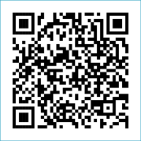
Scan to Donate

ST MARY’S PARISH NEWSLETTER - TARBERT
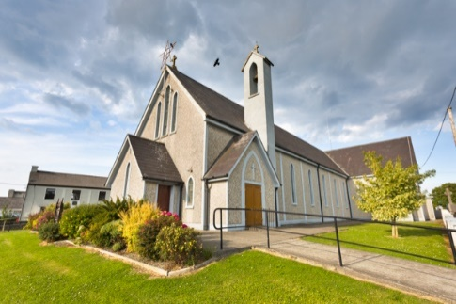
Parish Office Opening Hours:
Mon. 10.30am -2.30pm. Wed. 10.30am-2.30pm Priests :
Phone ; 068-36111. Fr. Sean Hanafin 087-8341083

Email: tarbert@dioceseofkerry.ie Fr. John Buckley 087-2409624
Notices for Parish Newsletter have to be in on Safeguarding Children: 087-6362780 Wednesday by 12 Noon. Defib. Emergency No. 999 or 112
Webpage: www.stmarystarbert.com (Outside Surgery Hours)

22nd Sunday in Ordinary Time
31st August 2025

R.I.P. Mary T. (Tessie) Holly (née O’ Connor), Tarmons Hill. Mary Holly (née Gorry), Ballybunion.
Teresa Hayes (née Nally), St. Patrick’s Tce.
Day/Date | Time | Intention
Saturday 30th | 11am  6pm | Funeral Mass for Teresa Hayes, St. Patrick’s Tce.  John Paul Collins, Dooncaha.
Sunday 31st | 11.30am | John Leslie, Tarbert House.  Tom and Margaret Manaher and  Jim Donnelly, Tieraclea.
Monday 1st | _____ | No Mass.
Tuesday 2nd | _____ | No Mass.
Wednesday 3rd | _____ | No Mass.
Thursday 4th | ______ | No Mass.
Friday 5th | 7pm | Graveyard Mass in Reilg Mhichíl.
Saturday 6th | 6pm | Anna Marie McGibney and Deceased McGibney and  Keane Families, Tieraclea Park.
Sunday 7th | 11.30am | Theresa Mackessy, London.  Margaret Courtney and  Deceased Courtney and Wallace Families, Tarmons.

PRIEST ON DUTY THIS WEEKEND: Fr. Brendan Walsh 087-7913271 / 068-49308.
PARISH OFFERTORY COLLECTION Sunday 24th August - € 767 Míle Buíochas.
GRAVEYARD MASS – Reilg Mhichíl --- Friday 5th September at 7pm.
DIOCESAN COLLECTION – A special diocesan collection for the Diocesan Needs will be held next weekend Sat. 6th / Sun. 7th Sept.
LIVE SERVICES – All Masses are now being live streamed from our Church. Just go to the Church website – www.stmarystarbert.com and you can watch on your phone, tablet, computer or smart T.V. When you log in and see the picture of the Altar, just underneath this, click on the mute button and you will then have the audio as well.
A Student’s Prayer at the Beginning of School Year

We give you praise, O God, for everything that is new and beautiful,
for everything which holds promise and brings us joy.
Bless us as we start this new year with our friends and teachers.
Help us to make the most of every chance we have to start afresh.
May we show love to one another and to all.
May the new beginning of this school year remind us that
You give us chances to start over again and again.
Help us to forgive others as we receive Your forgiveness.
Help us to learn and to work together.
Help us to listen when we should and to know the best words
when we speak and when it is better not to speak.
We thank You for our friends, help us to be good friends this year.
Help us to be patient with ourselves and with others.
Bless our school and keep us safe. Be with us as we travel each day.
Help us to be aware of Your love shown to us in the people around us.
Bless all those who care for us in school and at home.
Help us show our care for them and to say sorry when we need to.
May the Blessed Mother Mary protect us and help us to live
as well as we can, giving thanks and glory to God as she did.
Through Christ our Lord, Amen.

CANONISATION OF BL. CARLO ACUTIS & BL. PIER GIORGIO FRASSATI - Pope Leo XIV will canonise both Blessed Carlo Acutis and Blessed Pier Giorgio Frassati in St. Peter’s on Sunday 7th September. The Mass commences at 10am Rome time (9am Irish time). Blessed Carlo Acutis will become the first millennial Saint and is very popular here in Ireland especially among young people. The Mass will be broadcast by RTÉ.

TARBERT ACTIVE RETIREMENT - is resuming on the 5th of September, (over 55’s) meet in Tarbert Bridewell every Friday between 10.30am and 12 Noon. We have different activities every week followed by refreshments. New Members are welcome.

FREE COMPUTER CLASSES - will be provided in Tralee by Kerry Education and Training Board, from the middle of September to the middle of December (one two-hour class per week). Classes are at all levels, from absolute beginner to QQI Level 3. To inquire, please phone Ed on 086-0749786 or email traleeabe@staff.kerryetb.ie

THANK YOU - for your continuing support and financial donations that underpin the smooth running of St. Mary’s Parish Church. Please continue to donate what you can on a weekly basis at any of our Masses on Saturday, Sunday. Donations can also be made by bank transfer – our bank details are as follows :
IBAN No- IE76 AIBK 9354 3380 3050 83, Account Name – Tarbert Church Account,
Bank - AIB, The Square, Listowel Co. Kerry.

