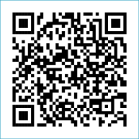
Scan to Donate

ST MARY’S PARISH NEWSLETTER - TARBERT
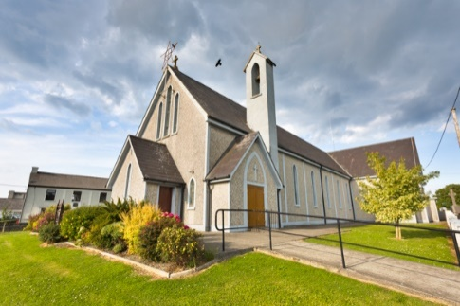
Parish Office Opening Hours:
Mon. 10.30am -2.30pm. Wed. 10.30am-2.30pm Priests :
Phone ; 068-36111. Fr. Sean Hanafin 087-8341083

Email: tarbert@dioceseofkerry.ie Fr. John Buckley 087-2409624
Notices for Parish Newsletter have to be in on Safeguarding Children: 087-6362780 Wednesday by 12 Noon. Defib. Emergency No. 999 or 112
Webpage: www.stmarystarbert.com (Outside Surgery Hours)

18th Sunday in Ordinary Time
3rd August 2025

Day/Date | Time | Intention
Saturday 2nd | 6pm | Con Leane, Tieraclea. ( Months Mind )
Sunday 3rd | 11.30am | Dermot O’ Connor, Main St.  Michael and Elizabeth Wren, Tarmons.  Michael Carmody,and Deceased Family, Chapel St.  Johnny and Peggy McElligott, St. Patrick’s Tce.
Monday 4th | _____ | No Mass.
Tuesday 5th | 11am | Funeral Mass for Kitty and Michael Joyce,  London / Shanaway.
Wednesday 6th | _____ | No Mass.
Thursday 7th | ______ | No Mass.
Friday 8th | 7pm | Graveyard Mass in Aghavallen Cemetery.
Saturday 9th | 6pm | Josephine Holly and Deceased Holly Family, Tarmons.  Doreen Normile, Clareview.  Thomas Lyndon, Kilpadogue.
Sunday 10th | 11.30am | Margaret O’ Dowd, Carhoona.  Maurice and Kathleen Buckley, Sligo.
PRIEST ON DUTY THIS WEEKEND: Fr. Seán Hanafin 087-8341083 / 068-27102.
PARISH OFFERTORY COLLECTION Sunday 27th July - € 839 Maintenance Fund - € 620
Online Banking - € 135 Míle Buíochas.
GRAVEYARD MASSES – Aghavallen Cemetery – Friday 8th August at 7pm. Kilnaughtin Graveyard – Friday 15th August at 7pm. St. Mary’s Cemetery, Tarbert --- Friday 22nd August at 7pm. Reilg Mhichíl --- Friday 5th September at 7pm. Please note that all Graveyard Masses will be celebrated at 7pm.
DIOCESAN COLLECTION – A second collection will be taken up for the Pastoral Centre this weekend Sat. 2nd / Sun. 3rd August.

All our Masses at St. Mary’s Church, Tarbert, can be viewed online at www.stmarystarbert.com

HEALING THE WOUNDS OF THE HEART

We are wounded by sin.
The part of us which is most
deeply damaged by sin is the heart.
The heart is so beautiful, so innocent,
but it can be betrayed, scorned and broken.
Darkness of the heart is the blackest night of all.
Emptiness of the heart is the greatest poverty of all.
A heavy heart is the most wearisome burden of all.
A broken heart is the most painful wound of all.
Only love can heal the wounds of the heart.
Lord, send your Holy Spirit to us,
to heal the wounds of our hearts,
so that we may produce the fruits of love.

THE THIRD ANNUAL DIOCESAN PILGRIMAGE - to Knock will take place on Saturday 23rd of August. Please note the date and consider taking part in this special time of prayer and reflection at Ireland's National Marian Shrine. Please check with your Pastoral Area regarding buses. May our prayer be "To Jesus through Mary". Please pray for the safety of all pilgrims who travel.

THANK YOU - for your continuing support and financial donations that underpin the smooth running of St. Mary’s Parish Church. Please continue to donate what you can on a weekly basis at any of our Masses on Saturday, Sunday or Monday. Donations can also be made by bank transfer – our bank details are as follows :
IBAN No- IE76 AIBK 9354 3380 3050 83, Account Name – Tarbert Church Account,
Bank - AIB, The Square, Listowel Co. Kerry.

