
Scan to Donate

ST MARY’S PARISH NEWSLETTER - TARBERT
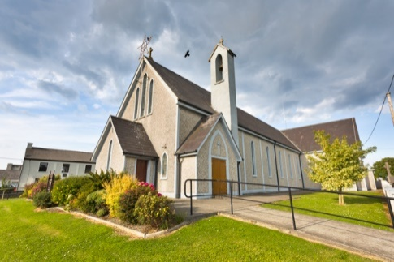
Parish Office Opening Hours:
Mon. 10.30am -2.30pm. Wed. 10.30am-2.30pm Priests :
Phone ; 068-36111. Fr. Sean Hanafin 087-8341083

Email: tarbert@dioceseofkerry.ie Fr. John Buckley 087-2409624
Notices for Parish Newsletter have to be in on Safeguarding Children: 087-6362780 Wednesday by 12 Noon. Defib. Emergency No. 999 or 112
Webpage: www.stmarystarbert.com (Outside Surgery Hours)

17th Sunday in Ordinary Time 27th July 2025

World Day of Prayer for Grandparents & the Elderly

R.I.P. Moss Dee, Listowel / Templeglantine.
Day/Date | Time | Intention
Saturday 26th | 6pm | Pat Sheehy, Woodview Place.  Noreen O’ Connor Usher, Dublin / Tieraclea.
Sunday 27th | 11.30am | Josephine ( Josie ) Walsh, Tarmons ( Months Mind )  Patrick and Sheila Shanahan and  Deceased Family Members, Kilcolgan.
Monday 28th | _____ | No Mass.
Tuesday 29th | _____ | No Mass.
Wednesday 30th | _____ | No Mass.
Thursday 31st | ______ | No Mass.
Friday 1st | 7pm | Graveyard Mass in Lislaughtin Abbey.
Saturday 2nd | 6pm | Con Leane, Tieraclea. ( Months Mind )
Sunday 3rd | 11.30am | Dermot O’ Connor, Main St.  Michael and Elizabeth Wren, Tarmons.  Michael Carmody and Deceased Family, Chapel St.  Johnny and Peggy McElligott, St. Patrick’s Tce.
PRIEST ON DUTY THIS WEEKEND: Fr. Pat Crean-Lynch 087-2200114. / 066-7134131.
PARISH OFFERTORY COLLECTION Sunday 20th July - € 839 Míle Buíochas.
GRAVEYARD MASSES – Lislaughtin Abbey – Friday 1st August at 7pm. Aghavallen Cemetery – Friday 8th August at 7pm. Kilnaughtin Graveyard – Friday 15th August at 7pm. St. Mary’s Cemetery, Tarbert --- Friday 22nd August at 7pm. Reilg Mhichíl --- Friday 5th September at 7pm. Please note that all Graveyard Masses will be celebrated at 7pm.
LIVE SERVICES – All Masses are now being live streamed from our Church. Just go to the Church website – www.stmarystarbert.com and you can watch on your phone, tablet, computer or smart T.V. When you log in and see the picture of the Altar, just underneath this, click on the mute button and you will then have the audio as well.
Farewell and Welcome

As we bid farewell to Fr. Michael Hussey
we thank him for his ministry here in Tarbert
and pray he will enjoy his retirement.

We welcome Fr. John Buckley as our Moderator
here in Tarbert and pray that God will bless
him in his future role.

Prayer for Grandparents

Lord Jesus,
You were born of the Virgin Mary,
the daughter of Saints Joachim and Anne.
Look with love on grandparents the world over.
Protect them! They are a source of enrichment
for families, for the church and for all of society.
Support them! As they grow older,
may they continue to be for their families
strong pillars of the Gospel faith,
guardian of noble domestic ideals,
living treasuries of sound religious traditions.
Make them teachers of wisdom and courage,
that they may pass on to future generations the fruits
of their mature human and spiritual experience.
Lord Jesus,
help families and society to value the presence
and roles of grandparents.
May they never be ignored or excluded,
but always encounter respect and love.
Help them to live serenely and to feel welcomed
in all the years of life which you give them.
Mary, Mother of all the living,
keep grandparents constantly in your care,
accompany them on their earthly pilgrimage,
and by your prayers grant that all families
may one day be reunited in our heavenly homeland
where you await all humanity for the great
embrace of life without end. AMEN.

