
Scan to Donate

ST MARY’S PARISH NEWSLETTER - TARBERT
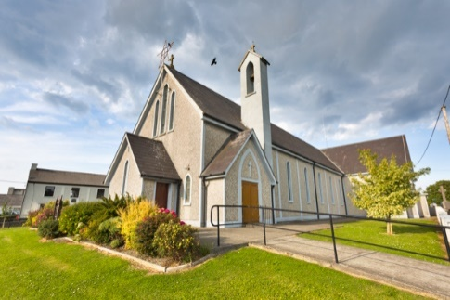
Parish Office Opening Hours:
Mon. 10.30am -2.30pm. Wed. 10.30am-2.30pm Priests :
Phone ; 068-36111. Fr. Sean Hanafin 087-8341083

Email: tarbert@dioceseofkerry.ie Fr. John Buckley 087-2409624
Notices for Parish Newsletter have to be in on Safeguarding Children: 087-6362780 Wednesday by 12 Noon. Defib. Emergency No. 999 or 112
Webpage: www.stmarystarbert.com (Outside Surgery Hours)

16th Sunday in Ordinary Time
20th July 2025
R.I.P. Donie ( Daniel ) O’ Brien, Tieraclea.
Day/Date | Time | Intention
Saturday 19th | 6pm | Mike Sheehan, Tarmons.  Garry Costelloe, Tieraclea.
Sunday 20th | 11.30am | Patricia Conway, Tieraclea Park.  Mary Ann and Tommy Donovan and  Deceased Family Members, Tieraclea.
Monday 21st | _____ | No Mass.
Tuesday 22nd | _____ | No Mass.
Wednesday 23rd | _____ | No Mass.
Thursday 24th | ______ | No Mass.
Friday 25th | _____ | No Mass.
Saturday 26th | 6pm | Pat Sheehy, Woodview Place.  Noreen O’ Connor Usher, Dublin / Tieraclea.
Sunday 27th | 11.30am | Josephine ( Josie ) Walsh, Tarmons. ( Months Mind )  Patrick and Sheila Shanahan and  Deceased Family Members, Kilcolgan.
PRIEST ON DUTY THIS WEEKEND: Fr. Gerard Finucane 087-0554874.
PARISH OFFERTORY COLLECTION Sunday 13th July - € 569 Míle Buíochas.
GRAVEYARD MASSES – Aghavallen Cemetery – Friday ____ at 7pm. Lislaughtin Abbey – Friday ____ at 7pm. St. Mary’s Cemetery, Tarbert - Friday _____ at 7pm. Kilnaughtin Graveyard – Friday ______ at 7pm. Please note that the dates for the Graveyard Masses will be published in next week’s newsletter.
LIVE SERVICES – All Masses are now being live streamed from our Church. Just go to the Church website – www.stmarystarbert.com and you can watch on your phone, tablet, computer or smart T.V. When you log in and see the picture of the Altar, just underneath this, click on the mute button and you will then have the audio as well.
All our Masses at St. Mary’s Church, Tarbert, can be viewed online at www.stmarystarbert.com
Prayer

Lord God,
whose days are without end
and whose mercies beyond counting,
keep us mindful
that life is short and the hour of death unknown.
Let your Spirit guide our days on earth
in the ways of holiness and justice,
that we may serve you
in union with the whole Church,
sure in faith, strong in hope, perfect in love.
And when our earthly journey is ended,
lead us rejoicing into your kingdom,
where you live for ever and ever. Amen.

Prayer for going on holiday

Heavenly Father,
please bless our holiday time.
Help our family to have patience and understanding.
Guide us to be mindful of this gift of time together.
Help us to make compromises when necessary and
handle any chaos that comes our way with Your love and grace.
Open our eyes to truly see the beauty of the memories we are creating.
Through Christ our Lord. Amen.

TARBERT ACTIVE RETIREMENT GROUP – has now finished for the Summer and will resume in September.
THANK YOU - for your continuing support and financial donations that underpin the smooth running of St. Mary’s Parish Church. Please continue to donate what you can on a weekly basis at any of our Masses on Saturday, Sunday or Monday. Donations can also be made by bank transfer – our bank details are as follows :
IBAN No- IE76 AIBK 9354 3380 3050 83, Account Name – Tarbert Church Account,
Bank - AIB, The Square, Listowel Co. Kerry.

