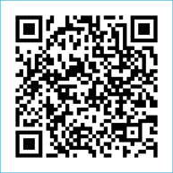
Scan to Donate

ST MARY’S PARISH NEWSLETTER - TARBERT

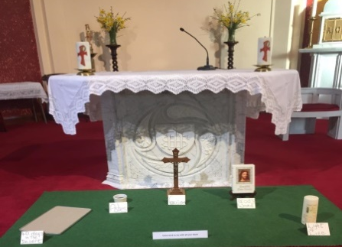
Parish Office Opening Hours:
Mon. 10.30am -2.30pm. Wed. 10.30am-1.30pm Priests :
Fri. 10.30am-2.30pm Phone ; 068-36111. Fr. Sean Hanafin 087-8341083

Email: tarbert@dioceseofkerry.ie Fr. Michael Hussey 087-2386084
Notices for Parish Newsletter have to be in on Safeguarding Children: 087-6362780 Wednesday by 12 Noon. Defib. Emergency No. 999 or 112
Webpage: www.stmarystarbert.com (Outside Surgery Hours)

Palm Sunday of the Lord’s Passion 24th March 2024

Day/Date | Time | Intention
Saturday 23rd | 6pm | People of the Parish.
Sunday 24th | 11.30am | Jose and Batt Flavin, Carhoonakilla.
Monday 25th | 10am | Mass in Tarbert.  John Lavery, Tarbert Island.
Tuesday 26th | 7pm | Mass in Ballylongford.
Wednesday 27th | ______ | No Mass.
Thursday 28th  Holy Thursday. | 7.30pm  in Asdee | Evening Mass of the Lord’s Supper.
Friday 29th  Good Friday. | 7pm  in Ballylongford | Celebration of the Lord’s Passion.
Saturday 30th  Holy Saturday. | 6pm  in Tarbert | Celebration of the Easter Vigil in Tarbert.  People of the Parish.
Sunday 31st  Easter Sunday. | 11.30am | Easter Day of the Lord’s Resurrection.  Private Intention.

PRIEST ON DUTY THIS WEEKEND: Fr. Michael Hussey 087-2386084.
PARISH OFFERTORY COLLECTION Amount received will be published at the end of each month.
GRAVES – Families are asked to ensure that their graves are clean and tidy and to remove any unwanted items.
LIVE SERVICES – All Masses are now being live streamed from our Church. Just go to the Church website – www.stmarystarbert.com and you can watch on your phone, tablet, computer or smart T.V. When you log in and see the picture of the Altar, just underneath this, click on the mute button and you will then have the audio as well.

All our Masses at St. Mary’s Church, Tarbert
can be viewed online at www.stmarystarbert.com

Reflection for Good Friday

Why do we call this Friday ‘Good’ when so many bad things happened ?
It is a day of contrasts and of paradox, a day of contradictions.
It is a day of unparalleled evil but we strangely call it ‘Good’.
God came to earth so that we may go to heaven.
God became human so that we might become divine.
The Son of God became a slave so that we could be set free.
Jesus was rejected so that we might be accepted.
Jesus forgave so that we would forgive.
Jesus was convicted so that we might have conviction.
Jesus was sold so that we could be redeemed.
Jesus was hurt so that we could be healed.
Jesus was scourged – we were purged.
Jesus descended into hell so that we might ascend to heaven.
Jesus was crowned with thorns so that we might have the crown of eternal life.
The sky went dark so that we might see the light.
The earth shook so that we might be calm.
Jesus was condemned as guilty so that we might be found innocent.
Jesus carried his cross so that Satan’s plan would be crossed out.
Jesus heart was opened by a spear so that our hearts might be opened by love.
Jesus laid in a borrowed tomb for only three days.
This is a day of supreme contrasts, paradox and even contradiction.
Jesus suffered all those bad things, so that we might call This Friday ‘Good’.

TARBERT ACTIVE RETIREMENT GROUP – (over 55’s) meet in Tarbert Bridewell every Friday between 10.30am and 12 Noon. We have different activities every week followed by refreshments. New Members are welcome.
SHANNONSIDE WOMEN’S GROUP – are meeting on next Tuesday 26th March at 3pm in the Community Centre. New members welcome.
DIOCESAN YOUTH PILGRIMAGE TO TAIZÉ, FRANCE - Interested in coming to Taizé this June? The diocese will be taking a group of young adults on this amazing pilgrimage from Sunday, June 23rd to Sunday June 30th 2024. Please contact Tomás Kenny for more information on 086-3683778 or email Tomás at tomaskenny@dioceseofkerry.ie

THANK YOU - for your continuing support and financial donations that underpin the smooth running of St. Mary’s Parish Church. Please continue to donate what you can on a weekly basis at any of our Masses on Friday, Saturday, Sunday or Monday. Donations can also be made by bank transfer – our bank details are as follows :
IBAN No- IE76 AIBK 9354 3380 3050 83, Account Name – Tarbert Church Account,
Bank - AIB, The Square, Listowel Co. Kerry.

