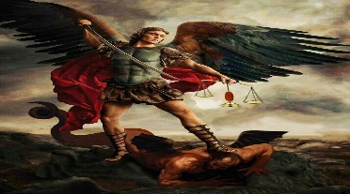
St Michael’s Church Allihies/Cahermore Parish
Mass Schedule March 2024
Priest on Duty 17 Mar Fr. George Hayes. 087-1226888
Every Thurs evening @ 7pm Cahermore: Every Friday evening @ 6.30pm Allihies Every second Sunday Cahermore @10.00am: Every second Saturday Allihies @ 6.30pm.
Fr. John Kerin may be contacted on 086-1918246.
Please pray for all those who died recently, and those whose anniversaries occur at this time.
Mass Intentions for Weekend 16th & 17th March 5th Sunday of Lent.
March
Thursday | 14th Mar | Cahermore | Julia & Joseph O’Sullivan Cloghane
Friday | 15th Mar | Allihies | Mass for the people of the Parish
Sunday  St Patricks Day | 17th Mar  This Photo by Unknown Author is licensed under CC BY-NC | Cahermore | Jimmy O’Sullivan Ballinacarriga, remembering his daughter Mary Farrell who died recently.
2nd Collection this weekend 17th March for Emigrant Services

Mass Intentions for Weekend 23rd & 24th March Passion Sunday.
March
Thursday | 21st Mar | Cahermore | Mass for the people of the Parish
Friday | 22nd Mar | Allihies | Michael Hanley, Lichbarrahan & New York. 10th Anniversary
Saturday | 23rd Mar | Allihies | Joe Harrington, Cahermeelaboe  Don O’Neill, Canalmore & Newcastlewest
Eucharist Adoration at Cahermore Church at 6pm every Thursday.
Please contact Claire at the parish office to book Mass, Weddings, or Christenings, on 086-8344354 or email allihies@dioceseofkerry.ie Parish Office Opening Hours Tues & Thurs 2pm to 6pm . If you have any items for the parish bulletin, please email it to the parish office the Tues before you want it included.
First Friday Calls: If you or anyone you might know would like Fr John to include you in his First Friday Calls, please contact the parish office 086-8344354 during office hours.
Notices: Dear Parishioners thank you for your weekly contributions can you all please use the YELLOW envelopes only for the weekly collection. If you haven’t already received them, please contact the parish office.

Please Get INVOLVED: Following on from our Parish Gathering many people feel it is vital that we have some more people taking part in our church liturgies & groups. Therefore, we are hoping for some people to come forward who are willing to help out. Please contact Claire. 0868344354
Castletownbere St. Patrick’s Day Parade will be held on Sunday 17th of March. Come along and enjoy celebrating St. Patrick’s Day with a huge entry of floats it promises to be a great day out for all the family. Bere Island community radio will be live in the square at 11am. There will be live music in the square by Garnish Sound The parade will start at 3pm sharp led by piper Etienne Baranger and will take the usual route to the West End and back to the square, Where the winners will be announced. We will have a fundraising raffle to fund the parade. 1st prize sponsored by Super Valu. We ask you all to support the raffle thanks a mill. IMPORTANT TO NOTE: Anyone participating in the parade are asked to line up at the West End of the Pier at 2.20pm to allow for a prompt start. If you like further information or would like to enter a float, please contact Anne Marie Cronin on 0872386068
Services for Older People Our services for older people in our community include meal deliveries on Thursdays, with locally prepared meals costing €5; arranging monitored personal alarms which offer reassurance and peace of mind for individuals living alone; and regular social phone calls to keep people in touch with the community. If you, or someone you know, might benefit from any or all these services, please contact the Centre at 027 70998.
The Legion of Mary in the Diocese are having their annual Consecration to Our Blessed Lady on Sunday March 24th at 3 p.m. This will be held at the Prince of Peace Church in Fossa. All are welcome to attend.

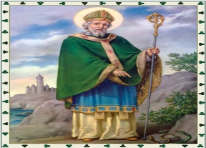
Christ be within me, Christ behind me, Christ before me, Christ beside me, Christ to win me, Christ to comfort and restore me, Christ beneath me, Christ above me, Christ inquired, Christ in danger, Christ in hearts of all that love me, Christ in mouth of friend and stranger. St. Patrick

